Series
OFE-A Advantage Electric Furnace
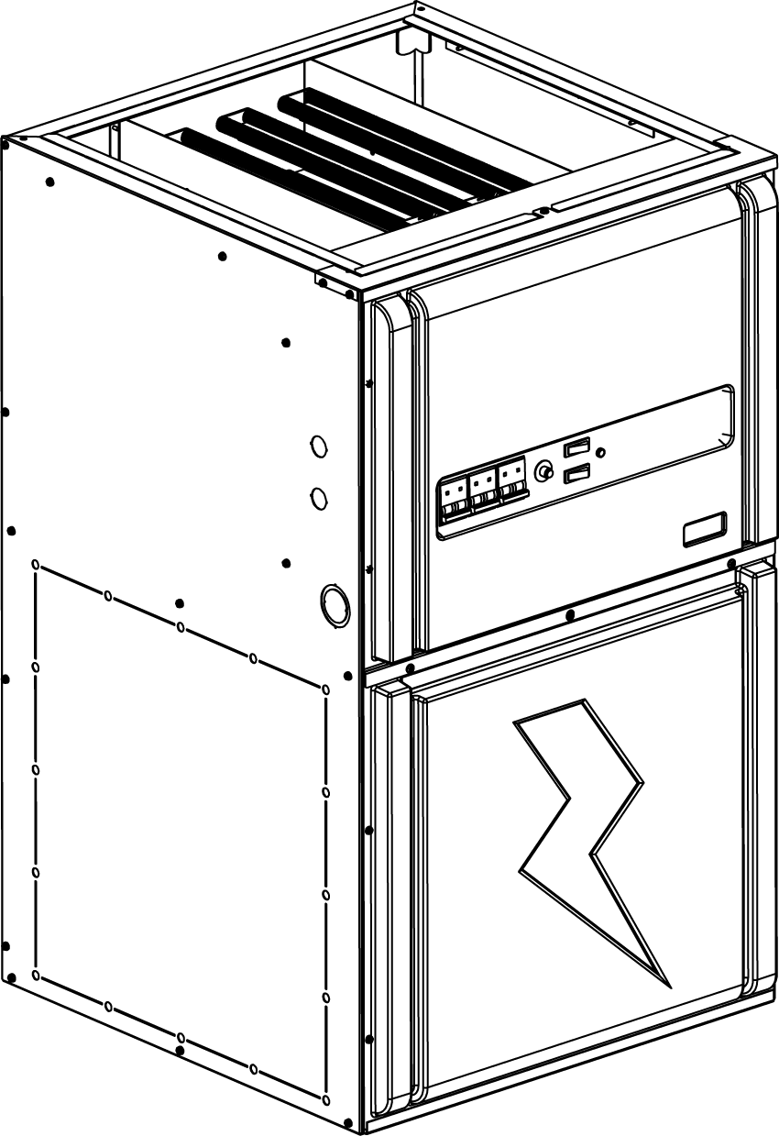

Features
Color - Standard: grey.
Voltage - 240/208V, 1-phase.
Construction - Steel casing, all insulated for reduced heat loss and noise.
- Dual access panels on casing provide easy access to internal parts.
Fan - High quality precision balanced blower for quiet operation and optimal performance.
Motor - Variable speed electronically commutated motor (ECM), permanently lubricated.
- Rubber mounted for maximum vibration and noise reduction.
- Relay and printed circuit board (PCB) control automatic operation of motor and allow for the addition of air conditioning or heat pump.
Heating element - Heavy duty, reliable 4kW and 5kW helical coil nickel-chromium alloy wire provide superior heat transfer with unrestricted air flow.
- Heating elements can be individually replaced.
- High-limit temperature control with automatic reset.
- Heating element sequence is done by a low voltage printed circuit boards with rectifier/timers to prevent power surges.
Control - Heavy duty 24VAC transformer provides power to relays and controls.
- Easy access built-in breakers with manual reset.
- Thermostat "On" light indicates a call for heat by the thermostat.
- “Speed Selector” switch: “Low” or “High”.
- “Fan Selector” switch: “On” or “Off”.
- Compatible with 1 or 2-stage thermostat with or without external unit.
- A 120V terminal block also permits installation of accessories such as humidifier and electronic filter (maximum 2A).
Installation - Multi-position installation, sides, back, or bottom air returns.
- Approved for zero clearance installation against combustible surfaces.
Warranty - 5-year warranty against defects.
Application - For cottages, homes or offices, also approved for mobile homes use. May be installed in a basement, closet, crawl space or any unused area or alcove.

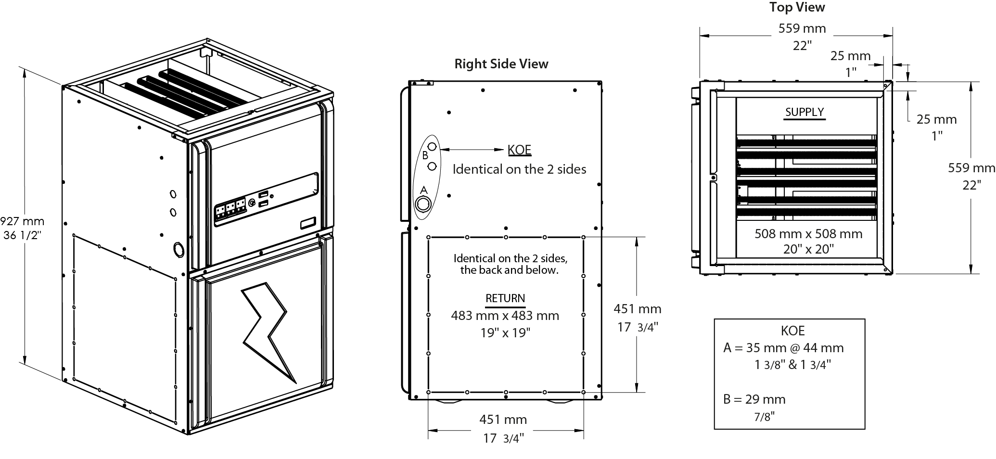

Models with Variable Speed Motor (ECM)
Product # | Volts (1 ph)  2 wires | kW (BTU/hr) | Amp including  motor | Motor  HP | Motor Speed | Weight |  | Qty
 |  |  |  |  |  | lb | kg | Qty
OFEA10000-VV | 240/208 | 10.0 (34120) / 7.5 (25628) | 43.7 / 38.6 | 1/2 | Variable | 105 | 48
OFEA15000-VV | 240/208 | 15.0 (51180) / 11.3 (38442) | 64.4 / 56.5 | 1/2 | Variable | 105 | 48
OFEA18000-VV | 240/208 | 18.0 (61420) / 13.5 (46130) | 78.1 / 68.4 | 1/2 | Variable | 105 | 48
OFEA20000-VV | 240/208 | 20.0 (68240) / 15.0 (51256) | 85.1 / 74.5 | 1/2 | Variable | 105 | 48
OFEA23000-1HVV | 240/208 | 23.0 (78480) / 17.3 (58944) | 101.7 / 89.6 | 1 | Variable | 105 | 48
OFEA25000-1HVV | 240/208 | 25.0 (85360) / 18.8 (64070) | 108.7 / 95.7 | 1 | Variable | 105 | 48
OFEA27000-1HVV¹ | 240/208 | 27.0 (92130) / 20.3 (69195) | 118.8 / 104.5 | 1 | Variable | 105 | 48
OFEA30000-1HVV¹ | 240/208 | 30.0 (102432) / 22.5 (76884) | 129.5 / 113.7 | 1 | Variable | 105 | 48

Options
Product #  En trousse | Description | Qty
OFE-SO2 | Downflow sub-base
OFE-AK2 | Adaptor kit for 17 in. x17 in. duct
OFE-TM | Diagnostic tool for ECM motor
¹ These models come with two supply terminal blocks. It is possible to do a field conversion from two to one supply (requires copper wire). Refer to the installation instructions and owner’s manual for details.
Standard color is grey.

Wall Controls
Compatible with any low voltage thermostat.

Specifications may change without prior notice
Project: | Approval  Information
Consultant Engineer: | Approval  Information
Electrician Contractor: | Approval  Information
Distributor: | Approval  Information
Date: | Approval  Information
Contact in Ouellet: | Approval  Information
Comments:

