Series
OFE-A Advantage Electric Furnace
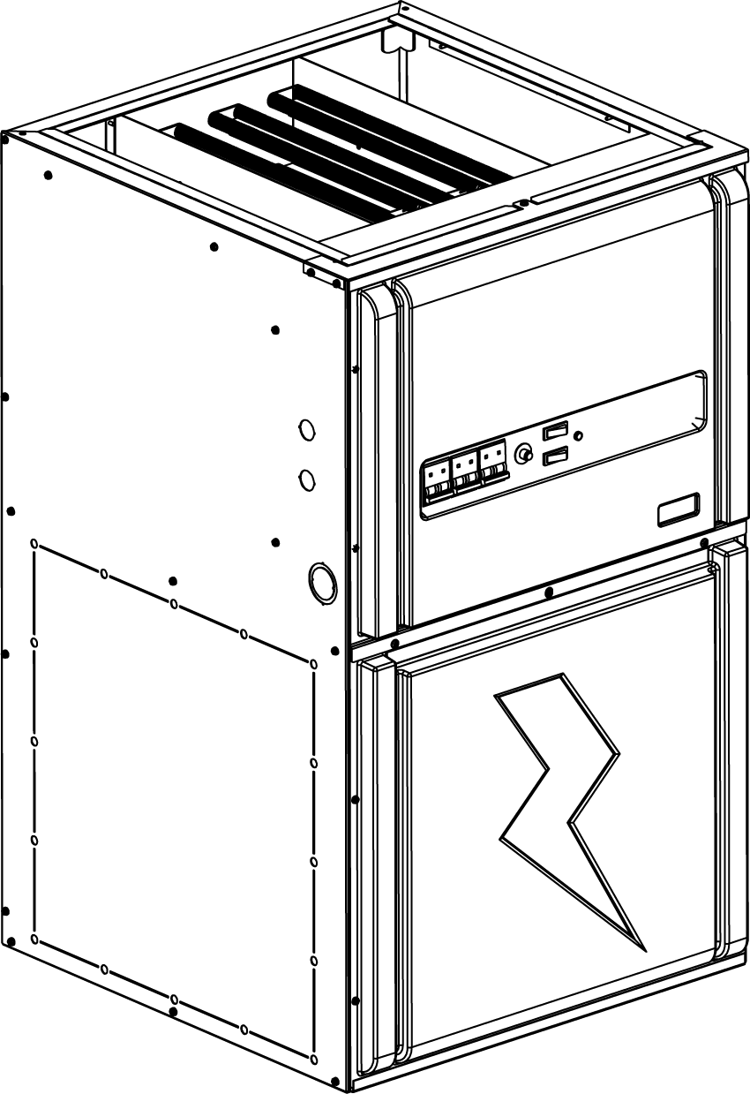

Features
Color - Standard: grey.
Voltage - 240/208V, 1-phase.
Construction - Steel casing, all insulated for reduced heat loss and noise.
- Dual access panels on casing provide easy access to internal parts.
Fan - High quality precision balanced blower for quiet operation and optimal performance.
Motor - Standard motor (PSC), permanently lubricated.
- Variable speed electronically commutated motor (ECM), permanently lubricated.
- Both motors are rubber mounted for maximum vibration and noise reduction.
- Relay and printed circuit board (PCB) control automatic operation of motor and allow for the addition of air conditioning or heat pump.
Heating element - Heavy duty, reliable 4kW and 5kW helical coil nickel-chromium alloy wire provide superior heat transfer with unrestricted air flow.
- Heating elements can be individually replaced.
- High-limit temperature control with automatic reset.
- Heating element sequence is done by a low voltage printed circuit boards with rectifier/timers to prevent power surges.
Control - Heavy duty 24VAC transformer provides power to relays and controls.
- Easy access built-in breakers with manual reset.
- Thermostat "On" light indicates a call for heat by the thermostat.
- “Speed Selector” switch: “Low” or “High”.
- “Fan Selector” switch: “On” or “Off”.
- Compatible with 1 or 2-stage thermostat with or without external unit.
- A 120V terminal block also permits installation of accessories such as humidifier and electronic filter (maximum 2A).
Installation - Multi-position installation, sides, back, or bottom air returns.
- Approved for zero clearance installation against combustible surfaces.
Warranty - 5-year warranty against defects.
Application - For cottages, homes or offices, also approved for mobile homes use. May be installed in a basement, closet, crawl space or any unused area or alcove.

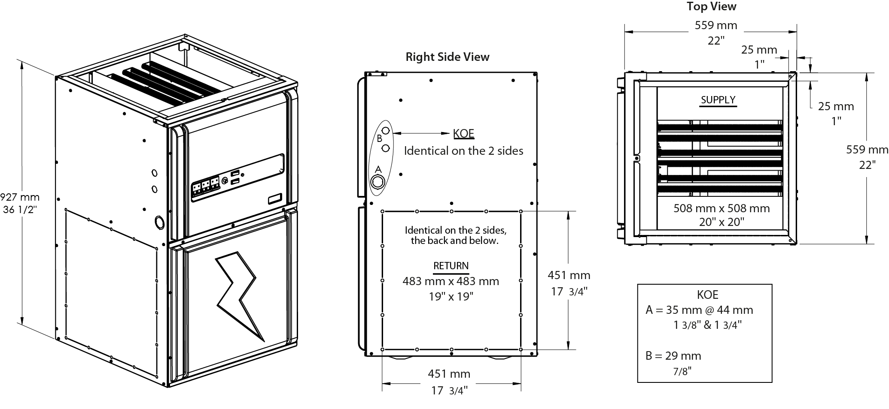

Models with Standard Motor (PSC)¹
Product # | Volts (1 ph)  2 wires | kW (BTU/hr) | Amp including  motor | Motor  HP | Static Pressure at 0.5" W.C. |  | Weight |  | Qty
 |  |  |  |  | Motor Speed² | cfm³ | lb | kg | Qty
OFEA10000 | 240/208 | 10.0 (34120) / 7.5 (25628) | 44.0 / 38.2 | 1/3 | Low | 595 | 105 | 48
OFEA15000 | 240/208 | 15.0 (51180) / 11.3 (38442) | 64.7 / 56.1 | 1/3 | Low | 595 | 105 | 48
OFEA18000 | 240/208 | 18.0 (61420) / 13.5 (46130) | 78.4 / 68.0 | 1/3 | Low | 595 | 105 | 48
OFEA20000 | 240/208 | 20.0 (68240) / 15.0 (51256) | 85.4 / 74.1 | 1/3 | Low | 595 | 105 | 48
OFEA23000-1H | 240/208 | 23.0 (78480) / 17.3 (58944) | 102.4 / 88.7 | 1 | Medium/Low | 1275 | 105 | 48
OFEA25000-1H | 240/208 | 25.0 (85360) / 18.8 (64070) | 109.4 / 94.8 | 1 | Medium/Low | 1275 | 105 | 48
OFEA27000-1H | 240/208 | 27.0 (92130) / 20.3 (69195) | 119.5 / 103.6 | 1 | Medium/Low | 1275 | 105 | 48
OFEA30000-1H | 240/208 | 30.0 (102432) / 22.5 (76884) | 130.2 / 112.8 | 1 | Medium/Low | 1275 | 105 | 48

Models with Variable Speed Motor (ECM)
Product # | Volts (1 ph)  2 wires | kW (BTU/hr) | Amp including  motor | Motor  HP | Motor Speed | Weight |  | Qty
 |  |  |  |  |  | lb | kg | Qty
OFEA10000-VV | 240/208 | 10.0 (34120) / 7.5 (25628) | 43.7 / 38.6 | 1/2 | Variable | 105 | 48
OFEA15000-VV | 240/208 | 15.0 (51180) / 11.3 (38442) | 64.4 / 56.5 | 1/2 | Variable | 105 | 48
OFEA18000-VV | 240/208 | 18.0 (61420) / 13.5 (46130) | 78.1 / 68.4 | 1/2 | Variable | 105 | 48
OFEA20000-VV | 240/208 | 20.0 (68240) / 15.0 (51256) | 85.1 / 74.5 | 1/2 | Variable | 105 | 48
OFEA23000-1HVV | 240/208 | 23.0 (78480) / 17.3 (58944) | 101.7 / 89.6 | 1 | Variable | 105 | 48
OFEA25000-1HVV | 240/208 | 25.0 (85360) / 18.8 (64070) | 108.7 / 95.7 | 1 | Variable | 105 | 48
OFEA27000-1HVV⁴ | 240/208 | 27.0 (92130) / 20.3 (69195) | 118.8 / 104.5 | 1 | Variable | 105 | 48
OFEA30000-1HVV⁴ | 240/208 | 30.0 (102432) / 22.5 (76884) | 129.5 / 113.7 | 1 | Variable | 105 | 48
¹ Installation is forbidden outside Québec.
² Factory settings.
³ Refer to the installation instructions and owner’s manual for complete air flow tables.
⁴ These models come with two supply terminal blocks. It is possible to do a field conversion from two to one supply (requires copper wire). Refer to the installation instructions and owner’s manual for details.
Standard color is grey.

Options
Product #  En trousse | Description | Qty
OFE-SO2 | Downflow sub-base
OFE-AK2 | Adaptor kit for 17 in. x17 in. duct
OFE-TM | Diagnostic tool for ECM motor

Wall Controls
Compatible with any low voltage thermostat.

Specifications may change without prior notice
Project: | Approval  Information
Consultant Engineer: | Approval  Information
Electrician Contractor: | Approval  Information
Distributor: | Approval  Information
Date: | Approval  Information
Contact in Ouellet: | Approval  Information
Comments:

