Series
OFB Compact Wall Fan Heater

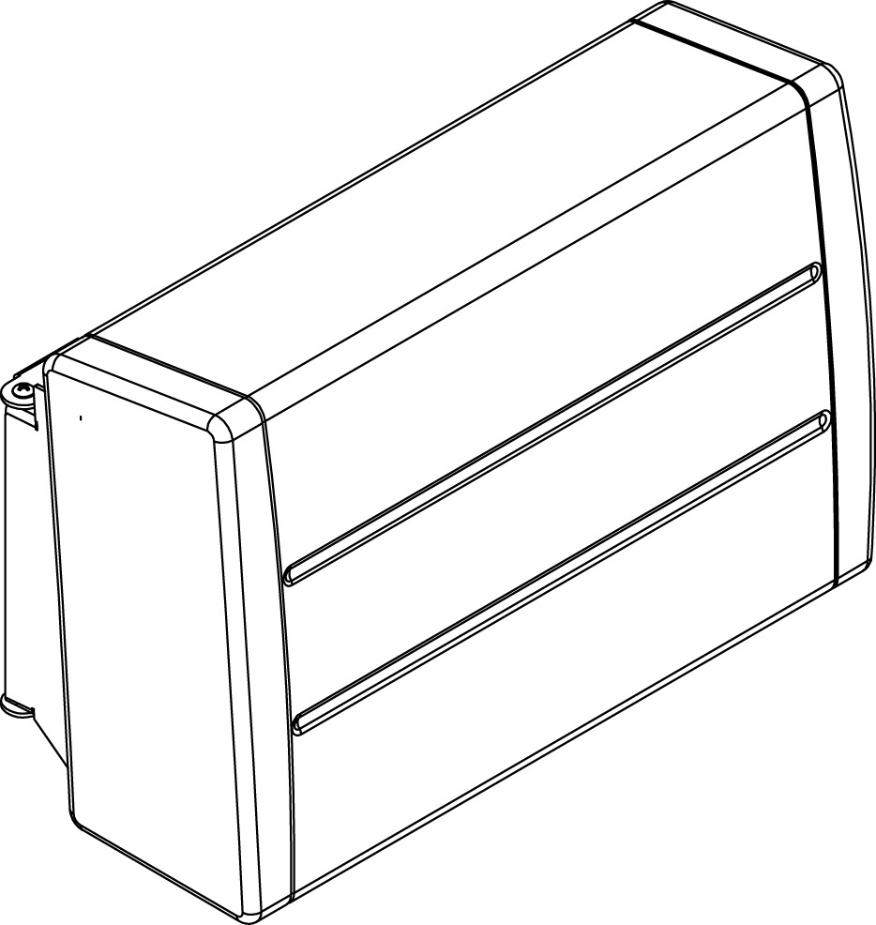

Features
Color - Standard: white.
Finish - Standard: epoxy/polyester powder paint.
Voltage - 120V, 240/208V, 1-phase.
Construction - 20-gauge steel cabinet.
- Warm air outlet that directs the air downwards, towards the center of the room.
- Bar grille prevents insertion of foreign objects; smooth-finish paint is washable
and anti-yellowing.
- Manual de-energize high-limit thermal protection.
Fan - Whisper-quiet squirrel-cage fan.
- Factory-lubricated motor.
Heating element - Nickel-chromium alloy stitched wire protected by mica insulators.
- Heating element provides instant heat.
Control - Line voltage control circuit for thermostat, timer or switch (not included, must be compatible with the selected voltage and wattage of the heater).
Note: If an electronic thermostat is used, it must be compatible with forced-air heaters.
Installation - Recommended installation height: max. 10 ft. (3 m), min. 6 ft. (1.8 m).
- Wattage must be selected at the time of wiring (750W or 1500W).
- Quick surface-mounted installation, with the included mounting bracket.
- Flexible cable with electrical wall box cover plate included.
- Requires installation of a wall electrical box not supplied.
Warranty - 2-year warranty against defects.
- 5-year warranty on the heating element.
Application - Bathroom, entrance way, stairwell.

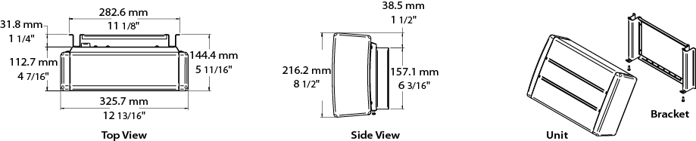

Models
Product # | Qty | Volts | Watts¹ | Weight
 |  |  |  | lb | kg
OFB1502BL |  | 120 | 750  1500 | 8.1 | 3.7
OFB1500BL |  | 240 | 750/563  1500/1125 | 8.1 | 3.7

¹Wattage can be selected on site (750W or 1500W).
Standard color is white.

Others
Type | Quantity | Model et description  Complementary information | Volts | Phase | Watts | Length  mm/in. | Information  Color/installation

Specifications may change without prior notice
Project: | Approval  Information
Consultant Engineer: | Approval  Information
Electrical Contractor: | Approval  Information
Distributor: | Approval  Information
Date: | Approval  Information
Contact in Ouellet: | Approval  Information
Comments:

