Series
ODS Ceiling Fan Heater


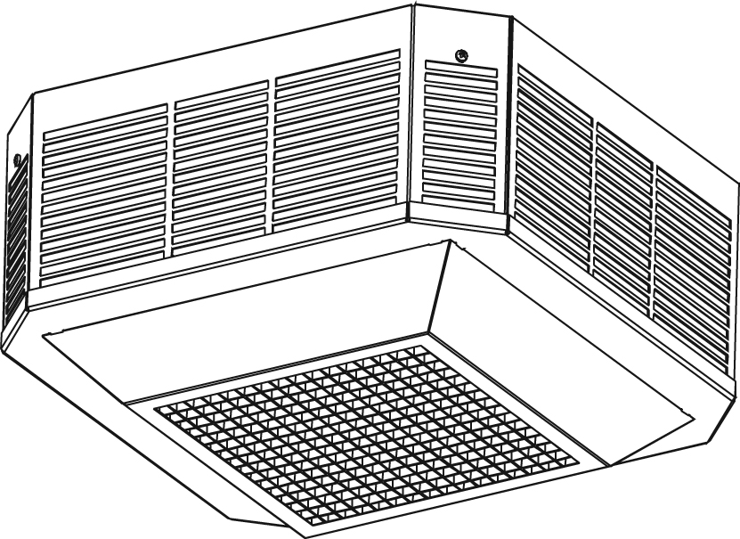

Features
Color - Standard: white, almond.
- Optional (upcharge applicable): metallic silver, bronze, metallic charcoal,
aluminum, semi-gloss black.
- Custom colors available upon request.
Finish - Standard: epoxy/polyester powder paint.
Voltage - 208V, 240V, 277V, 347V, 480V, 600V, 1 or-3 phase.
Construction - Outlet grille made of flat ribbon wire.
- High-limit temperature control with automatic reset.
Fan - Totally enclosed and lifetime-lubricated ball bearing motor.
- Fan delay purges heater of residual heat.
Heating element - Three stainless steel tubular heating elements with aluminum fins.
Control - 240/208V control circuit standard (except for 2 to 5kW at 277V have
277V control standard).
- Built-in 240V contactor for some models (see table).
- 24V and 120V control circuit available.
- Built-in tamperproof thermostat available.
- 24V relay (with or without transformer) available.
- Continuous circulation controlled by a built-in switch with power-on indicator
light available (-CV).
Any remote thermostat or relay must be connected to the heater control terminal block.
Installation - Recommended height: between 8 ft. (2.4 m) and 12 ft. (3.6 m).
- Recessed into insulated or T-bar ceiling (ODSR).
- Surface mounting (ODSA and ODSB), T-BAR adaptor optional.
Note: We recommend installing this product on an outside ceiling to avoid vibrations spreading
to an adjacent room.
Warranty - 5-year warranty against defects.
Application - Apartment building, commercial building, drop ceiling, stairwell, garage.

Models
Watts | Volts (ph) | Product # | Qty | Volts (ph) | Product # | Qty | cfm | Temperature Rise |  | Motor
 |  |  |  |  |  |  |  | °C | °F | HP | rpm
ODSA Surface
2000 | 240 (1) | ODSAU02000 |  | 240 (3) | ODSAU02030¹ |  | 310 | 11 | 20 | 1/50 | 1550
3000 | 240 (1) | ODSAU03000 |  | 240 (3) | ODSAU03030¹ |  | 310 | 17 | 30 | 1/50 | 1550
4000 | 240 (1) | ODSAU04000 |  | 240 (3) | ODSAU04030¹ |  | 310 | 23 | 41 | 1/50 | 1550
5000 | 240 (1) | ODSAU05000¹ |  | 240 (3) | ODSAU05030¹ |  | 310 | 28 | 51 | 1/50 | 1550
2000 | 208 (1) | ODSAU02008 |  | 208 (3) | ODSAU02038¹ |  | 310 | 11 | 20 | 1/50 | 1550
3000 | 208 (1) | ODSAU03008 |  | 208 (3) | ODSAU03038¹ |  | 310 | 17 | 30 | 1/50 | 1550
4000 | 208 (1) | ODSAU04008 |  | 208 (3) | ODSAU04038¹ |  | 310 | 23 | 41 | 1/50 | 1550
5000 | 208 (1) | ODSAU05008¹ |  | 208 (3) | ODSAU05038¹ |  | 310 | 28 | 51 | 1/50 | 1550
2000 | 277 (1) | ODSAU02077 |  | - | - |  | 310 | 11 | 20 | 1/50 | 1550
3000 | 277 (1) | ODSAU03077 |  | - | - |  | 310 | 17 | 30 | 1/50 | 1550
4000 | 277 (1) | ODSAU04077 |  | - | - |  | 310 | 23 | 41 | 1/50 | 1550
5000 | 277 (1) | ODSAU05077 |  | - | - |  | 310 | 28 | 51 | 1/50 | 1550
2000 | 480 (1) | ODSAU02004¹ |  | 480 (3) | ODSAU02034¹ |  | 310 | 11 | 20 | 1/50 | 1550
3000 | 480 (1) | ODSAU03004¹ |  | 480 (3) | ODSAU03034¹ |  | 310 | 17 | 30 | 1/50 | 1550
4000 | 480 (1) | ODSAU04004¹ |  | 480 (3) | ODSAU04034¹ |  | 310 | 23 | 41 | 1/50 | 1550
5000 | 480 (1) | ODSAU05004¹ |  | 480 (3) | ODSAU05034¹ |  | 310 | 28 | 51 | 1/50 | 1550
ODSB Surface
7500 | 240 (1) | ODSBU07500¹ |  | 240 (3) | ODSBU07530¹ |  | 600 | 22 | 39 | 1/33 | 1550
10000 | 240 (1) | ODSBU10000¹ |  | 240 (3) | ODSBU10030¹ |  | 600 | 29 | 53 | 1/33 | 1550
7500 | 208 (1) | ODSBU07508¹ |  | 208 (3) | ODSBU07538¹ |  | 600 | 22 | 39 | 1/33 | 1550
9900 | 208 (1) | ODSBU09908¹ |  | 208 (3) | ODSBU09938¹ |  | 600 | 29 | 53 | 1/33 | 1550
7500 | 277 (1) | ODSBU07577¹ |  | 347 (1) | - |  | 600 | 22 | 39 | 1/33 | 1550
10000 | 277 (1) | ODSBU10077¹ |  | 347 (1) | - |  | 600 | 29 | 53 | 1/33 | 1550
7500 | 480 (1) | ODSBU07504¹ |  | 480 (3) | ODSBU07534¹ |  | 600 | 22 | 39 | 1/33 | 1550
10000 | 480 (1) | ODSBU10004¹ |  | 480 (3) | ODSBU10034¹ |  | 600 | 29 | 53 | 1/33 | 1550
ODSR Recessed
2000 | 240 (1) | ODSRU02000 |  | 240 (3) | ODSRU02030¹ |  | 310 | 11 | 20 | 1/50 | 1550
3000 | 240 (1) | ODSRU03000 |  | 240 (3) | ODSRU03030¹ |  | 310 | 17 | 39 | 1/50 | 1550
4000 | 240 (1) | ODSRU04000 |  | 240 (3) | ODSRU04030¹ |  | 310 | 23 | 41 | 1/50 | 1550
5000 | 240 (1) | ODSRU05000¹ |  | 240 (3) | ODSRU05030¹ |  | 310 | 28 | 51 | 1/50 | 1550
2000 | 208 (1) | ODSRU02008 |  | 208 (3) | ODSRU02038¹ |  | 310 | 11 | 20 | 1/50 | 1550
3000 | 208 (1) | ODSRU03008 |  | 208 (3) | ODSRU03038¹ |  | 310 | 17 | 30 | 1/50 | 1550
4000 | 208 (1) | ODSRU04008 |  | 208 (3) | ODSRU04038¹ |  | 310 | 23 | 41 | 1/50 | 1550
5000 | 208 (1) | ODSRU05008¹ |  | 208 (3) | ODSRU05038¹ |  | 310 | 28 | 51 | 1/50 | 1550
2000 | 277 (1) | ODSRU02077 |  | - | - |  | 310 | 11 | 20 | 1/50 | 1550
3000 | 277 (1) | ODSRU03077 |  | - | - |  | 310 | 17 | 30 | 1/50 | 1550
4000 | 277 (1) | ODSRU04077 |  | - | - |  | 310 | 23 | 41 | 1/50 | 1550
5000 | 277 (1) | ODSRU05077 |  | - | - |  | 310 | 28 | 51 | 1/50 | 1550
2000 | 480 (1) | ODSRU02004¹ |  | 480 (3) | ODSRU02034¹ |  | 310 | 11 | 20 | 1/50 | 1550
3000 | 480 (1) | ODSRU03004¹ |  | 480 (3) | ODSRU03034¹ |  | 310 | 17 | 30 | 1/50 | 1550
4000 | 480 (1) | ODSRU04004¹ |  | 480 (3) | ODSRU04034¹ |  | 310 | 23 | 41 | 1/50 | 1550
5000 | 480 (1) | ODSRU05004¹ |  | 480 (3) | ODSRU05034¹ |  | 310 | 28 | 51 | 1/50 | 1550

Options
Product #  Kit | Product #  Factory installed* | Description | Qty
- | 120 | 120V control circuit
- | CV | Summer fan switch and pilot light
KIT-ODS-DIS20² | DIS20² | Disconnect switch, double-pole, 20A at 277V and less
KIT-ODS-DIS40² | DIS40² | Disconnect switch, triple-pole, 40A at 600V max.
- | DIS80² | Disconnect switch, triple-pole, 80A at 600V
KIT-ODS-R | R | 24V control relay, without transformer
- | RCV24 | Summer fan relay 24V, remote control and pilot light (switch not included)
- | RCV240 | Summer fan relay 240V, remote control and pilot light (switch not included)
- | RT | 24V control relay, with transformer
KIT-ODS-T-AV | TAV | Thermostat tamperproof
KIT-ODSA-T-BAR | - | Adaptor for T-bar ceiling, ODSA only
KIT-ODSB-T-BAR | - | Adaptor for T-bar ceiling, ODSB only

* For factory installed options, add the option number to the product number. See the Product Code section inside the front cover.
¹ Built-in 240V contactor.
² For the U.S. only: The nominal current of the unit must not exceed 80% of the capacity of the disconnect.

Others
Type | Quantity | Model et description  Complementary informations | Volts | Phase | Watts | Length  mm/in. | Informations  Color/installation

Specifications may change without prior notice
Project: | Approval  Information
Consultant Engineer: | Approval  Information
Eectrician Contractor: | Approval  Information
Distributor: | Approval  Information
Date: | Approval  Information
Contact in Ouellet: | Approval  Information
Comments:

