Series
ODL High-End Baseboard Heater


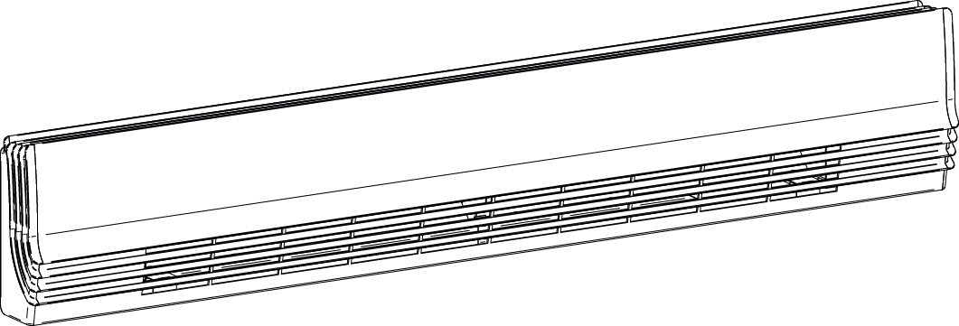

Features
Color - Standard: white, metallic charcoal.
- Optional (upcharge applicable): almond, metallic silver, bronze, aluminum,
semi-gloss black, sand.
- Custom colors available upon request.
Finish - Standard: epoxy/polyester powder paint.
Voltage - 120V, 208V, 240/208V, 277V, 347V, 480V, 600V, 1-phase.
Construction - Robust aluminum front cover.
- 20-gauge satin coat steel cabinet.
- Linear high-limit temperature control with automatic reset.
- High altitude version available (-HA).
Heating element - Stainless steel tubular heating element with aluminum ﬁns.
- Floating heating element on high-temperature nylon bushings
reducing expansion noises.
Watt density - Average standard watt density of 275W/ft.
- Average low watt density of 200W/ft.
Control - Built-in thermostat available with a control knob or tamperproof.
- Mechanical or electronic relays available (installed on the right end only).
- Compartment for low voltage connections (located directly under the junction box) to facilitate the installation of low voltage relay.
Ouellet highly recommends using an electronic wall thermostat for greater comfort.
Installation - Installation directly on the floor.
- Connection box at both ends.
- Single-screw built-in wire holder.
- Raceway for ease of installation.
- Two rows of mounting holes spaced at 2 in. (51 mm)
intervals for ease of installation.
Warranty - 5-year warranty against defects.
- Heating element has a lifetime warranty for the initial end user.
Application - Dining room-kitchen, living room, family room, bedroom, bay window, office building, commercial building.

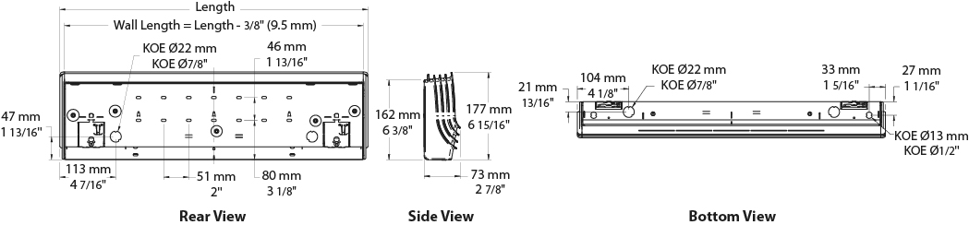
Average Standard Watt Density Models 275W/ft.
Watts | Watts  240/208V | Product # |  |  |  |  |  |  |  |  |  | Length¹ |  | Weight
Watts | Watts  240/208V | 120V | Qty | 208V | Qty | 240/208V | Qty | 347V | Qty | 600V | Qty | in. | mm | lb | kg
300 | 300/225 | ODL0302 |  | ODL0308 |  | ODL0300 |  | - | - | - | - | 24 _{5/8} | 625 | 7.4 | 3.4
500 | 500/375 | ODL0502 |  | ODL0508 |  | ODL0500 |  | ODL0507 |  | - | - | 29 _{1/2} | 750 | 8.5 | 3.9
750 | 750/563 | ODL0752 |  | ODL0758 |  | ODL0750 |  | ODL0757 |  | ODL0756 |  | 39 _{1/2} | 1004 | 10.7 | 4.9
1000 | 1000/750 | ODL1002 |  | ODL1008 |  | ODL1000 |  | ODL1007 |  | ODL1006 |  | 49 _{13/16} | 1265 | 13.0 | 5.9
1250 | 1250/938 | ODL1252 |  | ODL1258 |  | ODL1250 |  | ODL1257 |  | ODL1256 |  | 59 _{1/4} | 1506 | 15.1 | 6.9
1500 | 1500/1125 | ODL1502 |  | ODL1508 |  | ODL1500 |  | ODL1507 |  | ODL1506 |  | 68 | 1727 | 17.0 | 7.7
1750 | 1750/1313 | - | - | ODL1758 |  | ODL1750 |  | ODL1757 |  | ODL1756 |  | 77 _{5/16} | 1964 | 19.1 | 8.7
2000 | 2000/1500 | - | - | ODL2008 |  | ODL2000 |  | ODL2007 |  | ODL2006 |  | 86 _{1/8} | 2187 | 21.0 | 9.6
2250 | 2250/1688 | - | - | ODL2258 |  | ODL2250 |  | ODL2257 |  | ODL2256 |  | 94 _{15/16} | 2412 | 23.0 | 10.5
2500 | 2500/1875 | - | - | ODL2508 |  | ODL2500 |  | ODL2507 |  | ODL2506 |  | 104 _{1/16} | 2644 | 25.0 | 11.4

Average Low Watt Density Models 200W/ft.
Watts | Watts  240/208V | Product # |  |  |  |  |  |  |  |  |  | Length¹ |  | Weight
Watts | Watts  240/208V | 120V | Qty | 208V | Qty | 240/208V | Qty | 347V | Qty | 600V | Qty | in. | mm | lb | kg
300 | 300/225 | ODL0302-750 |  | ODL0308-750 |  | ODL0300-750 |  | - | - | - | - | 29 _{1/2} | 750 | 8.5 | 3.9
500 | 500/375 | ODL0502-1004 |  | ODL0508-1004 |  | ODL0500-1004 |  | ODL0507-1004 |  | - | - | 39 _{1/2} | 1004 | 10.7 | 4.9
750 | 750/563 | ODL0752-1265 |  | ODL0758-1265 |  | ODL0750-1265 |  | ODL0757-1265 |  | ODL0756-1265 |  | 49 _{13/16} | 1265 | 13.0 | 5.9
1000 | 1000/750 | ODL1002-1506 |  | ODL1008-1506 |  | ODL1000-1506 |  | ODL1007-1506 |  | ODL1006-1506 |  | 59 _{1/4} | 1506 | 15.1 | 6.9
1250 | 1250/938 | ODL1252-1727 |  | ODL1258-1727 |  | ODL1250-1727 |  | ODL1257-1727 |  | ODL1256-1727 |  | 68 | 1727 | 17.0 | 7.7
1500 | 1500/1125 | ODL1502-2187 |  | ODL1508-2187 |  | ODL1500-2187 |  | ODL1507-2187 |  | ODL1506-2187 |  | 86 _{1/8} | 2187 | 21.0 | 9.6
1750 | 1750/1313 | - | - | ODL1758-2412 |  | ODL1750-2412 |  | ODL1757-2412 |  | ODL1756-2412 |  | 94 _{15/16} | 2412 | 23.0 | 10.5
2000 | 2000/1500 | - | - | ODL2008-2644 |  | ODL2000-2644 |  | ODL2007-2644 |  | ODL2006-2644 |  | 104 _{1/16} | 2644 | 23.0 | 10.5
2250 | 2250/1688 | - | - | ODL2258-2644 |  | ODL2250-2644 |  | ODL2257-2644 |  | ODL2256-2644 |  | 104 _{1/16} | 2644 | 23.0 | 10.5

Options
Product #  Kit | Product #  Factory installed* | Description | Qty
KIT-ODL-DIS20⁴ | DIS20⁴ | Disconnect switch, double-pole, 20A at 277V max.
- | HA | Linear high-limit temperature control for high altitude (3000 ft. to 8200 ft.)
KIT-ODL-R-347 | R | Single-pole relay, coil 24V, without transformer: 22A at 120V, 208V, 240V - 18A at 347V
KIT-ODL-R-600 | R | Single-pole relay, coil 24V, without transformer, 10A at 600V
KIT-ODL-RT-120 | RT | Single-pole relay, coil 24V, with transformer 120V/24V, 22A at 120V
KIT-ODL-RT-208 | RT | Single-pole relay, coil 24V, with transformer 208V/24V, 22A at 208V
KIT-ODL-RT-240 | RT | Single-pole relay, coil 24V, with transformer 240V/24V, 22A at 240V
KIT-ODL-RT-277 | RT | Single-pole relay, coil 24V, with transformer 277V/24V, 19A at 277V
KIT-ODL-RT-347 | RT | Single-pole relay, coil 24V, with transformer 347V/24V, 18A at 347V
KIT-ODL-RT-600² | RT² | Single-pole relay, coil 24V, with transformer 600V/24V, 10A at 600V (2-wire only)
KIT-ODL-TB6 | TB6 | Single-pole bi-metal thermostat: 25A at 120V, 208V, 240V, 277V - 10A at 347V, 480V, 600V
KIT-ODL-TB26³ | TB26³ | Double-pole bi-metal thermostat: 25A at 120V, 208V, 240V, 277V - 10A at 347V, 480V, 600V
KIT-ODL-TB6-AV | TB6AV | Single-pole bi-metal thermostat, tamperproof: 25A at 120V, 208V, 240V, 277V - 10A at 347V, 480V, 600V
KIT-ODL-TB26-AV³ | TB26AV³ | Double-pole bi-metal thermostat, tamperproof: 25A at 120V, 208V, 240V, 277V - 10A at 347V, 480V, 600V
KIT-ODL-TRIAC-347 | TRIAC | Single-pole electronic relay, coil 24V, without transformer, 15A at 347V max.
KIT-ODL-TRIAC-347T | TRIACT | Single-pole electronic relay, coil 24V, with transformer: 15A at 208V, 240V, 277V, 347V
KIT-ODL-TRIAC-600 | TRIAC | Single-pole electronic relay, coil 24V, without transformer, 6A at 600V max.

* For factory installed options, add the option number to the product number. See the Product Code section inside the front cover.
¹ Wall length = Length - 3/8" (9.5 mm).
² These 2-wire relays with transformer can't supply of 3-wire low voltage thermostats.
³ "Off" position.
⁴ For the U.S. only: The nominal current of the unit must not exceed 80% of the capacity of the disconnect.
Add "BL" for white, "CM" for metallic charcoal. Upcharge available for optional colors shown in the color chart section.
Other voltages available upon request.

Others
Type | Quantity | Model and description  Complementary informations | Volts | Phase | Watts | Length  mm/in. | Informations  Color/installation

Specifications may change without prior notice
Project: | Approval  Information
Consultant Engineer: | Approval  Information
Electrical Contractor: | Approval  Information
Distributor: | Approval  Information
Date: | Approval  Information
Contact at Ouellet: | Approval  Information
Comments:

