Series
ODIA Steel Sloped Top Draft Barrier
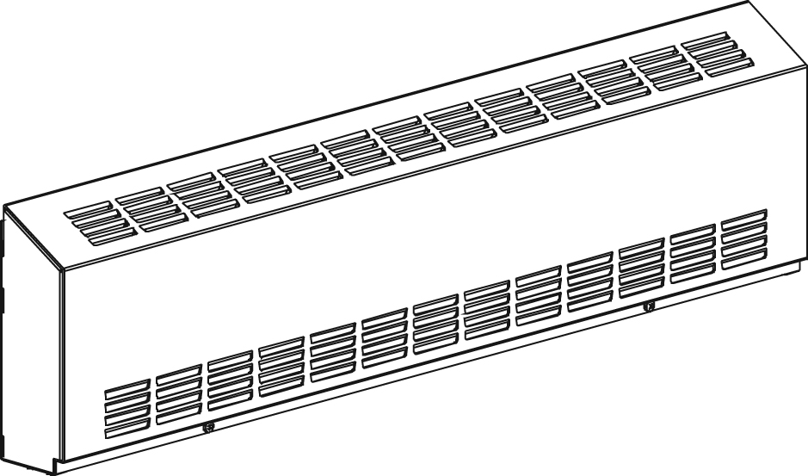
With bottom
fresh air inlet

Features
Color Standard: white, almond.
- Optional (upcharge applicable): metallic silver, bronze, metallic charcoal,
aluminum, semi-gloss black, sand.
- Custom colors available upon request.
Finish - Standard: epoxy/polyester powder paint.
Voltage - 120V, 208V, 240/208V, 277V, 347V, 600V, 50/60 Hz, 1-phase.
Construction - 16-gauge steel front cover.
- 18-gauge satin coat steel cabinet.
- Screw assembly for added strength.
- Full length built-in wireway.
- Front fresh air inlet; top warm air outlet.
- Bottom fresh air inlet available (-BAI).
- Clean back available (-BD).
- Linear high-limit temperature control with automatic reset.
High altitude version available (-HA).
- End caps included.
Heating element - Stainless steel tubular heating element with aluminum ﬁns.
- Floating heating element on high-temperature nylon bushings
reducing expansion noises.
Watt density - Average standard watt density of 275W/ft.
- Average low watt density of 100W/ft., 150W/ft., 200W/ft.
Control - Built-in thermostat available with a control knob
or tamperproof.
- Mechanical, electronic or pneumatic relays available
(installed on the right end only).
Ouellet highly recommends to use an electronic wall thermostat for greater comfort.
Installation - Heater must be installed at least 2 in. (51 mm) from finished floor
(for -BAI option).
- Mounting holes spaced on 4 in. (102 mm) intervals for ease of installation.
- Wall or floor mounted installation.
- Variety of accessories available for wall-to-wall installation.
- Pedestal kit available.
Warranty - 3-year warranty against defects.
Application - Commercial building, office building, hospital, daycare center, private residence.

Average Standard Watt Density Models 275W/ft.¹
Watts | Watts  240/208V² | Product # |  |  |  |  |  |  |  |  |  | Length |  | Weight
Watts | Watts  240/208V² | 120V | Qty | 208V | Qty | 240/208V | Qty | 347V | Qty | 600V | Qty | in. | mm | lb | kg
500 | 500/375 | ODIA0502 |  | ODIA0508 |  | ODIA0500 |  | ODIA0507 |  | - | - | 28 _{7/8} | 733 | 11.6 | 5.3
750 | 750/563 | ODIA0752 |  | ODIA0758 |  | ODIA0750 |  | ODIA0757 |  | ODIA0756 |  | 38 _{7/8} | 987 | 15.1 | 6.9
1000 | 1000/750 | ODIA1002 |  | ODIA1008 |  | ODIA1000 |  | ODIA1007 |  | ODIA1006 |  | 49 _{1/8} | 1248 | 18.7 | 8.5
1250 | 1250/938 | ODIA1252 |  | ODIA1258 |  | ODIA1250 |  | ODIA1257 |  | ODIA1256 |  | 58 _{5/8} | 1489 | 22.0 | 10.0
1500 | 1500/1125 | ODIA1502 |  | ODIA1508 |  | ODIA1500 |  | ODIA1507 |  | ODIA1506 |  | 67 _{5/16} | 1710 | 25.0 | 11.4
1750 | 1750/1313 | - | - | ODIA1758 |  | ODIA1750 |  | ODIA1757 |  | ODIA1756 |  | 76 _{5/8} | 1947 | 28.3 | 12.8
2000 | 2000/1500 | - | - | ODIA2008 |  | ODIA2000 |  | ODIA2007 |  | ODIA2006 |  | 85 _{7/16} | 2170 | 31.3 | 14.2
2250 | 2250/1688 | - | - | ODIA2258 |  | ODIA2250 |  | ODIA2257 |  | ODIA2256 |  | 94 _{5/16} | 2395 | 34.4 | 15.6
2500 | 2500/1875 | - | - | ODIA2508 |  | ODIA2500 |  | ODIA2507 |  | ODIA2506 |  | 103 _{7/16} | 2627 | 37.6 | 17.1

Average Low Watt Density Models
Product #³ | Length | Weight | Average  Density W/ft. | Watts | Watts  240/208V² | 120V | Qty | 208V | Qty | 240/208V | Qty | 347V | Qty | 600V | Qty
ODIA020X-733 | 28 7/8"  (733 mm) | 11.6 lb  (5.3 kg) | 100 | 200 | 200/150 | √ |  | √ |  | √ |  | ----- | ----- | ----- | -----
ODIA030X-733 | 28 7/8"  (733 mm) | 11.6 lb  (5.3 kg) | 150 | 300 | 300/225 | √ |  | √ |  | √ |  | ----- | ----- | ----- | -----
ODIA040X-733¹ | 28 7/8"  (733 mm) | 11.6 lb  (5.3 kg) | 200 | 400 | 400/300 | √ |  | √ |  | √ |  | √ |  | ----- | -----
ODIA030X-987 | 38 7/8"  (987 mm) | 15.1 lb  (6.9 kg) | 100 | 300 | 300/225 | √ |  | √ |  | √ |  | √ |  | ----- | -----
ODIA045X-987 | 38 7/8"  (987 mm) | 15.1 lb  (6.9 kg) | 150 | 450 | 450/338 | √ |  | √ |  | √ |  | √ |  | ----- | -----
ODIA060X-987¹ | 38 7/8"  (987 mm) | 15.1 lb  (6.9 kg) | 200 | 600 | 600/450 | √ |  | √ |  | √ |  | √ |  | ----- | -----
ODIA040X-1248 | 49 1/8"  (1248 mm) | 18.7 lb  (8.5 kg) | 100 | 400 | 400/300 | √ |  | √ |  | √ |  | √ |  | ----- | -----
ODIA060X-1248 | 49 1/8"  (1248 mm) | 18.7 lb  (8.5 kg) | 150 | 600 | 600/450 | √ |  | √ |  | √ |  | √ |  | ----- | -----
ODIA080X-1248¹ | 49 1/8"  (1248 mm) | 18.7 lb  (8.5 kg) | 200 | 800 | 800/600 | √ |  | √ |  | √ |  | √ |  | √
ODIA050X-1489 | 58 5/8"  (1489 mm) | 22.0 lb  (10.0 kg) | 100 | 500 | 500/375 | √ |  | √ |  | √ |  | √ |  | ----- | -----
ODIA075X-1489 | 58 5/8"  (1489 mm) | 22.0 lb  (10.0 kg) | 150 | 750 | 750/563 | √ |  | √ |  | √ |  | √ |  | √
ODIA100X-1489¹ | 58 5/8"  (1489 mm) | 22.0 lb  (10.0 kg) | 200 | 1000 | 1000/750 | √ |  | √ |  | √ |  | √ |  | √
ODIA060X-1710 | 67 5/16"  (1710 mm) | 25.0 lb  (11.4 kg) | 100 | 600 | 600/450 | √ |  | √ |  | √ |  | √ |  | √
ODIA090X-1710 | 67 5/16"  (1710 mm) | 25.0 lb  (11.4 kg) | 150 | 900 | 900/675 | √ |  | √ |  | √ |  | √ |  | √
ODIA120X-1710¹ | 67 5/16"  (1710 mm) | 25.0 lb  (11.4 kg) | 200 | 1200 | 1200/900 | √ |  | √ |  | √ |  | √ |  | √
ODIA070X-1947 | 76 5/8"  (1947 mm) | 28.3 lb  (12.8 kg) | 100 | 700 | 700/525 | √ |  | √ |  | √ |  | √ |  | √
ODIA105X-1947 | 76 5/8"  (1947 mm) | 28.3 lb  (12.8 kg) | 150 | 1050 | 1050/788 | √ |  | √ |  | √ |  | √ |  | √
ODIA140X-1947¹ | 76 5/8"  (1947 mm) | 28.3 lb  (12.8 kg) | 200 | 1400 | 1400/1050 | √ |  | √ |  | √ |  | √ |  | √
ODIA080X-2170 | 85 7/16"  (2170 mm) | 31.3 lb  (14.2 kg) | 100 | 800 | 800/600 | √ |  | √ |  | √ |  | √ |  | √
ODIA120X-2170 | 85 7/16"  (2170 mm) | 31.3 lb  (14.2 kg) | 150 | 1200 | 1200/900 | √ |  | √ |  | √ |  | √ |  | √
ODIA160X-2170¹ | 85 7/16"  (2170 mm) | 31.3 lb  (14.2 kg) | 200 | 1600 | 1600/1200 | ----- | ----- | √ |  | √ |  | √ |  | √
ODIA090X-2395 | 94 5/16"  (2395 mm) | 34.4 lb  (15.6 kg) | 100 | 900 | 900/675 | √ |  | √ |  | √ |  | √ |  | √
ODIA135X-2395 | 94 5/16"  (2395 mm) | 34.4 lb  (15.6 kg) | 150 | 1350 | 1350/1013 | ----- | ----- | √ |  | √ |  | √ |  | √
ODIA180X-2395¹ | 94 5/16"  (2395 mm) | 34.4 lb  (15.6 kg) | 200 | 1800 | 1800/1350 | ----- | ----- | √ |  | √ |  | √ |  | √
ODIA100X-2627 | 103 7/16"  (2627 mm) | 37.6 lb  (17.6 kg) | 100 | 1000 | 1000/750 | √ |  | √ |  | √ |  | √ |  | √
ODIA150X-2627 | 103 7/16"  (2627 mm) | 37.6 lb  (17.6 kg) | 150 | 1500 | 1500/1125 | ----- | ----- | √ |  | √ |  | √ |  | √
ODIA200X-2627¹ | 103 7/16"  (2627 mm) | 37.6 lb  (17.6 kg) | 200 | 2000 | 2000/1500 | ----- | ----- | √ |  | √ |  | √ |  | √
ODIA225X-2627¹ | 103 7/16"  (2627 mm) | 37.6 lb  (17.6 kg) | 200 | 2250 | 2250/1688 | ----- | ----- | √ |  | √ |  | √ |  | √

¹ Not for residential use in the United States.

² 208V = 75% of wattage at 240V.

³ X = 2 (120V), 8 (208V), 0 (240/208V), 7 (347V), 6 (600V).

√ = Available.
Add "BL" for white, "AM" for almond.
Other color, accessories and finishes are available upon request. Please contact your customer service representative.
Other voltages available upon request.

Options
Product #  Kit | Product #  Factory installed* | Description | Qty
Finish
- | BAI | Bottom fresh air inlet
- | BD | Clean back
KIT-ODIA-CE | - | Outside corner, 4 in. (102 mm)
KIT-ODIA-CI | - | Inside corner, 4 in. (102 mm)
KIT-ODIA-JT | - | Splice plate, 2 in. (51 mm)
KIT-ODIA-JT-PE | - | Contour splice plate for BD option and/or heater with pedestals, 2 in. (51 mm)
KIT-ODIA-PE | - | Round pedestal kit (2), 3 in. (76 mm)
KIT-ODIA-PEC | - | Square-shaped pedestal kit (2), 2 in. (51 mm)
ODIA-SV-XX | - | Empty cabinet length of XX mm (minimum: 154 mm, maximum: 2625 mm)
Controls
KIT-ODIA-DIS20³ | DIS20³ | Disconnect switch, 20A at 277V max.
KIT-ODIA-DIS40³ | DIS40³ | Disconnect switch, 40A at 600V max.
- | HA | Linear high limit temperature control for high altitude (3000 ft. to 8200 ft.)
- | PM | Pneumatic relay, 20A at 600V max.
KIT-ODIA-R-347 | R | Single-pole relay, coil 24V, without transformer: 22A at 120V, 208V, 240V - 19A at 277V - 18A at 347V
KIT-ODIA-R-600 | R | Single-pole relay, coil 24V, without transformer, 10A at 600V
KIT-ODIA-RT-120¹ | RT¹ | Single-pole relay, coil 24V, with transformer 120V/24V, 22A at 120V
KIT-ODIA-RT-208 | RT | Single-pole relay, coil 24V, with transformer 208V/24V, 22A at 208V
KIT-ODIA-RT-240 | RT | Single-pole relay, coil 24V, with transformer 240V/24V, 22A at 240V
KIT-ODIA-RT-277 | RT | Single-pole relay, coil 24V, with transformer 277V/24V, 19A at 277V
KIT-ODIA-RT-347 | RT | Single-pole relay, coil 24V, with transformer 347V/24V, 18A at 347V
KIT-ODIA-RT-600¹ | RT¹ | Single-pole relay, coil 24V, with transformer 600V/24V, 10A at 600V (2-wire only)
KIT-ODIA-TB6 | TB6 | Single-pole bi-metal thermostat: 25A at 120V, 208V, 240V, 277V - 10A at 347V, 480V, 600V
KIT-ODIA-TB26² | TB26² | Double-pole bi-metal thermostat: 25A at 120V, 208V, 240V, 277V - 10A at 347V, 480V, 600V
KIT-ODIA-TB6-AV | TB6AV | Single-pole bi-metal tamperproof thermostat: 25A at 120V, 208V, 240V, 277V - 10A at 347V, 480V, 600V
KIT-ODIA-TB26-AV² | TB26AV² | Double-pole bi-metal tamperproof thermostat: 25A at 120V, 208V, 240V, 277V - 10A at 347V, 480V, 600V
KIT-ODIA-TRIAC-347 | TRIAC | Single-pole electronic relay, coil 24V, without transformer, 15A at 347V max.
KIT-ODIA-TRIAC-347T | TRIACT | Single-pole electronic relay, coil 24V, with transformer: 15A at 208V, 240V, 347V
KIT-ODIA-TRIAC-600 | TRIAC | Single-pole electronic relay, coil 24V, without transformer, 6A at 600V max.

* For factory installed options, add the option number to the product number. See the Product Code section inside the front cover.
¹ These 2-wire relays with transformer can't supply of 3-wire low voltage thermostats.
² "Off" position.
³ For the U.S. only: The nominal current of the unit must not exceed 80% of the capacity of the disconnect.

Others
Type | Quantity | Model et description  Complementary informations | Volts | Phase | Watts | Length  mm/in. | Informations  Color/installation

Specifications may change without prior notice
Project: | Approval  Information
Consultant Engineer: | Approval  Information
Electrician Contractor: | Approval  Information
Distributor: | Approval  Information
Date : | Approval  Information
Contact in Ouellet: | Approval  Information
Comments:

