Series

ODH Electric Duct Heater

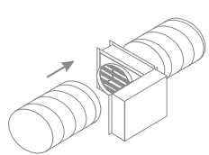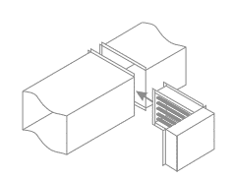

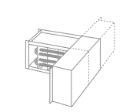



Features

Finish - Non-painted galvanized steel.

* Optional: 304 stainless steel for special applications.

Voltage - 120V, 208V, 240V, 277V, 347V, 480V, 600V, 1 or 3-phase.

Construction - Galvanized steel or 304 stainless steel.

- Zero clearance construction: Allows installation in tight spaces.

- Standard control panel door with removable hinges for easy access.

Heating element - Three heating element models (Heating capacities from 0.5kW to 1000kW):

- Open coil element (C):

-Grade A (NiCr80) and Grade C (NiCr60) (maximum: 1000 °C (1850 °F)).

-Heating capacities up to 40kW/sq. ft. for CSA and 24kW/sq. ft. for UL.

- Tubular element (T):

- Incoloy 840 (Nickel alloy)

- Stainless steel 316L

- U or W shapes depending on heater dimension

- Heating capacities up to 13 kW/sq. ft.

- Finned tubular element (F):

- Steel tube with steel fins

- 316L stainless steel tube with 304 stainless steel fins.

- U or W shapes depending on heater dimension

- Heating capacities up to 15 kW/sq. ft.

Control - Modulating SCR controls, ON/OFF or staging.

- Standard control panel.

- Control panel options: Bottom control panel, insulated control panel, remote control panel.

- Enclosure types: Nema 1 (Standard), Nema 12 (Dust proof), Nema 4 and

Nema 4X (Outdoor applications).

- HECB Networkable Controller available for BACnet and Modbus applications.

- Patented EAS Electronic Air Flow Sensors (US 7,012,223).

- Various thermostats and temperature sensors available.

Installation - Horizontal (H) or vertical (V) mounting.

- Optional left and right protective screens are available.

- Frame: Slip-in (I), 1 in. (25.4 mm) flanged (F) or round (R) collar installation options,

minimum 6 in. (152 mm).

- Round collar: available for installation on 6 in. (152 mm) to 24 in. (609 mm) round duct.

- Suitable for most standard HVAC ducted systems.

- Maximum inlet air temperature: 35 °C (95 °F) for open coil elements, 27 °C (81 °F) for tubular

elements.

- Maximum outlet air temperature: 93 °C (200 °F).

- All heaters are designed and approved for zero clearance to combustible material.

Benefits - Precise temperature control: They offer quick, dependable, and precise temperature control for commercial and residential applications and allow zone control for comfort heating.

- Customizable: The heaters can be custom-built for different sizes and wattage ratings, with horizontal and vertical design configurations.

- Energy efficiency: They heat precisely and energy-efficiently with available fully modulating controls.

- Integrates with related controllers, sensors and accessories.

- Can be a retrofit or an integral part of a central HVAC system.

- Is BACnet MS/TP or Modbus compatible.

Warranty - 2-year warranty on the product from the date of delivery with exception of actuators which are

warranted for a period of 3 years and valves which are warranted for a period of 1 year.

Note - 100% configurable product; shipping costs are not included in quotations. Not eligible for prepaid freight level.

Application - These heaters are suitable for various applications, including HVAC systems, VAV boxes,

fan coil units, load banks, make-up air/air handlers, process heaters, and more.

* Residential, commercial, institutional and industrial.

- They are suitable for both new installations and retrofits.

**Variety of Heating Elements**

|  |  |  |
| --- | --- | --- |
|  |  |  |
| **Open Coil**   * Grade C NiCr60 (60% Nickel and 16% Chrome) * Grade A NiCr80 (80% Nickel and 20% Chrome)   **Benefits**   * Excellent heat dissipation * Minimal pressure drops * Fast response time * More kilowatts per sq.ft. * Quick delivery | **Tubular**   * Incoloy 840 (Nickel alloy) * Stainless steel 316L * U or W shapes depending  on heater dimension   **Benefits**   * Less sensitive to humidity and dust * Suited for demanding environments * Excellent mechanical resistance * Heating element not in direct contact with air | **Finned Tubular**   * Steel (with steel fins) * Stainless steel 316L  (with stainless steel 304 fins) * U or W shapes depending on heater dimension.   **Benefits**   * Fins allow for more efficient heat dissipation * Less sensitive to humidity and dust * Suited for demanding environments * Excellent mechanical resistance * Heating element not in direct contact with air |

**Typical Installation**

|  |  |  |
| --- | --- | --- |
|  |  |  |
| **Slip-in**  The slip-in type electric heaters are designed  so that the entire frame can be inserted into the duct. Using a slip-in heater permits the installation of the entire ventilation duct system before the heaters become available. | **Flanged**  Flanged heaters are designed so that the heater is an integral part of the duct work. The heater frame is attached to matching duct flanges. Standard 1" (25.4mm) flanges on the heater frame are used to attach it to the duct. | **Round Collar**  Round collar electric heaters are available  for installation on round duct systems. They are provided with one male and one female adapter for ease of installation. |

**Mounting**

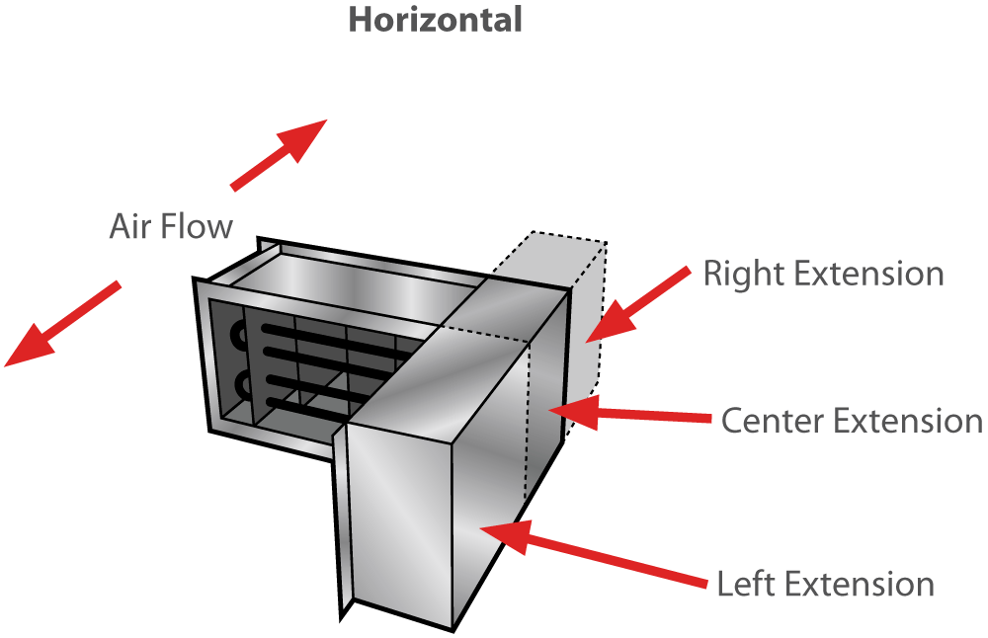

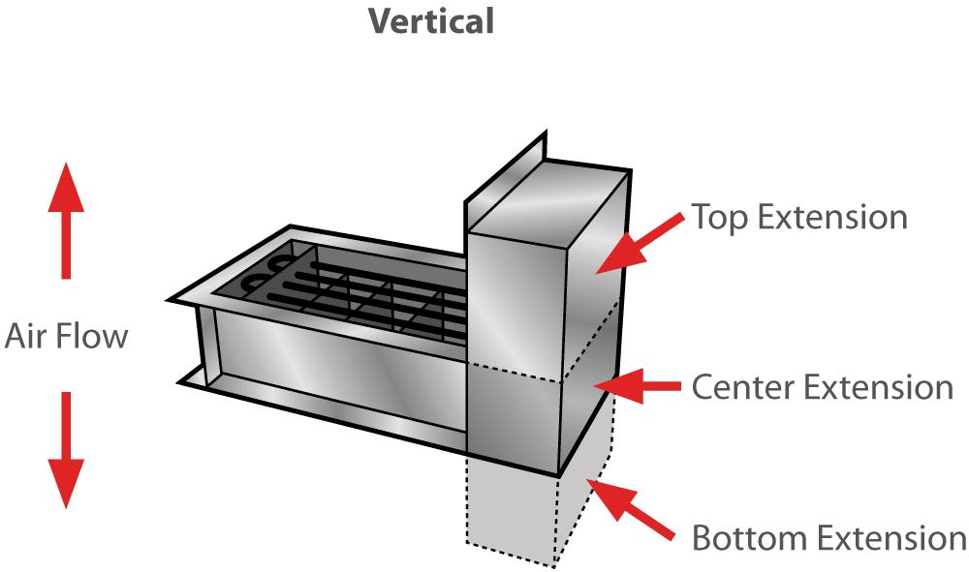

**Panel Options**

|  |  |  |
| --- | --- | --- |
|  |  |  |
| **Bottom Control Panel**  A bottom control panel can be supplied, when required for easy installation and maintenance. This option is available for all heaters (Slip-in, flanged and round collar) of small dimensions. | **Insulated Control Panel**  An insulated control panel is recommended for high duct temperatures. Insulation material, 1" (25.4mm) thick is installed between the panel and the hot area to prevent condensation on electrical components. | **Remote Control Panel**  In certain cases, it may be more convenient to install the control panel remotely from the heater or in a separate room. A remote-control panel is available as an option. |

**Thermostats & Temperature Sensors for Electric Heaters**

|  |  |  |
| --- | --- | --- |
|  |  |  |
| **Room Controller thermostat TRO24-EXT1**   * For modulating, ON-OFF, staging  or pulsed heater * Backlit LCD display * 2 heat / cool analog outputs (0-10VDC) * 4 TRIAC outputs (for ON-OFF, pulse  or floating signal) * Selectable internal/external  temperature sensor * Selectable proportional control band * Fahrenheit or Celsius scale selectable | **Room Controller thermostat TRO5404**   * For modulating, ON-OFF, staging  or pulsed heater * Backlit LCD display * 2 heat / 2 cool analog outputs (0-10VDC) * 1 TPM (time proportional modulation)  output (0 or 22VDC) * Selectable internal/external  temperature sensor * Selectable proportional control band * Fahrenheit or Celsius scale selectable | **Wall thermostat STS3 / ITO3**   * Modulating, ON-OFF or staging heater * STS3 with sensor 3.3 KΩ or available in 10 KΩ * ITO3 wall thermostat must be used * with external duct or wall sensor * Fahrenheit or Celsius scale selectable |
|  |  |  |
| **Room temperature sensor STR1**   * Wall sensor for remote temperature reading * Sensor 3.3 KΩ or 10 KΩ available | **Duct temperature sensor**  **STC8**   * Duct sensor for remote temperature reading * Sensor 10 KΩ and 3.3 KΩ * High accuracy, fast thermal response * Epoxy encapsulated sensor * High stability | **Wall temperature sensor TMA54**   * Features a fully configurable Proportional-Integral-Derivative (PID) * 2 heat / cool analog outputs (0-10VDC) * Selectable internal/external * temperature sensor * Fahrenheit or Celsius scale selectable |

|  |  |  |
| --- | --- | --- |
| **Product #** | **Description** | **Qty** |
| **TRO24-EXT1** | Room Controller thermostat |  |
| **TRO5404** | Room Controller thermostat |  |
| **STS3 / ITO3** | Wall thermostat |  |
| **STR1** | Room temperature sensor |  |
| **STC8** | Duct temperature sensor |  |
| **TMA54** | Wall temperature sensor |  |

### Others

|  |  |  |  |  |  |  |  |
| --- | --- | --- | --- | --- | --- | --- | --- |
| **Type** | **Quantity** | **Model et description**  **Complementary informations** | **Volts** | **Phase** | **Watts** | **Length**  **mm/in.** | **Informations**  **Color/installation** |
|  |  |  |  |  |  |  |  |
|  |  |  |  |  |  |  |  |
|  |  |  |  |  |  |  |  |
|  |  |  |  |  |  |  |  |
|  |  |  |  |  |  |  |  |
|  |  |  |  |  |  |  |  |

**Specifications may change without prior notice**

|  |  |
| --- | --- |
| Project: | Approval  Information |
| Consultant Engineer: |
| Electrician Contractor: |
| Distributor: |
| Date: |
| Contact in Ouellet: |
| Comments: | |