Series
ODB Aluminum Draft Barrier
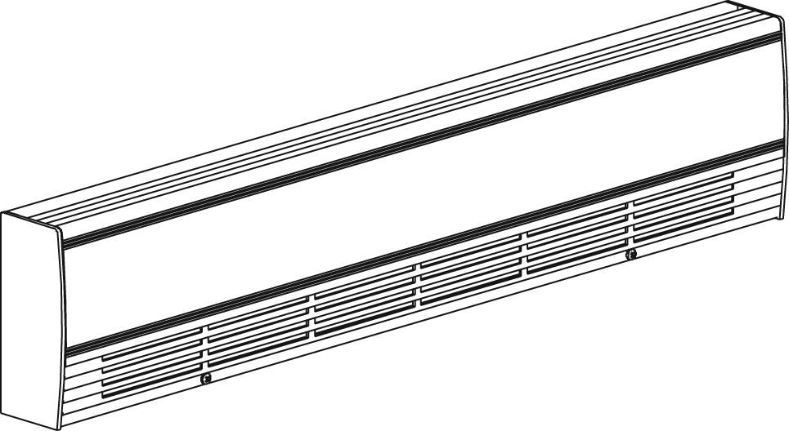
With bottom
fresh air inlet

Features
Color - Standard: white, almond.
- Optional (upcharge applicable): metallic silver, bronze, metallic charcoal,
aluminum, semi-gloss black, sand.
- Custom colors available upon request.
Finish - Standard: epoxy/polyester powder paint.
- Optional: anodized aluminum.
Voltage - 120V, 208V, 240/208V, 277V, 347V, 600V, 50/60 Hz, 1-phase.
Construction - 14-gauge (0.0787 in. [2 mm]) aluminum front cover.
- 18-gauge satin coat steel cabinet.
- Screw assembly for added strength.
- Full length built-in wireway.
- Pencil-proof openings less than 1/4 in. (6.4 mm).
- Front fresh air inlet; top warm air outlet.
- Bottom fresh air inlet available (-BAI).
- Clean back available (-BD).
- Linear high-limit temperature control with automatic reset.
High altitude version available (-HA).
- End caps included.
Heating element - Stainless steel tubular heating element with aluminum ﬁns.
- Floating heating element on high-temperature nylon bushings
reducing expansion noises.
Watt density - Average standard watt density of 275W/ft.
- Average low watt density of 100W/ft., 150W/ft., 200W/ft.
Control - Built-in thermostat available with a control knob
or tamperproof.
- Mechanical, electronic or pneumatic relays available
(installed on the right end only).
Ouellet highly recommends to use an electronic wall thermostat for greater comfort.
Installation - Heater must be installed at least 2 in. (51 mm) from finished floor (for -BAI option).
- Mounting holes spaced on 4 in. (102 mm) intervals for ease of installation.
- Wall or floor mounted installation.
- Variety of accessories available for wall-to-wall installation.
- Pedestal kit available.
Warranty - 3-year warranty against defects.
Application - Commercial building, office building, hospital, daycare center, private residence.

Average Standard Watt Density Models 275W/ft.
Watts | Watts  240/208V¹ | Product # |  |  |  |  |  |  |  |  |  | Length |  | Weight
Watts | Watts  240/208V¹ | 120V | Qty | 208V | Qty | 240/208V | Qty | 347V | Qty | 600V | Qty | in. | mm | lb | kg
500 | 500/375 | ODB0502 |  | ODB0508 |  | ODB0500 |  | ODB0507 |  | - | - | 29 _{1/16} | 738 | 8.0 | 3.6
750 | 750/563 | ODB0752 |  | ODB0758 |  | ODB0750 |  | ODB0757 |  | ODB0756 |  | 39 _{1/16} | 992 | 10.4 | 4.7
1000 | 1000/750 | ODB1002 |  | ODB1008 |  | ODB1000 |  | ODB1007 |  | ODB1006 |  | 49 _{5/16} | 1253 | 12.8 | 5.8
1250 | 1250/938 | ODB1252 |  | ODB1258 |  | ODB1250 |  | ODB1257 |  | ODB1256 |  | 58 _{13/16} | 1494 | 15.1 | 6.8
1500 | 1500/1125 | ODB1502 |  | ODB1508 |  | ODB1500 |  | ODB1507 |  | ODB1506 |  | 67 _{1/2} | 1715 | 17.2 | 7.8
1750 | 1750/1313 | - | - | ODB1758 |  | ODB1750 |  | ODB1757 |  | ODB1756 |  | 76 _{7/8} | 1952 | 19.4 | 8.8
2000 | 2000/1500 | - | - | ODB2008 |  | ODB2000 |  | ODB2007 |  | ODB2006 |  | 85 _{5/8} | 2175 | 21.5 | 9.7
2250 | 2250/1688 | - | - | ODB2258 |  | ODB2250 |  | ODB2257 |  | ODB2256 |  | 94 _{1/2} | 2400 | 23.6 | 10.7
2500 | 2500/1875 | - | - | ODB2508 |  | ODB2500 |  | ODB2507 |  | ODB2506 |  | 103 _{5/8} | 2632 | 25.8 | 11.7

Average Low Watt Density Models
Product #² | Length | Weight | Average  Density W/ft. | Watts | Watts  240/208V¹ | 120V | Qty | 208V | Qty | 240/208V | Qty | 347V | Qty | 600V | Qty
ODB020X-738 | 29 1/16"  (738 mm) | 8.0 lb  (3.6 kg) | 100 | 200 | 200/150 | √ |  | √ |  | √ |  | ----- | ----- | ----- | -----
ODB030X-738 | 29 1/16"  (738 mm) | 8.0 lb  (3.6 kg) | 150 | 300 | 300/225 | √ |  | √ |  | √ |  | ----- | ----- | ----- | -----
ODB040X-738 | 29 1/16"  (738 mm) | 8.0 lb  (3.6 kg) | 200 | 400 | 400/300 | √ |  | √ |  | √ |  | √ |  | ----- | -----
ODB030X-992 | 39 1/16"  (992 mm) | 10.4 lb  (4.7 kg) | 100 | 300 | 300/225 | √ |  | √ |  | √ |  | √ |  | ----- | -----
ODB045X-992 | 39 1/16"  (992 mm) | 10.4 lb  (4.7 kg) | 150 | 450 | 450/338 | √ |  | √ |  | √ |  | √ |  | ----- | -----
ODB060X-992 | 39 1/16"  (992 mm) | 10.4 lb  (4.7 kg) | 200 | 600 | 600/450 | √ |  | √ |  | √ |  | √ |  | ----- | -----
ODB040X-1253 | 49 5/16"  (1253 mm) | 12.8 lb  (5.8 kg) | 100 | 400 | 400/300 | √ |  | √ |  | √ |  | √ |  | ----- | -----
ODB060X-1253 | 49 5/16"  (1253 mm) | 12.8 lb  (5.8 kg) | 150 | 600 | 600/450 | √ |  | √ |  | √ |  | √ |  | ----- | -----
ODB080X-1253 | 49 5/16"  (1253 mm) | 12.8 lb  (5.8 kg) | 200 | 800 | 800/600 | √ |  | √ |  | √ |  | √ |  | √
ODB050X-1494 | 58 13/16"  (1494 mm) | 15.1 lb  (6.8 kg) | 100 | 500 | 500/375 | √ |  | √ |  | √ |  | √ |  | ----- | -----
ODB075X-1494 | 58 13/16"  (1494 mm) | 15.1 lb  (6.8 kg) | 150 | 750 | 750/563 | √ |  | √ |  | √ |  | √ |  | √
ODB100X-1494 | 58 13/16"  (1494 mm) | 15.1 lb  (6.8 kg) | 200 | 1000 | 1000/750 | √ |  | √ |  | √ |  | √ |  | √
ODB060X-1715 | 67 1/2"  (1715 mm) | 17.2 lb  (7.8 kg) | 100 | 600 | 600/450 | √ |  | √ |  | √ |  | √ |  | √
ODB090X-1715 | 67 1/2"  (1715 mm) | 17.2 lb  (7.8 kg) | 150 | 900 | 900/675 | √ |  | √ |  | √ |  | √ |  | √
ODB120X-1715 | 67 1/2"  (1715 mm) | 17.2 lb  (7.8 kg) | 200 | 1200 | 1200/900 | √ |  | √ |  | √ |  | √ |  | √
ODB070X-1952 | 76 7/8"  (1952 mm) | 19.6 lb  (8.8 kg) | 100 | 700 | 700/525 | √ |  | √ |  | √ |  | √ |  | √
ODB105X-1952 | 76 7/8"  (1952 mm) | 19.6 lb  (8.8 kg) | 150 | 1050 | 1050/788 | √ |  | √ |  | √ |  | √ |  | √
ODB140X-1952 | 76 7/8"  (1952 mm) | 19.6 lb  (8.8 kg) | 200 | 1400 | 1400/1050 | √ |  | √ |  | √ |  | √ |  | √
ODB080X-2175 | 85 5/8"  (2175 mm) | 21.5 lb  (9.7 kg) | 100 | 800 | 800/600 | √ |  | √ |  | √ |  | √ |  | √
ODB120X-2175 | 85 5/8"  (2175 mm) | 21.5 lb  (9.7 kg) | 150 | 1200 | 1200/900 | √ |  | √ |  | √ |  | √ |  | √
ODB160X-2175 | 85 5/8"  (2175 mm) | 21.5 lb  (9.7 kg) | 200 | 1600 | 1600/1200 | ----- | ----- | √ |  | √ |  | √ |  | √
ODB090X-2400 | 94 1/2"  (2400 mm) | 23.6 lb  (10.7 kg) | 100 | 900 | 900/675 | √ |  | √ |  | √ |  | √ |  | √
ODB135X-2400 | 94 1/2"  (2400 mm) | 23.6 lb  (10.7 kg) | 150 | 1350 | 1350/1013 | ----- | ----- | √ |  | √ |  | √ |  | √
ODB180X-2400 | 94 1/2"  (2400 mm) | 23.6 lb  (10.7 kg) | 200 | 1800 | 1800/1350 | ----- | ----- | √ |  | √ |  | √ |  | √
ODB100X-2632 | 103 5/8"  (2632 mm) | 26.8 lb  (11.7 kg) | 100 | 1000 | 1000/750 | √ |  | √ |  | √ |  | √ |  | √
ODB150X-2632 | 103 5/8"  (2632 mm) | 26.8 lb  (11.7 kg) | 150 | 1500 | 1500/1125 | ----- | ----- | √ |  | √ |  | √ |  | √
ODB200X-2632 | 103 5/8"  (2632 mm) | 26.8 lb  (11.7 kg) | 200 | 2000 | 2000/1500 | ----- | ----- | √ |  | √ |  | √ |  | √
ODB225X-2632 | 103 5/8"  (2632 mm) | 26.8 lb  (11.7 kg) | 200 | 2250 | 2250/1688 | ----- | ----- | √ |  | √ |  | √ |  | √

¹ 208V = 75% of wattage at 240V.

² X = 2 (120V), 8 (208V), 0 (240/208V), 7 (347V), 6 (600V).

√ = Available.

Add "BL" for white, "AM" for almond.
Other colors, accessories and finishes are available upon request.
Other voltages available upon request.

Options
Product #  Kit | Product #  Factory installed* | Description | Qty
Finish
- | BAI | Bottom fresh air inlet
- | BD¹ | Clean back
KIT-ODB-CE | - | Outside corner, 4 in. (102 mm)
KIT-ODB-CI | - | Inside corner, 4 in. (102 mm)
KIT-ODB-JT | - | Splice plate, 2 in. (51 mm)
KIT-ODB-JT-PE | - | Contour splice plate for BD option and/or heater with pedestals, 2 in. (51 mm)
KIT-ODB-PE | - | Round pedestal kit (2), 3 in. (76 mm)
KIT-ODB-PEC | - | Square-shaped pedestal kit (2), 2 in. (51 mm)
ODB-SV-XX | - | Empty cabinet with length of XX mm (minimum: 154 mm, maximum: 2632 mm)
Controls
KIT-ODB-DIS20⁴ | DIS20⁴ | Disconnect switch, 20A at 277V max.
KIT-ODB-DIS40⁴ | DIS40⁴ | Disconnect switch, 40A at 600V max.
- | HA | Linear high-limit temperature control for high altitude (3000 ft. to 8200 ft.)
- | PM | Pneumatic relay, 20A at 600V max.
KIT-ODB-R-347 | R | Single-pole relay, coil 24V, without transformer: 22A at 120V, 208V, 240V - 19A at 277V - 18A at 347V
KIT-ODB-R-600 | R | Single-pole relay, coil 24V, without transformer, 10A at 600V
KIT-ODB-RT-120² | RT² | Single-pole relay, coil 24V, with transformer 120V/24V, 22A at 120V
KIT-ODB-RT-208 | RT | Single-pole relay, coil 24V, with transformer 208V/24V, 22A at 208V
KIT-ODB-RT-240 | RT | Single-pole relay, coil 24V, with transformer 240V/24V, 22A at 240V
KIT-ODB-RT-277 | RT | Single-pole relay, coil 24V, with transformer 277V/24V, 19A at 277V
KIT-ODB-RT-347 | RT | Single-pole relay, coil 24V, with transformer 347V/24V, 18A at 347V
KIT-ODB-RT-600² | RT² | Single-pole relay, coil 24V, with transformer 600V/24V, 10A at 600V (2-wire only)
KIT-ODB-TB6 | TB6 | Single-pole bi-metal thermostat: 25A at 120V, 208V, 240V, 277V - 10A at 347V, 480V, 600V
KIT-ODB-TB26³ | TB26³ | Double-pole bi-metal thermostat: 25A at 120V, 208V, 240V, 277V - 10A at 347V, 480V, 600V
KIT-ODB-TB6-AV | TB6AV | Single-pole bi-metal tamperproof thermostat: 25A at 120V, 208V, 240V, 277V - 10A at 347V, 480V, 600V
KIT-ODB-TB26-AV³ | TB26AV³ | Double-pole bi-metal tamperproof thermostat: 25A at 120V, 208V, 240V, 277V - 10A at 347V, 480V, 600V
KIT-ODB-TRIAC-347 | TRIAC | Single-pole electronic relay, coil 24V. without transformer, 15A at 347V max.
KIT-ODB-TRIAC-347T | TRIACT | Single-pole electronic relay, coil 24V. with transformer: 15A at 208V, 240V, 347V
KIT-ODB-TRIAC-600 | TRIAC | Single-pole electronic relay, coil 24V. without transformer, 6A at 600V max.

* For factory installed options, add the option number to the product number. See the Product Code section inside the front cover.
¹ For anodized aluminum heaters, the clean back option will be fixed with visible rivets.
² These 2-wire relays with transformer can't supply of 3-wire low voltage thermostats.
³ "Off" position.
⁴ For the U.S. only: The nominal current of the unit must not exceed 80% of the capacity of the disconnect.

Others
Type | Quantity | Model et description  Complementary informations | Volts | Phase | Watts | Length  mm/in. | Informations  Color/installation

Specifications may change without prior notice
Project: | Approval  Information
Consultant Engineer: | Approval  Information
Eectrician Contractor: | Approval  Information
Distributor: | Approval  Information
Date: | Approval  Information
Contact in Ouellet: | Approval  Information
Comments:

