Series
OCP Kickspace Fan Heater

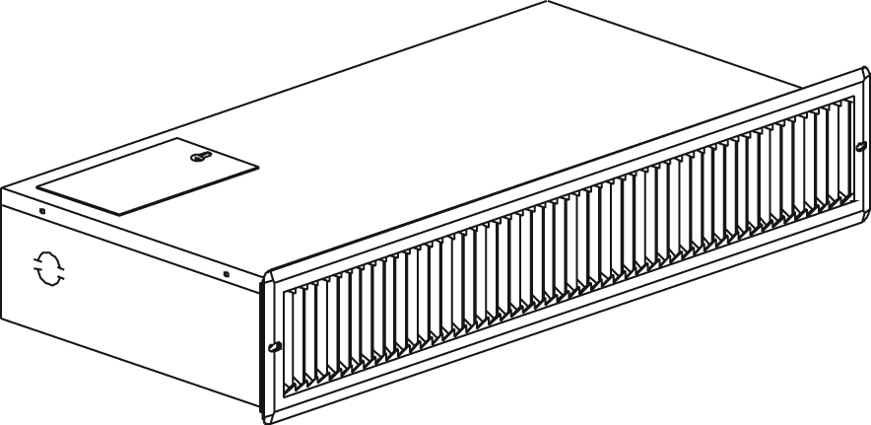

Features
Color - Standard: semi-gloss black, white, almond.
- Optional (upcharge applicable): metallic silver, bronze, metallic charcoal,
aluminum, sand.
- Custom colors available upon request.
Finish - Standard: epoxy/polyester powder paint.
Voltage - 120V, 240/208V, 1-phase.
Construction - 20-gauge steel.
- 1000W standard. Wattage can be converted to 500W at the time of wiring
(see installation instructions).
- High-limit temperature control with automatic reset (first level).
- High-limit temperature control with manual reset (second level).
Fan - 80 cfm fan (44.5 dBA).
- Factory-lubricated motor.
Heating element - Two elements of 500W (1000W in parallel).
- Durable tubular heating element with ﬁns.
Control - Built-in thermostat kit available.
Note: If an electronic thermostat is used, it must be compatible with forced-air heaters.
Installation - Do not install the heater near thermosensitive materials.
- Trim frame included.
Warranty - 5-year warranty against defects.
Application - Kitchen, bathroom, recessed in stair risers.

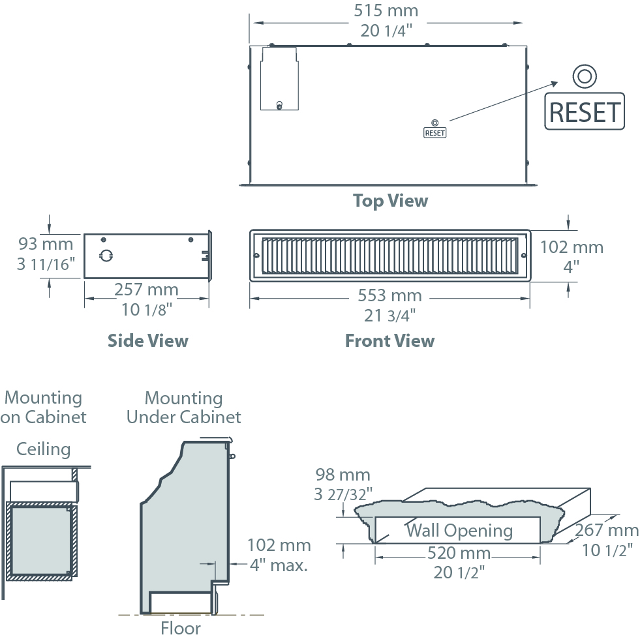
Models
Product # | Qty | Volts | Watts | Weight
 |  |  |  | lb | kg
OCPU1002 |  | 120 | 500  1000 | 13.0 | 5.9
OCPU1000 |  | 240/208 | 500/375  1000/750 | 13.0 | 5.9

Options
Product #  Kit | Product #  Factory installed* | Description | Qty
KIT-OCP-TB6 | TB6 | Single-pole bi-metal thermostat
KIT-OCP-TB26¹ | TB26¹ | Double-pole bi-metal thermostat

* For factory installed options, add the option number to the product number. See the Product Code section inside the front cover.
¹ "Off" position.
Add "NL" for semi-gloss black, "BL" for white, "AM" for almond.

Others
Type | Quantity | Model et description  Complementary informations | Volts | Phase | Watts | Length  mm/in. | Informations  Color/installation

Specifications may change without prior notice
Project: | Approval  Information
Consultant Engineer: | Approval  Information
Eectrician Contractor: | Approval  Information
Distributor: | Approval  Information
Date: | Approval  Information
Contact in Ouellet: | Approval  Information
Comments:

