Series

OCL Standard Convector



Features

Color - Standard: white.

- Optional (upcharge applicable): almond, metallic silver, bronze, aluminum,

semi-gloss black, metallic charcoal, sand.

- Custom colors available upon request.

Finish - Standard: epoxy/polyester powder paint.

Voltage - 120V, 208V, 240/208V, 277V, 347V, 480V, 600V, 60 Hz, 1-phase.

Construction - 20-gauge steel.

- Top warm air outlet for rapid, even heat distribution throughout the room and

optimum efficiency.

- Openings preventing insertion of foreign objects.

- High-limit temperature control with automatic reset.

Heating element - 2 stainless steel tubular heating elements with aluminum fins.

* Floating heating element on high-temperature nylon bushings reducing expansion noises.

Watt density - 700W/ft. (2320W/m).

Control - Built-in non programmable electronic thermostat for the 120V to 240V models (-TH models).

* Wall thermostat (not included).

Installation - 4 in. (102 mm) minimum clearance to ﬂoor and from an adjacent wall.

- Quick surface-mounted installation, with the included wall mounting bracket.

- Single-screw built-in wire holder for quick access to the junction box.

- Optional kit of 10 BX wire-holding plates, for installing an AC90 type electrical cable.

Warranty - 5-year warranty against defects.

*Ouellet highly recommends the use of an electronic wall thermostat for greater comfort.*

Application - Kitchen, living room, family room, office, bedroom, basement, entrance hall.

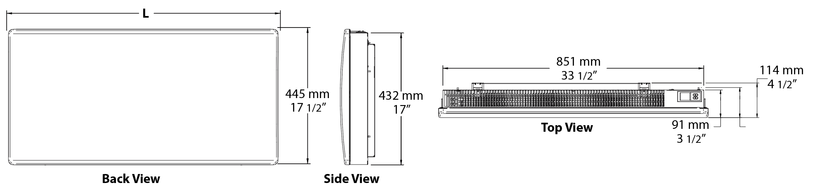

**Models**

|  |  |  |  |  |  |  |  |  |  |
| --- | --- | --- | --- | --- | --- | --- | --- | --- | --- |
| **Product #** | | | | **Volts** | **Watts** | **Length** | | **Weight** | |
| **Without thermostat** | **Qty** | **Built-in thermostat** | **Qty** | **po** | **mm** | **lb** | **kg** |
| **OCL0502BL** |  | OCL0502BL-TH |  | 120 | 500 | 18 | 457 | 13 | 6 |
| **OCL1002BL** |  | OCL1002BL-TH |  | 120 | 1000 | 23 9/16 | 598 | 16.7 | 7.6 |
| **OCL1502BL** |  | OCL1502BL-TH |  | 120 | 1500 | 29 1/16 | 739 | 20 | 9.12 |
| **OCL0508BL** |  | OCL0508BL-TH |  | 208 | 500 | 18 | 457 | 13 | 6 |
| **OCL1008BL** |  | OCL1008BL-TH |  | 208 | 1000 | 23 9/16 | 598 | 16.7 | 7.6 |
| **OCL1508BL** |  | OCL1508BL-TH |  | 208 | 1500 | 29 1/16 | 739 | 20 | 9.12 |
| **OCL2008BL** |  | OCL2008BL-TH |  | 208 | 2000 | 34 5/8 | 880 | 24 | 10.9 |
| **OCL0500BL** |  | OCL0500BL-TH |  | 240/208 | 500/375 | 18 | 457 | 13 | 6 |
| **OCL1000BL** |  | OCL1000BL-TH |  | 240/208 | 1000/750 | 23 9/16 | 598 | 16.7 | 7.6 |
| **OCL1500BL** |  | OCL1500BL-TH |  | 240/208 | 1500/1125 | 29 1/16 | 739 | 20 | 9.12 |
| **OCL2000BL** |  | OCL2000BL-TH |  | 240/208 | 2000/1875 | 34 5/8 | 880 | 24 | 10.9 |
| **OCL0507BL** |  | - |  | 347 | 500 | 18 | 457 | 13 | 6 |
| **OCL1007BL** |  | - |  | 347 | 1000 | 23 9/16 | 598 | 16.7 | 7.6 |
| **OCL1507BL** |  | - |  | 347 | 1500 | 29 1/16 | 739 | 20 | 9.12 |
| **OCL2007BL** |  | - |  | 347 | 2000 | 34 5/8 | 880 | 24 | 10.9 |
| **OCL1006BL** |  | - |  | 600 | 1000 | 23 9/16 | 598 | 16.7 | 7.6 |
| **OCL1506BL** |  | - |  | 600 | 1500 | 29 1/16 | 739 | 20 | 9.12 |
| **OCL2006BL** |  | - |  | 600 | 2000 | 34 5/8 | 880 | 24 | 10.9 |

*Standard color is white.*

### Options

|  |  |  |  |
| --- | --- | --- | --- |
| **Product #**  **Kit** | **Product #**  **Factory installed\*** | **Description** | **Qty** |
| **KIT-SERF-BX** | **-** | Kit of 10 BX wire-holding plates, for installing an AC90 type electrical cable |  |
| **KIT-OCL-TRIAC-347** | **TRIAC** | Single-pole electronic relay, coil 24V, without transformer: 15A at 347V max. |  |
| **KIT-OCL-TRIAC-347T** | **TRIACT** | Single-pole electronic relay, coil 24V, with transformer: 15A at 208V, 240V, 277V, 347V |  |
| **KIT-OCL-TRIAC-600** | **TRIAC** | Single-pole electronic relay, coil 24V, without transformer: 6A at 600V max. |  |

*\* For factory installed options, add the option number to the product number. See the* ***Product Code*** *section inside the front cover.*

*Other voltages available upon request.*

### Others

|  |  |  |  |  |  |  |  |
| --- | --- | --- | --- | --- | --- | --- | --- |
| **Type** | **Quantity** | **Model and description**  **Complementary informations** | **Volts** | **Phase** | **Watts** | **Length**  **mm/in.** | **Informations**  **Color/installation** |
|  |  |  |  |  |  |  |  |
|  |  |  |  |  |  |  |  |
|  |  |  |  |  |  |  |  |
|  |  |  |  |  |  |  |  |
|  |  |  |  |  |  |  |  |
|  |  |  |  |  |  |  |  |
|  |  |  |  |  |  |  |  |
|  |  |  |  |  |  |  |  |
|  |  |  |  |  |  |  |  |
|  |  |  |  |  |  |  |  |

**Specifications may change without prior notice**

|  |  |
| --- | --- |
| Project: | Approval  Information |
| Consultant Engineer: |
| Eectrician Contractor: |
| Distributor: |
| Date: |
| Contact in Ouellet: |
| Comments: | |