Series
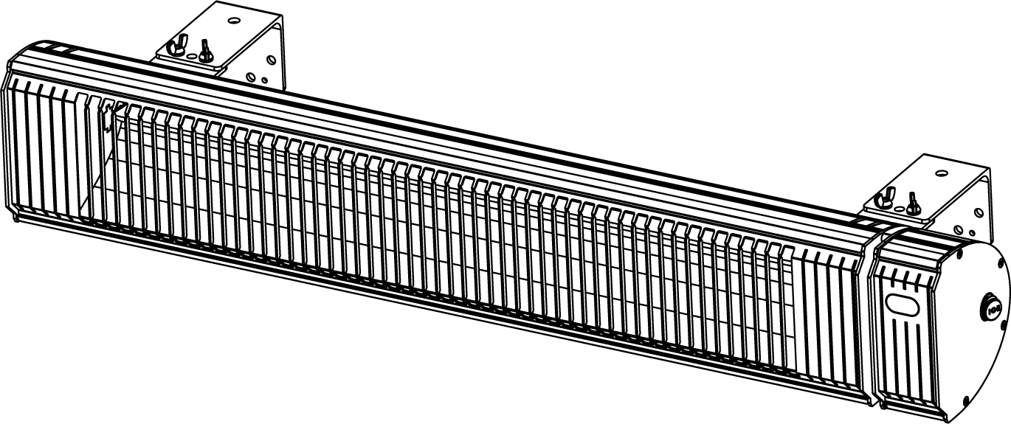
OCF Patio Infrared Heater
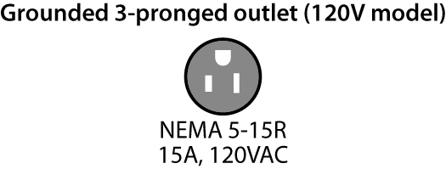



Features
Finish - Black anodized aluminum or stainless steel.
Voltage - 120V, 240/208V, 60 Hz, 1-phase.
Construction - Weatherproof IP65 certified for outdoor use.
- 2 mm wall thickness aluminum extrusion casing.
- High quality aluminum optical reflector.
- High quality power cord:
120V model: 7.5 ft. (2.25 m) with NEMA 5-15P plug.
240/208V models: 6 ft. (1.8 m) hard wire.
Heating element - Woven carbon filament infrared lamp inside a 15 mm Quartz tube.
- Element service life ± 5000h.
Wavelength - Mid-wave (2 µm).
Control - 1500W and 3000W models: On/Off integrated regulator and a remote control
with 6 settings.
- 4000W and 6000W models: Two heating level, 50% and 100%. Heater can be
wired to bypass the remote if requires.
Certification - Comply with the standard UL2021:2015 Ed.4 and C22.2 No.46: 2013 Ed.9.
Installation - Horizontal installation only.
- Pivoting wall mounting brackets included (120V and 240/208V models).
- Mounting brackets for ceiling suspension included (240/208V models).
- Installation minimum clearances:
- 1500W model: 6.7 ft. (2.0 m) from floor.
- 300W, 4000W and 6000W models: 8 ft. (2.4 m) from floor.
- All models: 12 in. (30 cm) from ceiling, 18 in. (45 cm) between the end of the unit
to the wall and 24 in. (61 cm) between the longer side of the unit to the wall.
- 120V Model: Wall mounted only.
Must be plugged into a grounded 3-pronged outlet, 15A, 120VAC.
- 240/208V models: Wall or ceiling mounted.
Hard-wired into an electrical junction box (not included).
Warranty - 1-year warranty against defects.
- 90-day warranty on the element (for industrial applications only).
Application - Resdiential: Solarium, pool & spa, balcony, patio.
- Commercial: Workshop, garage, restaurant patio or bar, hotel entranceway, churches.

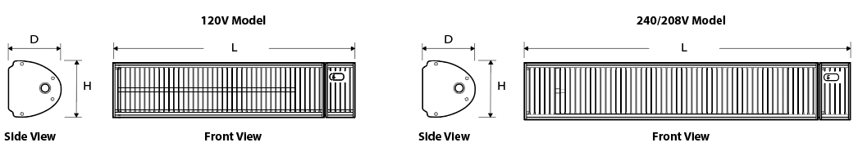
Models

Product #¹ | Volts | Watts | Grounded 3-pronged  outlet | Dimensions |  |  |  |  |  | Weight |  | Qty
 |  |  |  | L |  | H |  | D |  |  |  | Qty
 |  |  |  | in. | mm | in. | mm | in. | mm | lb | kg
CF15120B | 120 | 1500 | 15A, 120VAC | 27 | 685.8 | 6 1/2 | 165 | 6 5/16 | 161 | 10 | 4.5
CF30240SS² | 240/208 | 3000/2250 | - | 38 | 965.2 | 6 1/2 | 165 | 6 5/16 | 161 | 14.3 | 6.4
CF40240SS² | 240/208 | 4000/3000 | - | 42 | 1066.8 | 9 | 228.6 | 9 | 228.6 | 40 | 18.2
CF60240SS² | 240/208 | 6000/4500 | - | 42 | 1066.8 | 9 | 228.6 | 9 | 228.6 | 40 | 18.2

¹Mounting brackets included. Finish: “B” for black anodized aluminum, “SS” for stainless steel.
²Indoor residential installation forbidden.

Others
Type | Quantity | Model and description  Complementary informations | Volts | Phase | Watts | Length  mm/in. | Informations  Color/installation

Specifications may change without prior notice
Project: | Approval  Information
Consultant Engineer: | Approval  Information
Electrician Contractor: | Approval  Information
Distributor: | Approval  Information
Date: | Approval  Information
Contact in Ouellet: | Approval  Information
Comments:

