Series
OCC Portable Construction Heater
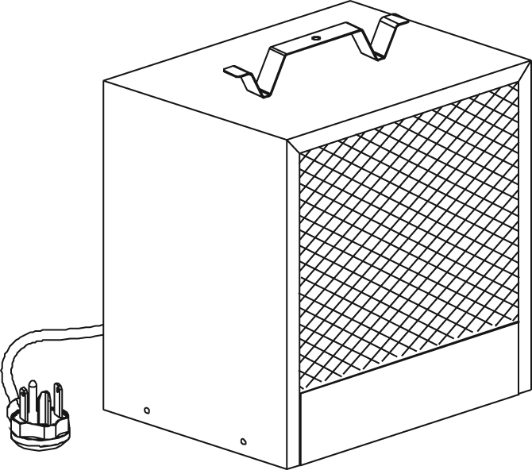

Features
Color - Standard: almond.
Finish - Standard: epoxy/polyester powder paint.
Voltage - 240/208V, 1-phase.
Construction - Handle may be used as a reel for the electric cable.
- 6 ft. (2 m) molded electric cable for extra durability.
- Safely recessed thermostat knob reduces heater size to a minimum.
- High-limit temperature control with automatic reset (first level) and single operation thermal fuse (second level).
Fan - Open motor permanently lubricated.
Note: The open motor is not intended for use in a dusty environment.
- 300 cfm fan.
Heating element - Helical coil nickel-chromium alloy wire protected by ceramic insulators.
- Heating element provides instant heat.
Temperature rise - 28 °C (51 °F).
Control - Built-in thermostat included.
Installation - 4000W must be plugged into a grounded 3-pronged outlet, 20A, 250VAC.
- 4800W must be plugged into a grounded 3-pronged outlet, 30A, 250VAC.
Note: Always unplug heater when not is use.
Warranty - 2-year warranty against defects.
Application - Construction area, workshop, garage.

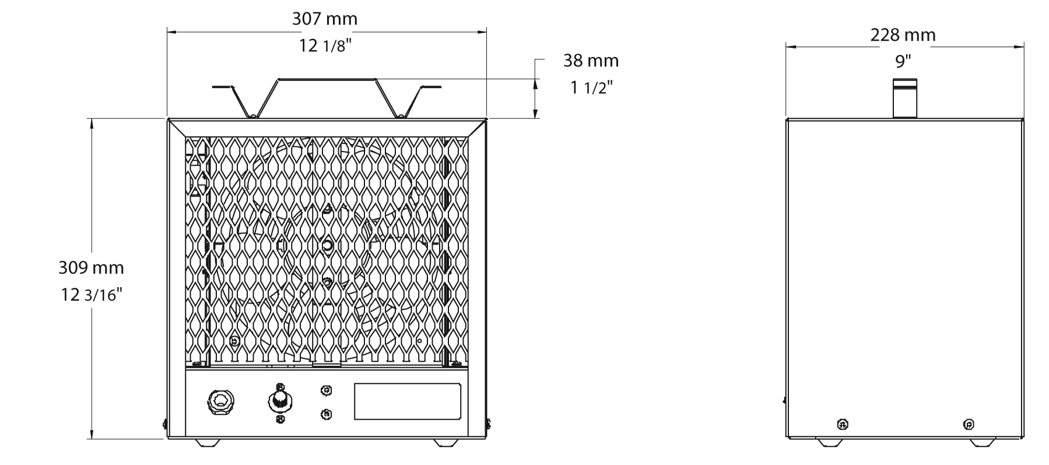
Models
Product #¹ | Qty | Watts | Volts | Grounded  3-pronged outlet | Weight
 |  |  |  |  | lb | kg
OCCU4000AM-MO-TB6 |  | 4000/3000 | 240/208 | 20A, 250VAC | 16.0 | 7.3
OCCU4800AM-MO-TB6 |  | 4800/3600 | 240/208 | 30A, 250VAC | 16.0 | 7.3

¹Built-in thermostat included.
Standard color is almond.

Others
Type | Quantity | Model and description  Complementary information | Volts | Phase | Watts | Length  mm/in. | Informations  Color/installation

Specifications may change without prior notice
Project: | Approval  Information
Consultant Engineer: | Approval  Information
Electrician Contractor: | Approval  Information
Distributor: | Approval  Information
Date: | Approval  Information
Contact at Ouellet: | Approval  Information
Comments:

