Series
OCA Cabinet Unit Heater


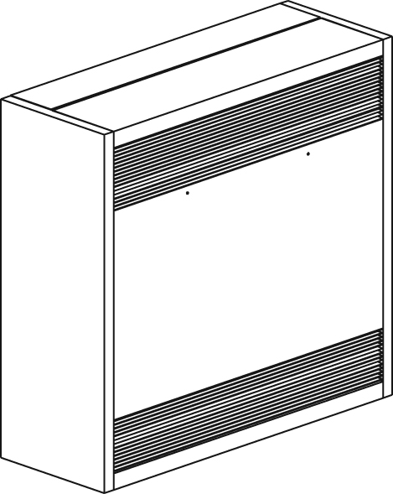

Features
Color - Standard: white, almond.
- Optional (upcharge applicable): metallic silver, bronze, metallic charcoal, aluminum,
semi-gloss black, sand.
- Custom colors available upon request.
Finish - Standard: epoxy/polyester powder paint.
Voltage - 208V, 240V, 277V, 347V, 480V, 600V, 1 or 3-phase.
Construction - 18-gauge steel.
- Insulated casing for noise reduction.
- Extruded aluminum bar grilles prevent insertion of foreign objects.
- Field adaptable air inlet and outlet.
- High-limit temperature control with automatic reset.
- 240V control circuit included.
- Optional fresh air inlet damper.
- Optional air ﬁlters.
Fan - Direct drive, variable speed squirrel-cage fan.
- Fan delay.
- 240/208V factory-lubricated motor (1/15 HP).
- 2 speed-motor available (1600/1500 rpm).
Heating element - Durable tubular heating element with fins.
Length - Four cabinet lengths are available: 28 in. (711 mm), 48 in. (1219 mm),
66 in. (1676 mm), 80 in. (2032 mm).
Control - Wide range of control available.
Ouellet highly recommends use of a wall thermostat for greater comfort.
Installation - Multi-position mounting (surface, semi-recessed, recessed).
- Maximum recommended installation height: 10 ft. (3 m).
- Recess trim kit available for recessed or semi-recessed units.
- Sub-base and special back plate available.
Warranty - 5-year warranty against defects.
Application - Hallway, entry way, exhibition center.

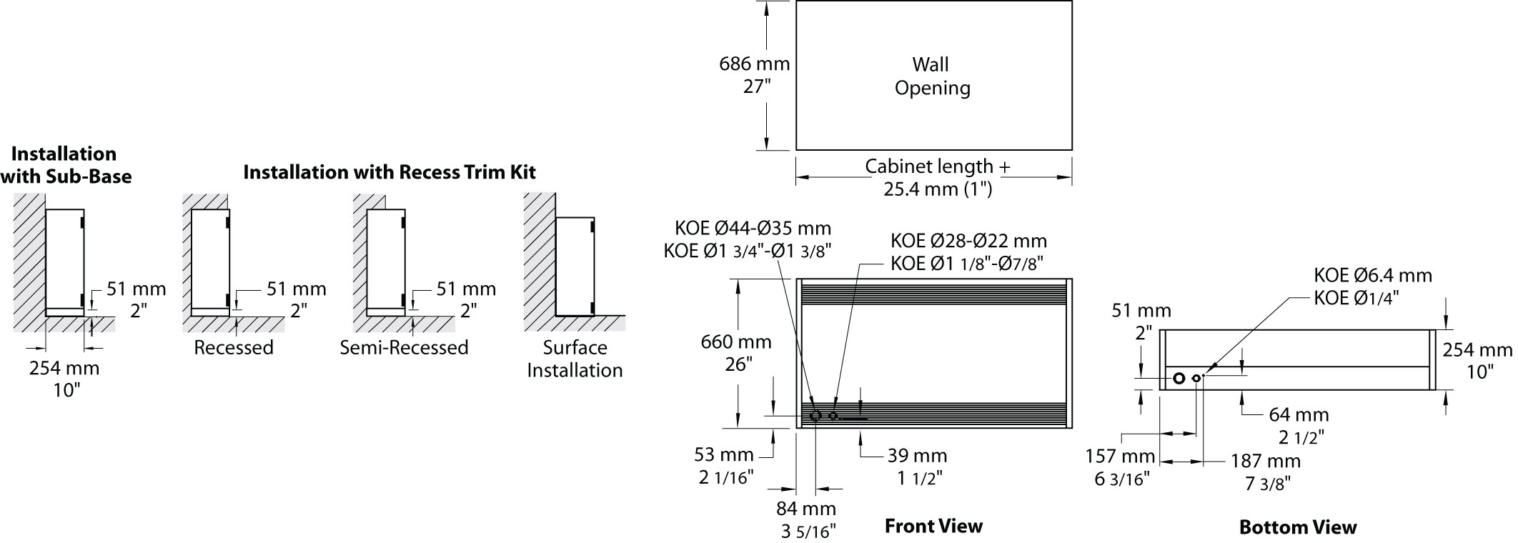

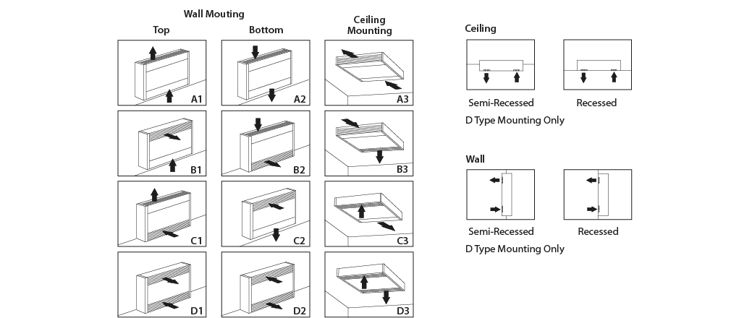
Models
Watts |  | Product # |  |  |  |  |  |  |  |  |  | BTU/hr |  | cfm |  | Length |  | Weight
Hi | Lo | 208V  (3 ph) | Qty | 240V  (1 ph) | Qty | 240V  (3 ph) | Qty | 277V  (1 ph) | Qty | 480V  (3 ph) | Qty | Hi | Lo | Hi | Lo | in. | mm | lb | kg
2000 | 1333 | OCAU02038¹ |  | OCAU02000 |  | OCAU02030 |  | OCAU02077 |  | OCAU02034¹ |  | 6830 | 4552 | 250 | 200 | 28 | 711 | 115 | 52.3
3000 | 1000 | OCAU03038¹ |  | OCAU03000 |  | OCAU03030 |  | OCAU03077 |  | OCAU03034¹ |  | 10246 | 3415 | 250 | 200 | 28 | 711 | 115 | 52.3
4000 | 2667 | OCAU04038¹ |  | OCAU04000 |  | OCAU04030 |  | OCAU04077 |  | OCAU04034¹ |  | 13661 | 9108 | 250 | 200 | 28 | 711 | 115 | 52.3
5000 | 3333 | OCAU05038¹ |  | OCAU05000 |  | OCAU05030 |  | OCAU05077 |  | OCAU05034¹ |  | 17076 | 11383 | 250 | 200 | 28 | 711 | 115 | 52.3
6000 | 4000 | OCAU06038¹ |  | OCAU06000 |  | OCAU06030 |  | OCAU06077 |  | OCAU06034¹ |  | 20491 | 13661 | 250 | 200 | 28 | 711 | 115 | 52.3
8000 | 4000 | OCAU08038¹ |  | OCAU08000 |  | OCAU08030 |  | OCAU08077 |  | OCAU08034¹ |  | 27321 | 13661 | 500 | 400 | 48 | 1219 | 146 | 66.4
10000 | 5000 | OCAU10038¹ |  | OCAU10000 |  | OCAU10030 |  | OCAU10077 |  | OCAU10034¹ |  | 34152 | 17076 | 500 | 400 | 48 | 1219 | 146 | 66.4
12000 | 6000 | OCAU12038¹ |  | OCAU12000 |  | OCAU12030 |  | OCAU12077 |  | OCAU12034¹ |  | 40982 | 20491 | 500 | 400 | 48 | 1219 | 146 | 66.4
15000 | 10000 | OCAU15038¹ |  | OCAU15000 |  | OCAU15030 |  | - | - | OCAU15034¹ |  | 51228 | 34152 | 750 | 600 | 66 | 1676 | 210 | 95.5
18000 | 12000 | OCAU18038¹ |  | OCAU18000 |  | OCAU18030 |  | - | - | OCAU18034¹ |  | 61473 | 40982 | 750 | 600 | 66 | 1676 | 210 | 95.5
20000 | 10000 | OCAU20038¹ |  | OCAU20000 |  | OCAU20030 |  | - | - | OCAU20034¹ |  | 68304 | 34152 | 1000 | 800 | 80 | 2032 | 240 | 109.1
24000 | 12000 | OCAU24038¹ |  | OCAU24000 |  | OCAU24030 |  | - | - | OCAU24034¹ |  | 81964 | 40982 | 1000 | 800 | 80 | 2032 | 240 | 109.1

¹ 1-phase available upon request (change the "3" for an "0" to the product number).
Add "BL" for white, "AM" for almond. Upcharge available for optional colors shown in the color chart section.

Options
Product #  Kit | Product #  Factory installed* | Description | Qty
- | 120 | 120V control circuit
- | 3P | Triple-pole contactor
- | AF¹ | Fresh air inlet
- | AFM ¹ | Power-operated fresh air inlet
- | DIS40 ⁴ | Disconnect switch, 40A
- | DIS80 ⁴ | Disconnect switch, 80A
- | DIS100 ⁴ | Disconnect switch, 100A
- | FUS | Circuit protection fuse
- | HL² | Hi/Lo power switch
KIT-OCA-IV | IV | On/Auto fan switch
KIT-OCA-OO | OO | On/Standby heating switch
KIT-OCA-R | R | 24V control relay, without transformer
- | RHL³ | 24V Hi/Lo power relay, with transformer
- | ROO³ | 24V On/Standby heating relay, with transformer
KIT-OCA-RT | RT | 24V control relay, with transformer
- | RV³ | 24V fan relay, with transformer
KIT-OCA-T-AV | TAV | Single-pole thermostat, tamperproof
- | T2S | 2-stage thermostat, tamperproof
Recess trim kit, 2 in. (51 mm)
KIT-OCA-CR-28 | - | 28 in. (711 mm) Models
KIT-OCA-CR-48 | - | 48 in. (1219 mm) Models
KIT-OCA-CR-66 | - | 66 in. (1676 mm) Models
KIT-OCA-CR-80 | - | 80 in. (2032 mm) Models
Special back plate
KIT-OCA-DU-28 | - | 28 in. (711 mm) Models
KIT-OCA-DU-48 | - | 48 in. (1219 mm) Models
KIT-OCA-DU-66 | - | 66 in. (1676 mm) Models
KIT-OCA-DU-80 | - | 80 in. (2032 mm) Models
Air filter, wall installation only
KIT-OCA-FI-28 | FI | 28 in. (711 mm) Models
KIT-OCA-FI-48 | FI | 48 in. (1219 mm) Models
KIT-OCA-FI-66 | FI | 66 in. (1676 mm) Models
KIT-OCA-FI-80 | FI | 80 in. (2032 mm) Models
Washable air filter, wall installation only
KIT-OCA-FIW-28 | FIW | 28 in. (711 mm) Models
KIT-OCA-FIW-48 | FIW | 48 in. (1219 mm) Models
KIT-OCA-FIW-66 | FIW | 66 in. (1676 mm) Models
KIT-OCA-FIW-80 | FIW | 80 in. (2032 mm) Models
Sub-base, 2 in. (51 mm)
KIT-OCA-SO-28 | - | 28 in. (711 mm) Models
KIT-OCA-SO-48 | - | 48 in. (1219 mm) Models
KIT-OCA-SO-66 | - | 66 in. (1676 mm) Models
KIT-OCA-SO-80 | - | 80 in. (2032 mm) Models

* For factory installed options, add the option number to the product number. See the Product Code section inside the front cover.
¹ Do not install a built-in thermostat with these options.
² OCAU06006, is not available with optional HL.
³ When one of these options is ordered, the heater control will automatically be shipped at 24V.
⁴ For the U.S. only: The nominal current of the unit must not exceed 80% of the capacity of the disconnect.

Others
Type | Quantity | Model et description  Complementary information | Volts | Phase | Watts | Length  mm/in. | Information  Color/installation

Specifications may change without prior notice
Project: | Approval  Information
Consultant Engineer: | Approval  Information
Eectrician Contractor: | Approval  Information
Distributor: | Approval  Information
Date: | Approval  Information
Contact in Ouellet: | Approval  Information
Comments:

