Series
OAWH Architectural Aluminum Wall Fan Heater
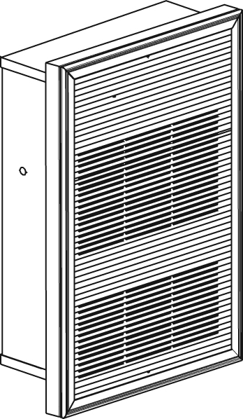

Features
Color - Standard: white, almond, metallic silver, bronze, metallic charcoal,
aluminum, semi-gloss black, sand.
- Custom colors available upon request.
Finish - Standard: epoxy/polyester powder paint.
- Optional: anodized aluminum.
Voltage - 120V, 208V, 240/208V, 277V, 347V, 480V, 600V, 1 or 3-phase.
Construction - Extruded aluminum front grille, 1/8 in. (3.2 mm) thick.
- Bottom air outlet.
- High-limit temperature control with automatic reset.
Fan - Closed, factory-lubricated motor.
- 160 cfm fan (single unit: 55 dBA); 2 X 160 cfm fan (double unit: 58 dBA);
3 X 160 cfm (triple unit: 61 dBA).
- Fan delay purges heater of residual heat.
Heating element - Durable tubular heating element with fins.
Control - Built-in tamperproof thermostat included.
- 24V relay, with or without transformer available.
Note: Thermostat is not included in heater with factory installed relay.
Any remote thermostat or relay must be connected to the heater control terminal block.
Installation - Minimum clearance from the floor and adjacent walls: 10 in. (25.4 cm).
- Surface mounting box available.
- Semi recessed trim kit available.
Warranty - 3-year warranty against defects.
Application - Apartment building, commercial building, entrance way, stairwell, garage.

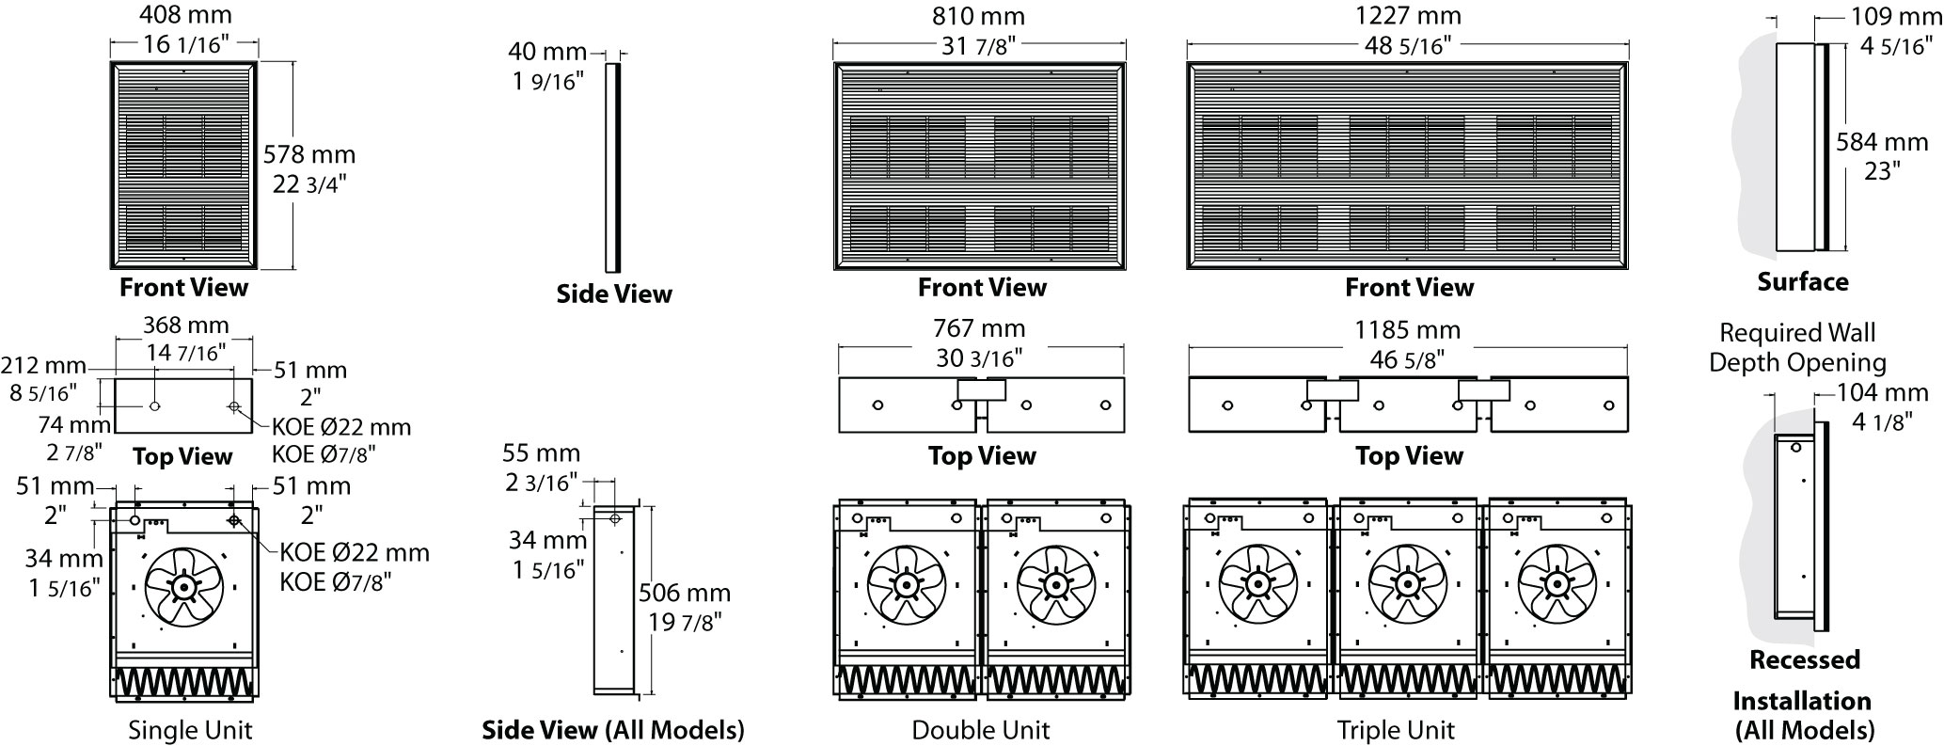
Models
Product #¹ | Qty | Volts (ph) | Watts | BTU/hr | Weight |  | Unit
 |  |  |  |  | lb | kg | Unit
OAWH01502-TAV |  | 120 (1) | 1500 | 5123 | 24,0 | 10,9 | single
OAWH02008-TAV |  | 208 (1) | 2000 | 6830 | 24,0 | 10,9 | single
OAWH04008-TAV |  | 208 (1) | 4000 | 13661 | 24,0 | 10,9 | single
OAWH04038-TAV |  | 208 (3) | 4000 | 13661 | 28,0 | 13,0 | single
OAWH04808-TAV |  | 208 (1) | 4800 | 16393 | 24,0 | 10,9 | single
OAWH05038-TAV |  | 208 (3) | 5000 | 17076 | 29,0 | 12,7 | single
OAWH06038-TAV |  | 208 (3) | 6000 | 20491 | 56,0 | 25,4 | double
OAWH08008-TAV |  | 208 (1) | 8000 | 27321 | 50,0 | 22,7 | double
OAWH09038-TAV |  | 208 (3) | 9000 | 30737 | 90,0 | 40,9 | triple
OAWH12008-TAV |  | 208 (1) | 12000 | 40982 | 90,0 | 40,9 | triple
OAWH12038-TAV |  | 208 (3) | 12000 | 40982 | 90,0 | 40,9 | triple
OAWH01500-TAV |  | 240/208 (1) | 1500/1125² | 5123/3842 | 24,0 | 10,9 | single
OAWH02000-TAV |  | 240/208 (1) | 2000/1500² | 6830/5123 | 24,0 | 10,9 | single
OAWH03000-TAV |  | 240/208 (1) | 3000/2250² | 10246/7684 | 24,0 | 10,9 | single
OAWH03030-TAV |  | 240/208 (3) | 3000/2250² | 10246/7684 | 28,0 | 13,0 | single
OAWH04000-TAV |  | 240/208 (1) | 4000/3000² | 13661/10246 | 24,0 | 10,9 | single
OAWH04030-TAV |  | 240/208 (3) | 4000/3000² | 13661/10246 | 28,0 | 13,0 | single
OAWH04800-TAV |  | 240/208 (1) | 4800/3600² | 16393/12295 | 24,0 | 10,9 | single
OAWH05030-TAV |  | 240/208 (3) | 5000/3750² | 17076/12807 | 28,0 | 12,7 | single
OAWH06000-TAV |  | 240/208 (1) | 6000/4500² | 20491/15368 | 50,0 | 22,7 | double
OAWH08000-TAV |  | 240/208 (1) | 8000/6000² | 27321/20491 | 50,0 | 22,7 | double
OAWH12000-TAV |  | 240/208 (1) | 12000/9000² | 40982/30737 | 90,0 | 40,9 | triple
OAWH01507-TAV |  | 347 (1) | 1500 | 5123 | 24,0 | 10,9 | single
OAWH02007-TAV |  | 347 (1) | 2000 | 6830 | 24,0 | 10,9 | single
OAWH03007-TAV |  | 347 (1) | 3000 | 10246 | 24,0 | 10,9 | single
OAWH04007-TAV |  | 347 (1) | 4000 | 13661 | 24,0 | 10,9 | single
OAWH04807-TAV |  | 347 (1) | 4800 | 16393 | 24,0 | 10,9 | single
OAWH06007-TAV |  | 347 (1) | 6000 | 20491 | 55,0 | 25,0 | double
OAWH08007-TAV |  | 347 (1) | 8000 | 27321 | 55,0 | 25,0 | double
OAWH12007-TAV |  | 347 (1) | 12000 | 40982 | 90,0 | 40,9 | triple
OAWH01504-TAV |  | 480 (1) | 1500 | 5123 | 28,0 | 12,7 | single
OAWH02004-TAV |  | 480 (1) | 2000 | 6830 | 28,0 | 12,7 | single
OAWH03004-TAV |  | 480 (1) | 3000 | 10246 | 28,0 | 12,7 | single
OAWH03034-TAV |  | 480 (3) | 3000 | 10246 | 32,0 | 15,0 | single
OAWH04004-TAV |  | 480 (1) | 4000 | 13661 | 28,0 | 12,7 | single
OAWH04034-TAV |  | 480 (3) | 4000 | 13661 | 32,0 | 15,0 | single
OAWH04804-TAV |  | 480 (1) | 4800 | 16393 | 28,0 | 12,7 | single
OAWH05034-TAV |  | 480 (3) | 5000 | 17076 | 32,0 | 15,0 | single
OAWH06004-TAV |  | 480 (1) | 6000 | 20491 | 55,0 | 25,0 | double
OAWH08004-TAV |  | 480 (1) | 8000 | 27321 | 55,0 | 25,0 | double
OAWH12004-TAV |  | 480 (1) | 12000 | 40982 | 90,0 | 40,9 | triple
OAWH12034-TAV |  | 480 (3) | 12000 | 40982 | 90,0 | 40,9 | triple
OAWH01506-TAV |  | 600 (1) | 1500 | 5123 | 28,0 | 12,7 | single
OAWH02006-TAV |  | 600 (1) | 2000 | 6830 | 28,0 | 12,7 | single
OAWH03006-TAV |  | 600 (1) | 3000 | 10246 | 28,0 | 12,7 | single
OAWH03036-TAV |  | 600 (3) | 3000 | 10246 | 32,0 | 15,0 | single
OAWH04806-TAV |  | 600 (1) | 4000 | 13661 | 28,0 | 12,7 | single
OAWH04036-TAV |  | 600 (3) | 4000 | 13661 | 32,0 | 15,0 | single
OAWH04806-TAV |  | 600 (1) | 4800 | 16393 | 28,0 | 12,7 | single
OAWH05036-TAV |  | 600 (3) | 5000 | 17076 | 32,0 | 15,0 | single
OAWH06006-TAV |  | 600 (1) | 6000 | 20491 | 55,0 | 25,0 | double
OAWH06036-TAV |  | 600 (3) | 6000 | 20491 | 60,0 | 27,2 | double
OAWH08006-TAV |  | 600 (1) | 8000 | 27321 | 55,0 | 25,0 | double
OAWH09036-TAV |  | 600 (3) | 9000 | 30737 | 90,0 | 40,9 | triple
OAWH12006-TAV¹ |  | 600 (1) | 12000 | 40982 | 90,0 | 40,9 | triple
OAWH12036-TAV¹ |  | 600 (3) | 12000 | 40982 | 90,0 | 40,9 | triple

Options
Product #  Kit | Product #  Factory installed* | Description | Qty
KIT-OAWH-BSA | - | Surface mounting box, single unit
KIT-OAWH-BSA1-1 | - | Semi recessed 1 in. trim kit, single unit
KIT-OAWH-BSA1-2 | - | Semi recessed 2 in. trim kit, single unit
KIT-OAWH-BSA2 | - | Surface mounting box, double unit
KIT-OAWH-BSA2-1 | - | Semi recessed 1 in. trim kit, double unit
KIT-OAWH-BSA2-2 | - | Semi recessed 2 in. trim kit, double unit
KIT-OAWH-BSA3 | - | Surface mounting box, triple unit
KIT-OAWH-BSA3-1 | - | Semi recessed 1 in. trim kit, triple unit
KIT-OAWH-BSA3-2 | - | Semi recessed 2 in. trim kit, triple unit
KIT-OAWH-DIS20³ | DIS20³ | Disconnect switch, double-pole, 20A at 277V and less
KIT-OAWH-DIS40³ | DIS40³ | Disconnect switch, triple-pole, 40A at 600V max.
KIT-OAWH-DIS80³ | DIS80³ | Disconnect switch, triple-pole, 80A at 600V max.
- | IV | Fan switch
- | R⁴ | 24V control relay, without transformer
- | RT⁴ | 24V control relay, with transformer

* For factory installed options, add the option number to the product number. See the Product Code section inside the front cover.
¹ Built-in tamperproof thermostat included.
³ 208V = 75% of wattage at 240V.
² For the U.S. only: The nominal current of the unit must not exceed 80% of the capacity of the disconnect.
⁴ If the built-in thermostat is not required with the 24V control relay, remove the “-TAV” from the product number (E.g.: OAWH04006-RT).
Add "BL" for white, "AM" for almond, "AE" for metallic silver, "BZ" for bronze, "CM" for mettallic charcoal, "AL" for aluminum, "NL" for semi-gloss black, «SA» for sand.
277V available upon request.

Others
Type | Quantity | Model et description  Complementary informations | Volts | Phase | Watts | Length  mm/in. | Informations  Color/installation

Specifications may change without prior notice
Project: | Approval  Information
Consultant Engineer: | Approval  Information
Electrician Contractor: | Approval  Information
Distributor: | Approval  Information
Date: | Approval  Information
Contact in Ouellet: | Approval  Information
Comments:

