Series
OAS Commercial Industrial Suspended Unit Heater


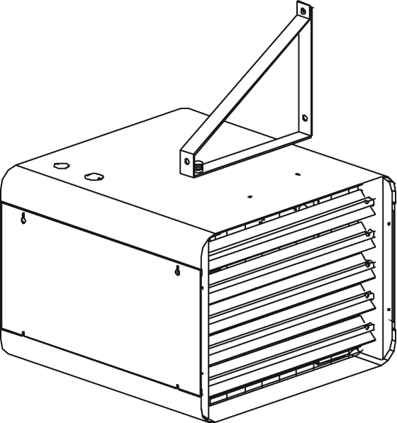

Features
Color - Standard: almond.
Finish - Standard: epoxy/polyester powder paint.
Voltage - 208V, 240V, 277V, 347V, 480V, 600V, 1 or 3-phase.
- Some units may be field converted from 3 to 1-phase.
Construction - 18 and 20-gauge steel.
- Adjustable louvres to direct air flow.
- High-limit temperature control with automatic reset.
Fan - Totally enclosed factory-lubricated ball bearing motor
(except for 15 to 25kW at 208/240V).
- 58 dBA fan (2 to 10kW), 67 dBA fan (15 to 30kW) and 77 dBA fan (40 to 60kW).
- Thermally-protected motor mounted in cold compartment.
- Fan delay purges heater of residual heat.
Heating element - Tubular heating elements; stainless steel (2 to 10kW); finned steel (15 to 60kW).
- Concentric disposition of heating elements.
- Factory sealed element upon request.
Control - Factory-installed contactor and 240/208V control circuit standard
(with transformer if necessary).
- 24V relay, with or without transformer available.
- 120V control circuit available.
- Built-in thermostat available.
Ouellet highly recommends to use a wall thermostat for greater comfort.
Any remote thermostat or relay must be connected to the heater control terminal block.
Installation - Not for residential use in the United States.
- Horizontal mounting:
2 to 30kW: wall or ceiling using the supplied brackets which allow 360° rotation.
40 to 60kW: ceiling only secured by the supplied 4 hooks of suspension.
- Vertical mounting (except option -MD):
2 to 60kW: using 4 threaded rods 1/2 in. X 13 UNC (not included).
- Diffuser cones available (except option -MD).
- Maximum recommended height (horizontal): 2 to 10kW: 8 ft. (2.4 m),
15 to 30kW: 10 ft. (3 m), 40 to 60kW: 15 ft. (4.5 m).
- Protective screen allows minimum horizontal mounting height:
Canada 2 to 30 kW: 24 in. (610 mm), 40 to 60kW: 8 ft. (2.4 m).
United States 2 to 30 kW 6 ft. (1.8 m), 40 to 60kW: 8 ft. (2.4 m).
- 30 °C (85 °F) maximum operating ambient temperature.
Warranty - 3-year warranty against defects.
Application - Commercial hall, warehouse, stairwell, factory.

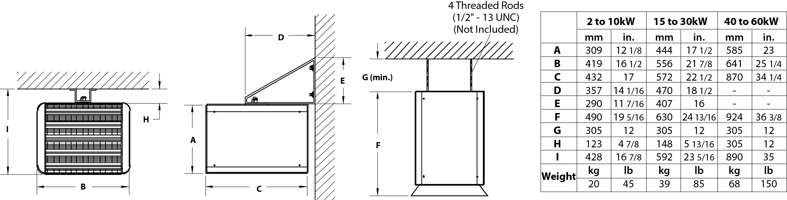

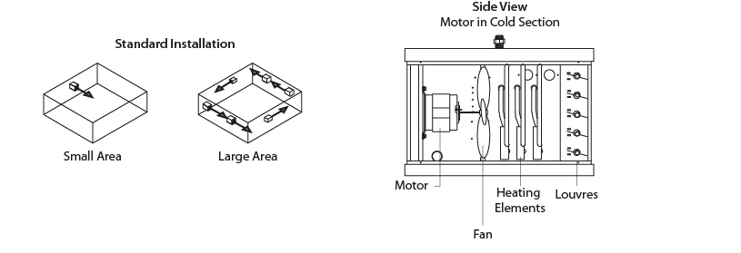
Models
Product # | Qty | Volts | Phase | kW (BTU/hr) | cfm | Temperature Rise |  | Motor
 |  |  |  |  |  | ºC | ºF | HP | rpm
OASU05000AM-T² |  | 240 | 1 | 5.0 (17060) | 700 | 13 | 23 | 1/30 | 1550
OASU07500AM-T² |  | 240 | 1 | 7.5 (25590) | 700 | 19 | 34 | 1/30 | 1550
OASU10000AM-T² |  | 240 | 1 | 10.0 (34120) | 700 | 25 | 45 | 1/30 | 1550
OASU05034AM-T² |  | 480 | 3 | 5.0 (17060) | 700 | 13 | 23 | 1/30 | 1550
OASU07534AM-T² |  | 480 | 3 | 7.5 (25590) | 700 | 19 | 34 | 1/30 | 1550
OASU10034AM-T² |  | 480 | 3 | 10.0 (34120) | 700 | 25 | 45 | 1/30 | 1550
OASU02008 |  | 208 | 1 | 2.0 (6824) | 510 | 7 | 13 | 1/30 | 1550
OASU03008 |  | 208 | 1 | 3.0 (10236) | 510 | 10 | 18 | 1/30 | 1550
OASU04008 |  | 208 | 1 | 4.0 (13648) | 510 | 14 | 25 | 1/30 | 1550
OASU05008 |  | 208 | 1 | 5.0 (17060) | 700 | 13 | 23 | 1/30 | 1550
OASU05038 |  | 208 | 3/1¹ | 5.0 (17060) | 700 | 13 | 23 | 1/30 | 1550
OASU07538 |  | 208 | 3/1¹ | 7.5 (25590) | 700 | 19 | 34 | 1/30 | 1550
OASU10008 |  | 208 | 1 | 10.0 (34120) | 700 | 25 | 45 | 1/30 | 1550
OASU10038 |  | 208 | 3 | 10.0 (34120) | 700 | 25 | 45 | 1/30 | 1550
OASU15038 |  | 208 | 3 | 15.0 (51180) | 1300 | 20 | 36 | 1/8 | 1550
OASU20038 |  | 208 | 3 | 20.0 (68240) | 1300 | 27 | 49 | 1/8 | 1550
OASU25038 |  | 208 | 3 | 25.0 (85300) | 1300 | 34 | 61 | 1/8 | 1550
OASU02000 |  | 240 | 1 | 2.0 (6824) | 510 | 7 | 13 | 1/30 | 1550
OASU03000 |  | 240 | 1 | 3.0 (10236) | 510 | 10 | 18 | 1/30 | 1550
OASU04000 |  | 240 | 1 | 4.0 (13648) | 510 | 14 | 25 | 1/30 | 1550
OASU05000 |  | 240 | 1 | 5.0 (17060) | 700 | 13 | 23 | 1/30 | 1550
OASU05030 |  | 240 | 3/1¹ | 5.0 (17060) | 700 | 13 | 23 | 1/30 | 1550
OASU07500 |  | 240 | 1 | 7.5 (25590) | 700 | 19 | 34 | 1/30 | 1550
OASU07530 |  | 240 | 3/1¹ | 7.5 (25590) | 700 | 19 | 34 | 1/30 | 1550
OASU10000 |  | 240 | 1 | 10.0 (34120) | 700 | 25 | 45 | 1/30 | 1550
OASU10030 |  | 240 | 3/1¹ | 10.0 (34120) | 700 | 25 | 45 | 1/30 | 1550
OASU15030 |  | 240 | 3 | 15.0 (51180) | 1300 | 20 | 36 | 1/8 | 1550
OASU20030 |  | 240 | 3 | 20.0 (68240) | 1300 | 27 | 49 | 1/8 | 1550
OASU25030 |  | 240 | 3 | 25.0 (85300) | 1300 | 34 | 61 | 1/8 | 1550
OASU02077 |  | 277 | 1 | 2.0 (6824) | 510 | 7 | 13 | 1/30 | 1550
OASU03077 |  | 277 | 1 | 3.0 (10236) | 510 | 10 | 18 | 1/30 | 1550
OASU04077 |  | 277 | 1 | 4.0 (13648) | 510 | 14 | 25 | 1/30 | 1550
OASU05077 |  | 277 | 1 | 5.0 (17060) | 700 | 13 | 23 | 1/30 | 1550
OASU07577 |  | 277 | 1 | 7.5 (25590) | 700 | 19 | 34 | 1/30 | 1550
OASU02034 |  | 480 | 3 | 2.0 (6824) | 510 | 7 | 13 | 1/30 | 1550
OASU03034 |  | 480 | 3 | 3.0 (10236) | 510 | 10 | 18 | 1/30 | 1550
OASU04034 |  | 480 | 3 | 4.0 (13648) | 510 | 14 | 25 | 1/30 | 1550
OASU05034 |  | 480 | 3 | 5.0 (17060) | 700 | 13 | 23 | 1/30 | 1550
OASU07534 |  | 480 | 3 | 7.5 (25590) | 700 | 19 | 34 | 1/30 | 1550
OASU10034 |  | 480 | 3 | 10.0 (34120) | 700 | 25 | 45 | 1/30 | 1550
OASU15034 |  | 480 | 3 | 15.0 (51180) | 1400 | 19 | 34 | 1/3 | 1725
OASU20034 |  | 480 | 3 | 20.0 (68240) | 1400 | 25 | 45 | 1/3 | 1725
OASU25034 |  | 480 | 3 | 25.0 (85300) | 1400 | 31 | 56 | 1/3 | 1725
OASU30034 |  | 480 | 3 | 30.0 (102360) | 1400 | 38 | 68 | 1/3 | 1725
OASU40034 |  | 480 | 3 | 40.0 (136480) | 2000 | 35 | 63 | 3/4 | 1140
OASU50034 |  | 480 | 3 | 50.0 (170600) | 2000 | 44 | 79 | 3/4 | 1140
OASU60034 |  | 480 | 3 | 60.0 (204720) | 2000 | 53 | 95 | 3/4 | 1140

¹ Models with the indication "3/1" can be field converted from 3 to 1-phase.
² Come with built-in thermostat.
Standard color is almond.
Add-MD to suffix for special Mine Duty Feature. 600V available upon request. 240V, 3-phase and 480V, 1-phase available upon request.
Remember to change the 3 for 0 when ordering. E.g.: OASU05034 becomes OASU05004.

Options
Product #  Kit | Product #  Factory installed* | Description | Qty
- | 120 | 120V control circuit
- | 3P | Triple-pole contactor
KIT-OAS-CD1AM | - | Diffuser cone, 2 to 10kW units
KIT-OAS-CD2AM | - | Diffuser cone, 15 to 30kW units
KIT-OAS-CD3AM | - | Diffuser cone, 40 to 60kW units
- | CV | Summer fan switch, with motor 240V and 277V
- | CV | Summer fan switch, with motor 480V and 600V
- | DIS40³ | Disconnect switch, 40A
- | DIS80³ | Disconnect switch, 80A
- | DIS100³ | Disconnect switch, 100A
- | ES¹ | Factory sealed element
- | FANAM | Fan blades with almond epoxy/polyester coating
- | MD² | Mine duty
KIT-OAS-R | R | 24V relay, without transformer
- | RCV240 | Summer fan relay 240V, remote control (switch not included)
KIT-OAS-RT | RT | 24V relay, with transformer
KIT-OAS-T | T | Thermostat

* For factory installed options, add the option number to the product number. See the Product Code section inside the front cover.
¹ The option "sealed element" increases the reliability of these in humid environments. It does not completely eliminate the leakage currents of metal shealthed heating elements.
² See features below.
³ For the U.S. only: The nominal current of the unit must not exceed 80% of the capacity of the disconnect.

Others
Type | Quantity | Model et description  Complementary informations | Volts | Phase | Watts | Length  mm/in. | Informations  Color/installation

Specifications may change without prior notice
Project: | Approval  Information
Consultant Engineer: | Approval  Information
Electrician Contractor: | Approval  Information
Distributor: | Approval  Information
Date: | Approval  Information
Contact in Ouellet: | Approval  Information
Comments:

