Series
OAE Economical Unit Heater

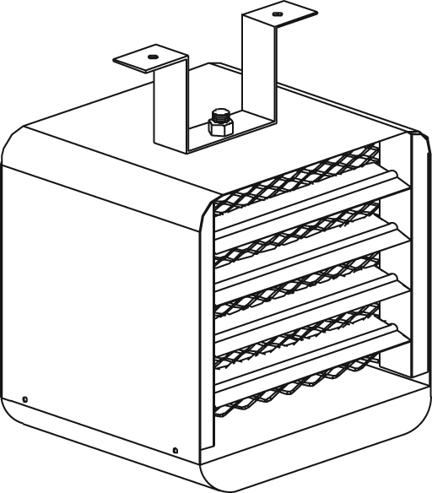

Features
Color - Standard: almond.
Finish - Standard: epoxy/polyester powder paint.
Voltage - 240/208V, 1-phase.
Construction - 20-gauge steel.
- Adjustable louvers to control warm air flow.
- High-limit temperature control with automatic reset.
Fan - 300 cfm fan (51 dBA).
- Totally enclosed factory-lubricated motor.
Heating element - Helical coil nickel-chromium alloy wire protected by ceramic insulators.
- Heating element provides instant heat.
Control - Built-in thermostat, included.
Installation - Mounting brackets for ceiling or wall installation included.
- Mounting brackets allow 360° rotation of the unit.
Warranty - 3-year warranty against defects.
Application - Garage, workshop.

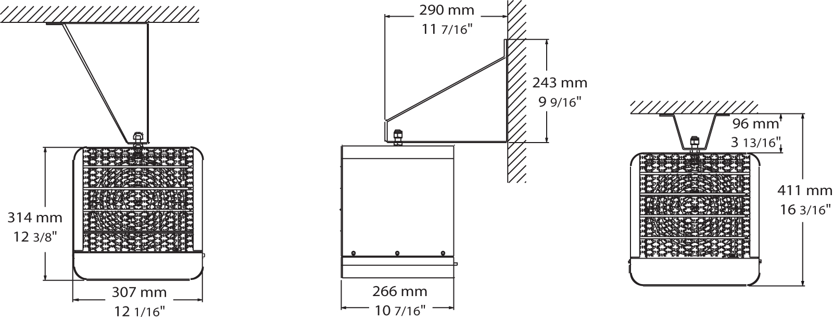
Models
Product #¹ | Qty | Watts | Volts | BTU/hr | Heating Element Type | Weight
 |  |  |  |  |  | lb | kg
OAE2000AM-EO-TB6 |  | 2000/1500 | 240/208 | 6824/5118 | Open | 20.0 | 9.1
OAE3000AM-EO-TB6 |  | 3000/2250 | 240/208 | 10236/7677 | Open | 20.0 | 9.1
OAE5000AM-EO-TB6 |  | 5000/3750 | 240/208 | 17060/12795 | Open | 20.0 | 9.1

¹ Mounting brackets included.
Standard color is almond.

Others
Type | Quantity | Model et description  Complementary informations | Volts | Phase | Watts | Length  mm/in. | Informations  Color/installation

Specifications may change without prior notice
Project: | Approval  Information
Consultant Engineer: | Approval  Information
Electrician Contractor: | Approval  Information
Distributor: | Approval  Information
Date: | Approval  Information
Contact in Ouellet: | Approval  Information
Comments:

