Series
OACP Commercial Ceiling Fan Heater


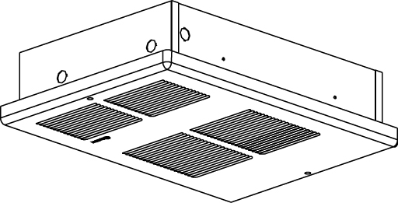

Features
Color - Standard: white, almond.
- Optional (upcharge applicable): metallic silver, bronze, metallic charcoal, aluminum,
semi-gloss black, sand.
- Custom colors available upon request.
Finish - Standard: epoxy/polyester powder paint.
Voltage - 120V, 208V, 240/208V, 277V, 347V, 480V, 600V, 1-phase.
Construction - 18-gauge steel front cover.
- High-limit temperature control with automatic reset.
Fan - Factory-lubricated motor (open and ventilated).
- 160 cfm fan (single unit: 55.5 dBA), 2 X 160 cfm fan (double unit: 58.5 dBA).
- Fan delay purges heater of residual heat.
Heating element - Durable tubular heating element with fins.
Control - 240/208V control circuit standard with contactor when needed
(except 120V model).
- 24V relay, with or without transformer available.
- Built-in thermostat available.
Note: If an electronic thermostat is used, it must be compatible with forced-air heaters.
Any remote thermostat or relay must be connected to the heater control terminal block.
Installation - Maximum recommended installation height: 10 ft. (3 m).
- Minimum clearance from adjacent walls: 10 in. (25.4 cm).
- Surface mounting box available.
- Adaptor for T-bar ceiling available.
Warranty - 3-year warranty against defects.
Application - Apartment building, commercial building, drop ceiling, stairwell, garage.

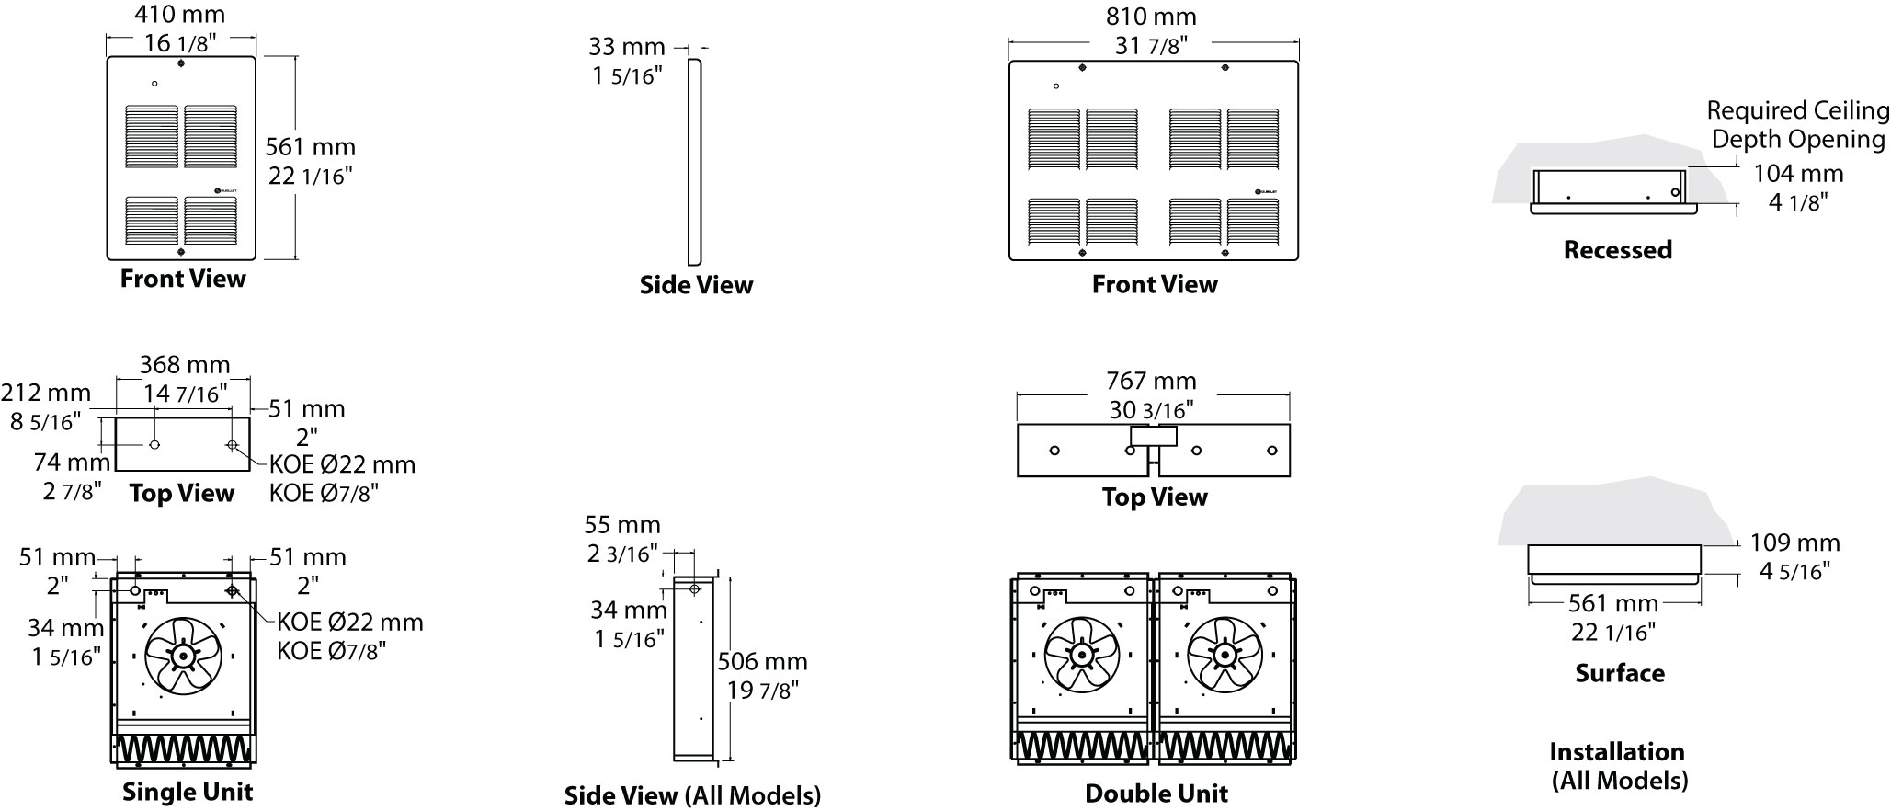

Models
Product # | Qty | Volts | Watts | BTU/hr | Weight |  | Unit
 |  |  |  |  | lb | kg | Unit
OACPU1502 |  | 120 | 1500 | 5123 | 24.0 | 10.9 | single
OACPU4008 |  | 208 | 4000 | 13661 | 24.0 | 10.9 | single
OACPU4808 |  | 208 | 4800 | 16393 | 24.0 | 10.9 | single
OACPU8008 |  | 208 | 8000 | 27321 | 50.0 | 22.7 | double
OACPU1500 |  | 240/208 | 1500/1125¹ | 5123/3842 | 24.0 | 10.9 | single
OACPU2000 |  | 240/208 | 2000/1500¹ | 6830/5123 | 24.0 | 10.9 | single
OACPU3000 |  | 240/208 | 3000/2250¹ | 10246/7684 | 24.0 | 10.9 | single
OACPU4000 |  | 240/208 | 4000/3000¹ | 13661/10246 | 24.0 | 10.9 | single
OACPU4800 |  | 240/208 | 4800/3600¹ | 16393/12295 | 24.0 | 10.9 | single
OACPU6000 |  | 240/208 | 6000/4500¹ | 20491/15368 | 50.0 | 22.7 | double
OACPU8000 |  | 240/208 | 8000/6000¹ | 27321/20491 | 50.0 | 22.7 | double
OACPU1577 |  | 277 | 1500 | 5123 | 28.0 | 12.7 | single
OACPU2077 |  | 277 | 2000 | 6830 | 28.0 | 12.7 | single
OACPU3077 |  | 277 | 3000 | 10246 | 28.0 | 12.7 | single
OACPU4077 |  | 277 | 4000 | 13661 | 28.0 | 12.7 | single
OACPU6077 |  | 277 | 6000 | 20491 | 50.0 | 22.7 | double
OACPU8077 |  | 277 | 8000 | 27321 | 50.0 | 22.7 | double
OACPU1504 |  | 480 | 1500 | 5123 | 28.0 | 12.7 | single
OACPU2004 |  | 480 | 2000 | 6830 | 28.0 | 12.7 | single
OACPU3004 |  | 480 | 3000 | 10246 | 28.0 | 12.7 | single
OACPU4004 |  | 480 | 4000 | 13661 | 28.0 | 12.7 | single
OACPU6004 |  | 480 | 6000 | 20491 | 50.0 | 22.7 | double
OACPU8004 |  | 480 | 8000 | 27321 | 50.0 | 22.7 | double

Options
Product #  Kit | Product #  Factory installed* | Description | Qty
KIT-OAWH-BSA | - | Surface mounting box for an extruded aluminum front grille, single unit
KIT-OAWH-BSA2 | - | Surface mounting box for an extruded aluminum front grille, double unit
KIT-OAC-BS1 | - | Surface mounting box, single unit
KIT-OAC-BS2 | - | Surface mounting box, double unit
KIT-OAC-DVA | - | Extruded aluminum front grille, single unit
KIT-OAC-DVA2 | - | Extruded aluminum front grille, double unit
KIT-OACP-DIS20² | DIS20² | Disconnect switch, double-pole, 20A at 240V
KIT-OACP-DIS40² | DIS40² | Disconnect switch, triple-pole, 40A at 600V
KIT-OACP-DIS80² | DIS80² | Disconnect switch, triple-pole, 80A at 600V
KIT-OACP-R | R | 24V control relay, without transformer
- | RT | 24V control relay, with transformer
KIT-OACP-T | T | Thermostat
KIT-OACP-T-BAR | - | Adaptor for T-bar ceiling installation, 23 3/4 in. X 23 3/4 in. (602 mm X 602 mm), single unit
KIT-OACP-T-BAR2 | - | Adaptor for T-bar ceiling installation, 23 3/4 in. X 47 11/16 in. (602 mm X 1211 mm), double unit

* For factory installed options, add the option number to the product number. See the Product Code section inside the front cover.
¹ 208V = 75% of wattage at 240V.
² For the U.S. only: The nominal current of the unit must not exceed 80% of the capacity of the disconnect.
Add "BL" for white, "AM" for almond. Upcharge available for optional colors shown in the color chart section.

Others
Type | Quantity | Model et description  Complementary informations | Volts | Phase | Watts | Length  mm/in. | Informations  Color/installation

Specifications may change without prior notice
Project: | Approval  Information
Consultant Engineer: | Approval  Information
Electrician Contractor: | Approval  Information
Distributor: | Approval  Information
Date: | Approval  Information
Contact in Ouellet: | Approval  Information
Comments:

