Series
OAC Commercial Wall Fan Heater


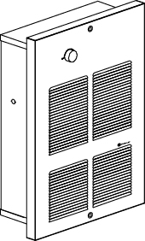

Features
Color - Standard: white, almond.
- Optional (upcharge applicable): metallic silver, bronze, metallic charcoal, aluminum,
semi-gloss black, sand.
- Custom colors available upon request.
Finish - Standard: epoxy/polyester powder paint.
Voltage - 120V, 208V, 240/208V, 277V, 347V, 480V, 600V, 1 or 3-phase.
Construction - 18-gauge steel front cover.
- Bottom air outlet.
- High-limit temperature control with automatic reset.
Fan - Closed, factory-lubricated motor.
- 160 cfm fan (single unit: 55 dBA); 2 X 160 cfm fan (double unit: 58 dBA);
3 X 160 cfm fan (triple unit: 61 dBA).
- Fan delay purges heater of residual heat.
Heating element - Durable tubular heating element with fins.
Control - Built-in thermostat included with control knob or tamperproof.
- 24V relay, with or without transformer available.
Note: Thermostat is not included in heater with factory installed relay.
Any remote thermostat or relay must be connected to the heater control terminal block.
Installation - Minimum clearance from the floor and adjacent walls: 10 in. (25.4 cm).
- Surface mounting box available.
- Semi recessed trim kit available.
Warranty - 5-year warranty against defects.
Application - Apartment building, commercial building, entrance way, stairwell, garage.
.

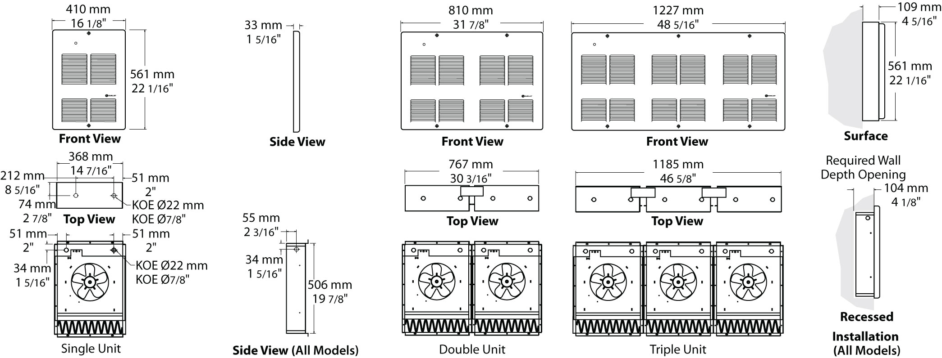
Models
Product #¹ | Qty | Volts (ph) | Watts | BTU/hr | Weight |  | Unit
 |  |  |  |  | lb | kg | Unit
OACU01502-T |  | 120 (1) | 1500 | 5123 | 24.0 | 10.9 | single
OACU02008-T |  | 208 (1) | 2000 | 6830 | 24.0 | 10.9 | single
OACU04008-T |  | 208 (1) | 4000 | 13661 | 24.0 | 10.9 | single
OACU04038-T |  | 208 (3) | 4000 | 13661 | 26.0 | 12.0 | single
OACU04808-T |  | 208 (1) | 4800 | 16393 | 24.0 | 10.9 | single
OACU05038-T |  | 208 (3) | 5000 | 17076 | 26.0 | 12.0 | single
OACU06038-T |  | 208 (3) | 6000 | 20491 | 54.0 | 24.5 | double
OACU08008-T |  | 208 (1) | 8000 | 27321 | 50.0 | 22.7 | double
OACU09038-T |  | 208 (3) | 9000 | 30737 | 90.0 | 40.9 | triple
OACU12008-T |  | 208 (1) | 12000 | 40982 | 90.0 | 40.9 | triple
OACU12038-T |  | 208 (3) | 12000 | 40982 | 90.0 | 40.9 | triple
OACU01500-T¹ |  | 240/208 (1) | 1500/1125 | 5123/3842 | 24.0 | 10.9 | single
OACU02000-T¹ |  | 240/208 (1) | 2000/1500 | 6830/5123 | 24.0 | 10.9 | single
OACU03000-T¹ |  | 240/208 (1) | 3000/2250 | 10246/7684 | 24.0 | 10.9 | single
OACU03030-T¹ |  | 240/208 (3) | 3000/2250 | 10246/7684 | 26.0 | 12.0 | single
OACU04000-T¹ |  | 240/208 (1) | 4000/3000 | 13661/10246 | 24.0 | 10.9 | single
OACU04030-T¹ |  | 240/208 (3) | 4000/3000 | 13661/10246 | 26.0 | 12.0 | single
OACU04800-T¹ |  | 240/208 (1) | 4800/3600 | 16393/12295 | 24.0 | 10.9 | single
OACU05030-T¹ |  | 240/208 (3) | 5000/3750 | 17076/12807 | 26.0 | 12.0 | single
OACU06000-T¹ |  | 240/208 (1) | 6000/4500 | 20491/15368 | 50.0 | 22.7 | double
OACU08000-T¹ |  | 240/208 (1) | 8000/6000 | 27321/20491 | 50.0 | 22.7 | double
OACU12000-T1 |  | 240/208 (1) | 12000/9000 | 40982/30737 | 90.0 | 40.9 | triple
OACU01577-T |  | 277 (1) | 1500 | 5123 | 28.0 | 12.7 | single
OACU02077-T |  | 277 (1) | 2000 | 6830 | 28.0 | 12.7 | single
OACU03077-T |  | 277 (1) | 3000 | 10246 | 28.0 | 12.7 | single
OACU04077-T |  | 277 (1) | 4000 | 13661 | 28.0 | 12.7 | single
OACU04877-T |  | 277 (1) | 4800 | 16393 | 28.0 | 12.7 | single
OACU06077-T |  | 277 (1) | 6000 | 20491 | 55.0 | 25.0 | double
OACU08077-T |  | 277 (1) | 8000 | 27321 | 55.0 | 25.0 | double
OACU12077-T |  | 277 (1) | 12000 | 40982 | 90.0 | 40.9 | triple
OACU01504-T |  | 480 (1) | 1500 | 5123 | 28.0 | 12.7 | single
OACU02004-T |  | 480 (1) | 2000 | 6830 | 28.0 | 12.7 | single
OACU03004-T |  | 480 (1) | 3000 | 10246 | 28.0 | 12.7 | single
OACU03034-T |  | 480 (3) | 3000 | 10246 | 30.0 | 14.0 | single
OACU04004-T |  | 480 (1) | 4000 | 13661 | 28.0 | 12.7 | single
OACU04034-T |  | 480 (3) | 4000 | 13661 | 30.0 | 14.0 | single
OACU04804-T |  | 480 (1) | 4800 | 16393 | 28.0 | 12.7 | single
OACU05034-T |  | 480 (3) | 5000 | 17076 | 30.0 | 14.0 | single
OACU06004-T |  | 480 (1) | 6000 | 20491 | 55.0 | 25.0 | double
OACU08004-T |  | 480 (1) | 8000 | 27321 | 55.0 | 25.0 | double
OACU12004-T |  | 480 (1) | 12000 | 40982 | 90.0 | 40.9 | triple
OACU12034-T |  | 480 (3) | 12000 | 40982 | 90.0 | 40.9 | triple

Options
Product #  Kit | Product #  Factory installed* | Description | Qty
KIT-OAC-BS1 | - | Surface mounting box, single unit
KIT-OAC-BS1-1 | - | Semi recessed 1 in. trim kit, single unit
KIT-OAC-BS1-2 | - | Semi recessed 2 in. trim kit, single unit
KIT-OAC-BS2 | - | Surface mounting box, double unit
KIT-OAC-BS2-1 | - | Semi recessed 1 in. trim kit, double unit
KIT-OAC-BS2-2 | - | Semi recessed 2 in. trim kit, double unit
KIT-OAC-BS3 | - | Surface mounting box, triple unit
KIT-OAC-BS3-1 | - | Semi recessed 1 in. trim kit, triple unit
KIT-OAC-BS3-2 | - | Semi recessed 2 in. trim kit, triple unit
KIT-OAC-DIS20³ | DIS20³ | Disconnect switch, double-pole, 20A at 277V and less
KIT-OAC-DIS40³ | DIS40³ | Disconnect switch, triple-pole, 40A at 600V max.
KIT-OAC-DIS80³ | DIS80³ | Disconnect switch, triple-pole, 80A at 600V max.
- | IV | Fan switch
- | OO | On/Standby heating switch
- | R⁴ | 24V control relay, without transformer
- | RT⁴ | 24V control relay, with transformer

* For factory installed options, add the option number to the product number. See the Product Code section inside the front cover.
¹ Built-in thermostat included with control knob or tamperproof.
² 208V = 75% of wattage at 240V.
³ For the U.S. only: The nominal current of the unit must not exceed 80% of the capacity of the disconnect.
⁴ If the built-in thermostat is not required with the 24V control relay, remove the “-T” from the product number (E.g.: OACU04004-RT).
Add "BL" for white, "AM" for almond. Upcharge available for optional colors shown in the color chart section.

Others
Type | Quantity | Model et description  Complementary informations | Volts | Phase | Watts | Length  mm/in. | Informations  Color/installation

Specifications may change without prior notice
Project: | Approval  Information
Consultant Engineer: | Approval  Information
Electrician Contractor: | Approval  Information
Distributor: | Approval  Information
Date: | Approval  Information
Contact in Ouellet: | Approval  Information
Comments:

