Series
OFE-ECM
Energy Efficient Nortron Electric Furnace
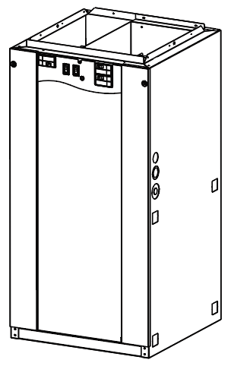

Features
Color - Standard: grey.
Voltage - 240V, 1-phase.
Construction - Steel casing, all insulated for reduced heat loss and noise.
- One panel on casing provides access to internal parts.
Fan - High quality precision balanced blower for quiet operation and optimal performance.
Motor - Variable speed electronically commutated motor (ECM), permanently lubricated and rubber mounted for maximum vibration and noise reduction.
- Relay and printed circuit board (PCB) control automatic operation of motor and allow for the addition of air conditioning or heat pump.
Heating element - Heavy duty, reliable Helical coil nickel-chromium alloy wire provide superior heat transfer with unrestricted air flow.
- Heating elements can be individually replaced.
- High-limit temperature control with automatic reset.
- Elements modulation is done by a low voltage printed circuit boards with rectifier/timers to prevent power surges.
Control - Heavy duty 24VAC transformer provides power to relays and controls.
- Easy access built-in breakers with manual reset (except the 10kW models).
- “Speed Selection” switch: “Low” or “High”.
- “Heat Activation” switch: “Slow” or “Fast”.
- Compatible with 1 or 2-stage thermostat with or without external unit.
Installation - Multi-position installation, sides, back, or bottom air returns.
- Approved for zero clearance installation against combustible surfaces.
Warranty - 5-year warranty against defects.
Application - For cottages, homes or offices, also approved for mobile homes use. May be installed in a basement, closet, crawl space or any unused area or alcove.

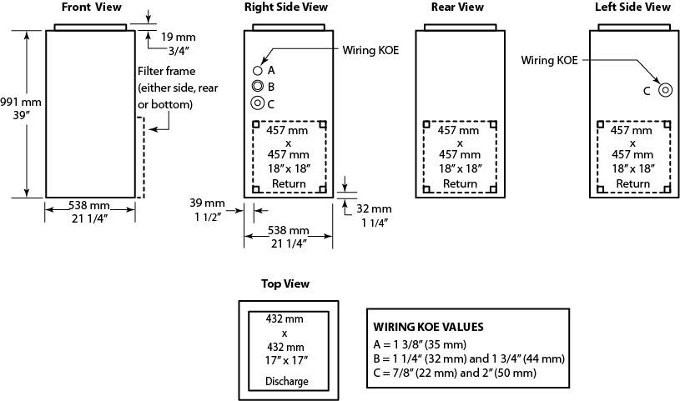

Models with Variable Speed Motor (ECM)
Product # | Volts (1 ph)  2 wires | kW (BTU/hr) | Amp. including motor | Motor  HP | Static Pressure at 0.2" W.C. |  | Weight |  | Qty
 |  |  |  |  | Motor Speed¹ | cfm² | lb | kg | Qty
21ECM10 | 240 | 10.0 (34152) | 43.0 | 1/3 | Low | 775 | 108 | 50.0
21ECM15 | 240 | 15.0 (51228) | 64.0 | 1/3 | Medium | 1020 | 108 | 50.0
21ECM18 | 240 | 18.0 (61473) | 76.0 | 1/3 | Medium | 1149 | 110 | 49.9
21ECM20 | 240 | 20.0 (68304) | 84.0 | 1/3 | Medium | 1149 | 110 | 49.9
21ECM23 | 240 | 22.5 (76842) | 94.0 | 1/3 | Medium | 1149 | 115 | 52.2

Option
Product #  Kit | Description | Qty
FSB1³ | Downflow sub-base

¹ Factory settings.
² Refer to the installation instructions and owner’s manual for complete air flow tables.
³ Available with 10kW,15kW,18kW and 20kW models.
Standard color is grey.

Wall Controls
Compatible with any low voltage thermostat.

Specifications may change without prior notice
Project: | Approval  Information
Consultant Engineer: | Approval  Information
Electrician Contractor: | Approval  Information
Distributor: | Approval  Information
Date: | Approval  Information
Contact in Ouellet: | Approval  Information
Comments:

