Series
HP6000ZB-MA Ductless heat pump interface
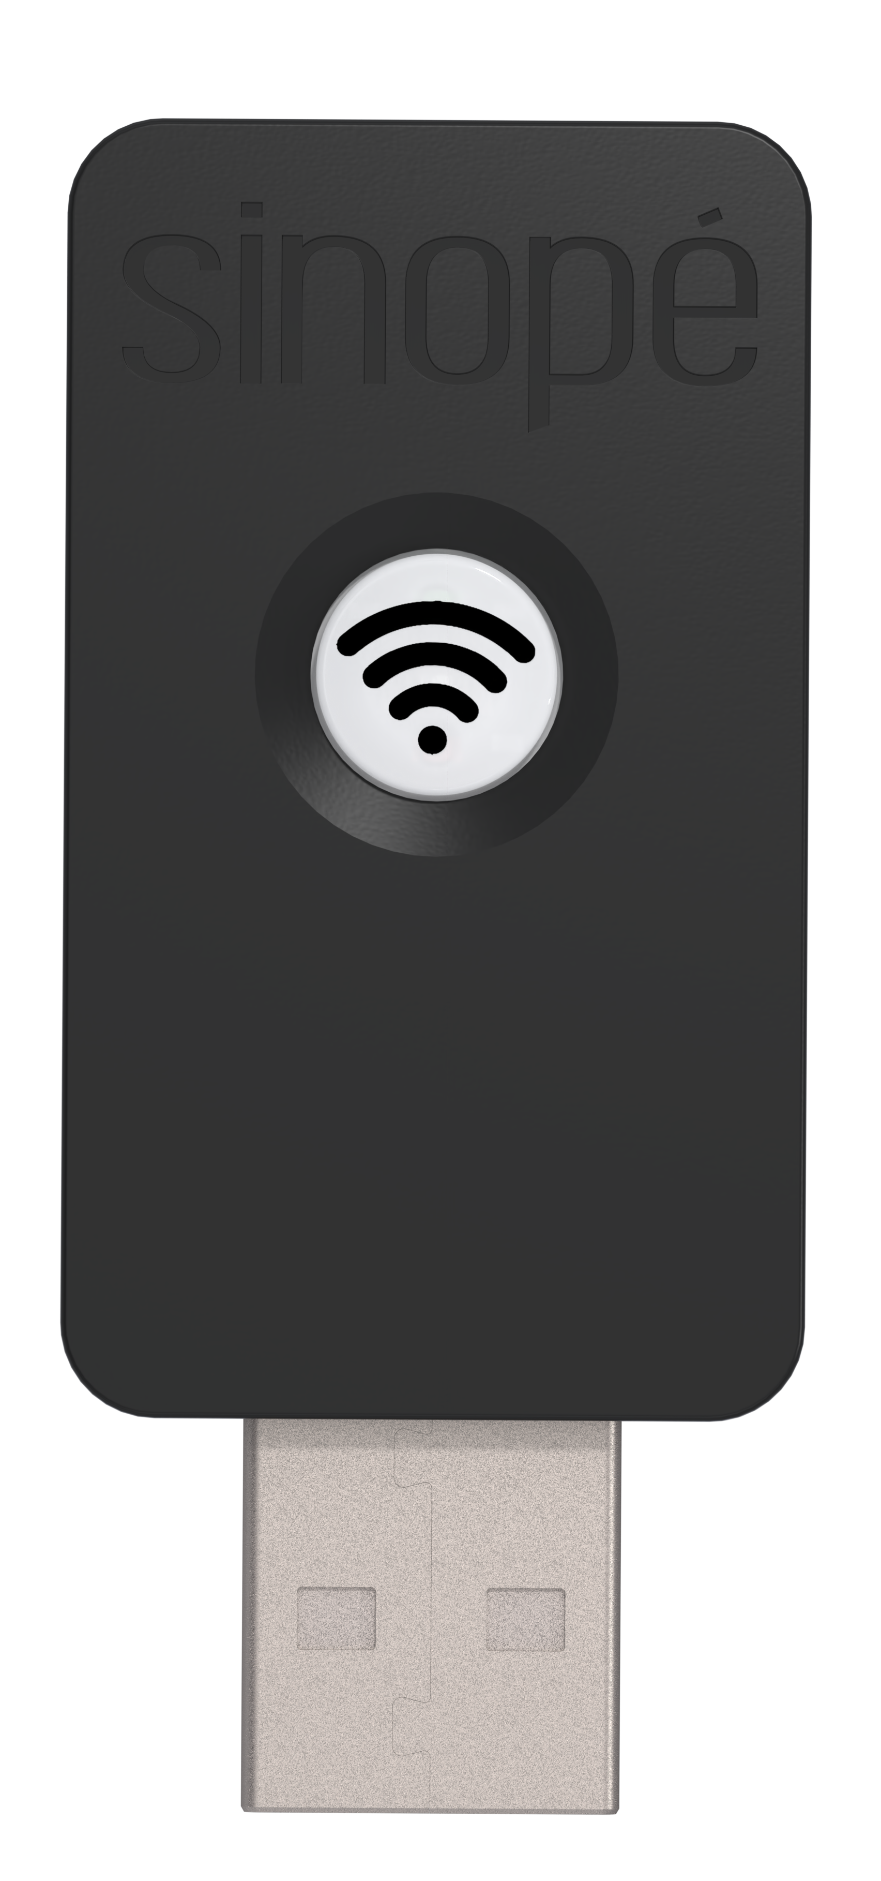

FCC15 Standard Complient
NMB-003 Standard Complient

Features

Remote access requires an Internet connection
and a GT130 smart gateway (not included).
Type - Ductless Convectair heat pump interface.
Color - Standard: black.
Power supply - Connect to the Wi-Fi port on the main board of the indoor unit.
Control - Protocol: Zigbee 3.0.
- Frequency: 2.4 GHz.
- Transmission power: +20 dBm.
- Receiver sensitivity: -108 dBm.
- Encryption key: AES-128.
Temperature range - 0 °C (32 °F) to 40 °C (104 °F).
Display - Cool, Heat, Dry, Fan and OFF.
- Adjustment of the orientation of the louvers.
- Adjustment of the fan intensity.
- Activation or deactivation of the display.
- Create custom automations.
- Advanced features in Neviweb and Sinopé Smart Systems.
- Programmation fonctions are available via Neviweb and require a GT130 smart
gateway.
Installation - Connect the interface to the USB type Wi-Fi port of the heat pump indoor unit main board.
Application - Convectair ductless heat pump¹.
Warranty - 3-year warranty against defects.

Models
Product # | Description | Qty
HP6000ZB-MA¹ | Ductless Convectair heat pump interface
GT130 | Smart gateway that provides remote access to the HP6000ZB-MA

¹ Requires the use of the GT130 smart gateway.

Standard color is black.

Specifications may change without prior notice
Project: | Approval  Information
Consultant Engineer: | Approval  Information
Electrician Contractor: | Approval  Information
Distributor: | Approval  Information
Date: | Approval  Information
Contact at manufacturer: | Approval  Information
Comments:

Available with selected models only.
Require the use of the GT130 smart gateway, an Internet connection and a Zigbee smart thermostat.

