Series

Capella MZ Ductless Multizone Heat Pump

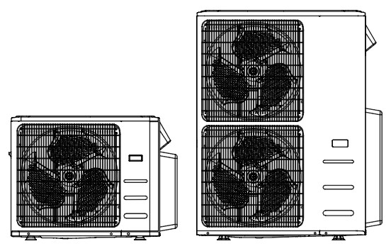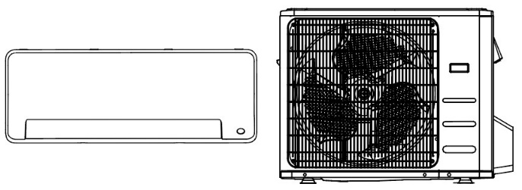**Logo AHRILogo Inverter**





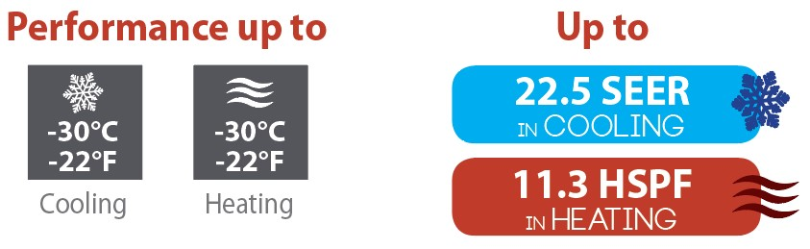

Features

Operation mode - Cooling, heating, dehumidifying, fan and auto.

Nominal capacity - 18000, 27000, 36000, 48000 BTU/hr.

Voltage - 230/208V, 60 Hz, 1-phase.

Indoor unit - High wall installation, dual side connection.

- Plastic housing, standard white.

- Cross-flow fan with selectable speed from 0% to 100% and 3 operation modes (turbo, auto and silence).

- Evaporator fins covered with hydrophilic coating for improved corrosion resistance.

- Washable filters.

Outdoor unit - Variable speed rotary compressor (INVERTER), with PCB control protection.

- Electronic expansion valve for precise control of refrigerant flow.

- Condenser fins covered with a hydrophilic coating for improved corrosion resistance.

- Quiet axial-flow fan.

- Multi-hole pan with smart heater to prevent ice formation.

- Compressor blanket and preheating technology.

- Installation on adjustable wall bracket or ground stand (optional).

Connection piping - Minimum piping length of 10 ft. (3 m).

* Flared connections.

Control - Wireless remote with wall bracket included with each indoor unit.

- Set temperature: 16 to 32 °C (61 to 90 °F).

- Temperature display format: °C or °F.

Warranty - 10-year basic warranty on parts and 10-year basic warranty on the compressor   
(labour not included).

* Labour warranty (sold separately) from the 1st to 10th year, on parts and labour with system replacement if the compressor fails.

Application - Dining room-kitchen, living room, family room, commercial building, office building, condo, restaurant.

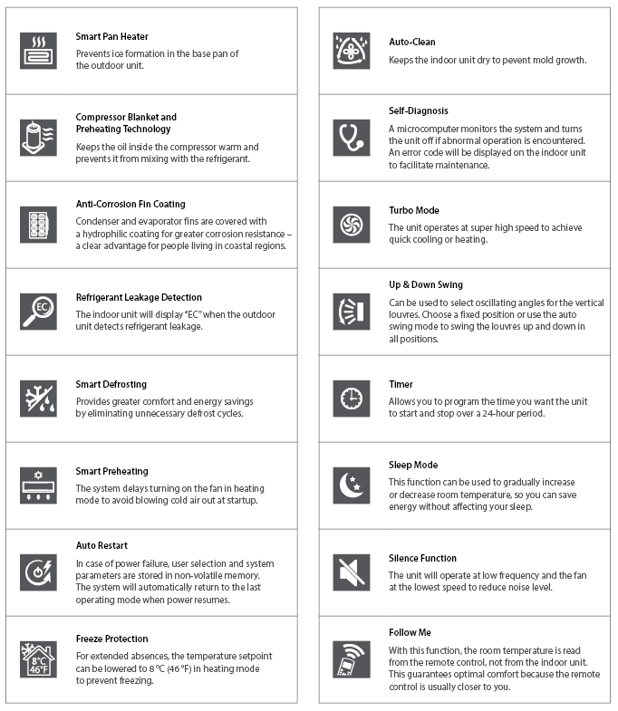**Features and functions**

Outdoor Unit Models

|  |  |  |  |  |  |  |  |
| --- | --- | --- | --- | --- | --- | --- | --- |
| **Product #** | | | | **8222-C18-O** | **8322-C27-O** | **8422-C36-O** | **8522-C48-O** |
| **Qty** | | | |  |  |  |  |
| **Technical Performance** | | | | | | | |
| **Number of connectable  indoor unit** | | | - | 1 to 2 | 2 to 3 | 2 to 4 | 2 to 5 |
| **Voltage** | | | Volts | 230/208 | 230/208 | 230/208 | 230/208 |
| **Cooling capacity** | | **Nominal** | W (BTU/hr) | 5572 (19000) | 8211 (28000) | 10557 (36000) | 14076 (48000) |
| **Min. – max.** | W (BTU/hr) | 1613 - 1804  (5500 - 25000) | 2344 - 9626  (7995 - 32826) | 5249 - 12317  (17900 - 42000) | 5660 - 14956  (19300 - 51000) |
| **Heating capacity** | | **Nominal** | W (BTU/hr) | 5882 (20000) | 8211 (28000) | 10704 (36500) | 14370 (49000) |
| **Min. – max.** | W (BTU/hr) | 2375 - 8710  (8100 - 29700) | 1477 - 10765  (5035 - 38712) | 3666 - 14370  (12500 - 49000) | 3372 - 17008  (11500 - 58000) |
| **Used cooling**  **power input** | | **Nominal** | W | 1520 | 2240 | 2650 | 4150 |
| **Min. – max.** | W | 230 - 2200 | 275 - 3493 | 740 - 4030 | 685 - 4700 |
| **Used heating**  **power input** | | **Nominal** | W | 1725 | 2240 | 2780 | 4000 |
| **Min. – max.** | W | 640 - 2700 | 303 - 4074 | 770 - 5230 | 710 - 5800 |
| **MCA** | | | A | 20 | 25 | 40 | 42 |
| **Max. over-current protection (MOCP)** | | | A | 25 | 40 | 50 | 50 |
| **SEER (SEER2)** | | | - | 22 (22) | 22.5 (23) | 21.8 (22.2) | 21.5 (21.8) |
| **HSPF (HSPF2)** | | | - | 10.2 (9.8) | 11.3 (10.6) | 11 (10.3) | 11 (9.8) |
| **EER** | | | W/W | 12.5 | 12.5 | 13.6 | 11.6 |
| **COP** | | | W/W | 3.40 | 3.66 | 3.85 | 3.59 |
| **AHRI number** | | | - | 207590846 | 207590849 | 207657622 | 207590852 |
| **ENERGY STAR** | | | - | ✓ | ✓ | ✓ | ✓ |
| **Air flow volume** | | | cfm | 2129 | 2147 | 4500 | 4500 |
| **Sound level** | | | dB (A) | 61 | 63 | 63 | 65 |
| **Compressor power input** | | | W | 1895 | 2600 | 3040 | 3565 |
| **Compressor LRA** | | | A | - | - | - | - |
| **Compressor RLA** | | | A | 18 | 20 | 26 | 30 |
| **Fan motor power output** | | | W | 150 | 150 | 126 | 126 |
| **Fan motor RLA** | | | A | - | - | - | - |
| **Refrigerant volume (R410A)** | | | oz (g) | 91.7 (2600) | 134.04 (3800) | 162 (4600) | 162 (4600) |
| **Net weight** | | | lb (kg) | 138 (63) | 168 (76) | 223 (101) | 238 (108) |
| **Operating ambient temperature** | **Cooling** | | °C (°F) | -30 to 50 (-22 to 122) | | | |
| **Heating** | | °C (°F) | -30 to 30 (-22 to 86) | | | |
| **Connection Piping/Refrigerant** | | | | | | | |
| **Pre-charge length** | | | ft. (m) | 49 (15) | 74 (22.5) | 98 (30) | 123 (37.5) |
| **Additional refrigerant charge** | | | oz/ft. (g/m) | 0.16 (15) | 0.16 (15) | 0.16 (15) | 0.16 (15) |
| **Liquid pipe outer diameter** | | | in. | 1/4 | 1/4 | 1/4 | 1/4 |
| **Gas pipe outer diameter** | | | in. | 3/8 | 3/8 | 3/8 | 3/8 |
| **Max. height difference outdoor to indoor unit** | | | ft. (m) | 49 (15) | 49 (15) | 49 (15) | 49 (15) |
| **Max. height difference between indoor units** | | | ft. (m) | 33 (10) | 33 (10) | 33 (10) | 33 (10) |
| **Max. length outdoor to last indoor unit** | | | ft. (m) | 82 (25) | 98 (30) | 118 (35) | 115 (35) |
| **Max. total length** | | | ft. (m) | 131 (40) | 197 (60) | 262 (80) | 262 (80) |

Indoor Unit Models

|  |  |  |  |  |  |  |  |
| --- | --- | --- | --- | --- | --- | --- | --- |
| **Product #** | | | | **8028-C09-I** | **8028-C12-I** | **8028-C18-I** | **8028-C24-I** |
| **Qty** | | | |  |  |  |  |
| **Cooling capacity** | **Nominal** | | W (BTU/hr) | 2638 (9000) | 3517 (12000) | 5275 (18000) | 7034 (24000) |
| **Min. – max.** | | W (BTU/hr) | 967 - 4191  (3300 - 14300) | 967 - 4191  (3300 - 14300) | 2600 - 5687  (8870 - 19400) | 2008 - 7913  (6850 - 27000) |
| **Heating capacity** | **Nominal** | | W (BTU/hr) | 3460 (11800) | 3517 (12000) | 5275 (18000) | 8504 (29000) |
| **Min. – max.** | | W (BTU/hr) | 1465 - 4455  (5000 - 15200) | 1465 - 4484  (5000 - 15300) | 4425 - 5715  (15100 - 19500) | 3488 - 9085  (11900 - 31000) |
| **Dehumidication** | | | pt/hr (l/hr) | 2.13 (1.14) | 2.54 (1.44) | 3.8 (2.16) | 5.49 (3.13) |
| **Air flow volume** | | **H / M / L1** | cfm | 335 / 229 / 176 | 335 / 229 / 176 | 524 / 376 / 306 | 611 / 414 / 319 |
| **Sound level** | | **H / M / L1** | dB (A) | 38 / 33.5 / 23.5 | 38 / 33.5 / 23.5 | 46 / 42 / 24 | 46 / 39 / 34 |
| **Fan motor power output** | | | W | 50 | 50 | 36 | 58 |
| **Fan motor RLA** | | | A | 0.25 | 0.25 | 0.4 | 0.5 |
| **Net weight** | | | lb (kg) | 23 (10.3) | 23 (10.4) | 27 (12.3) | 44 (20) |

*1 Cross-Flow Fan Speeds: (H) High (80%) / (M) Medium (60%) / (L) Low (40%).*

Note that each unit is individually packaged.

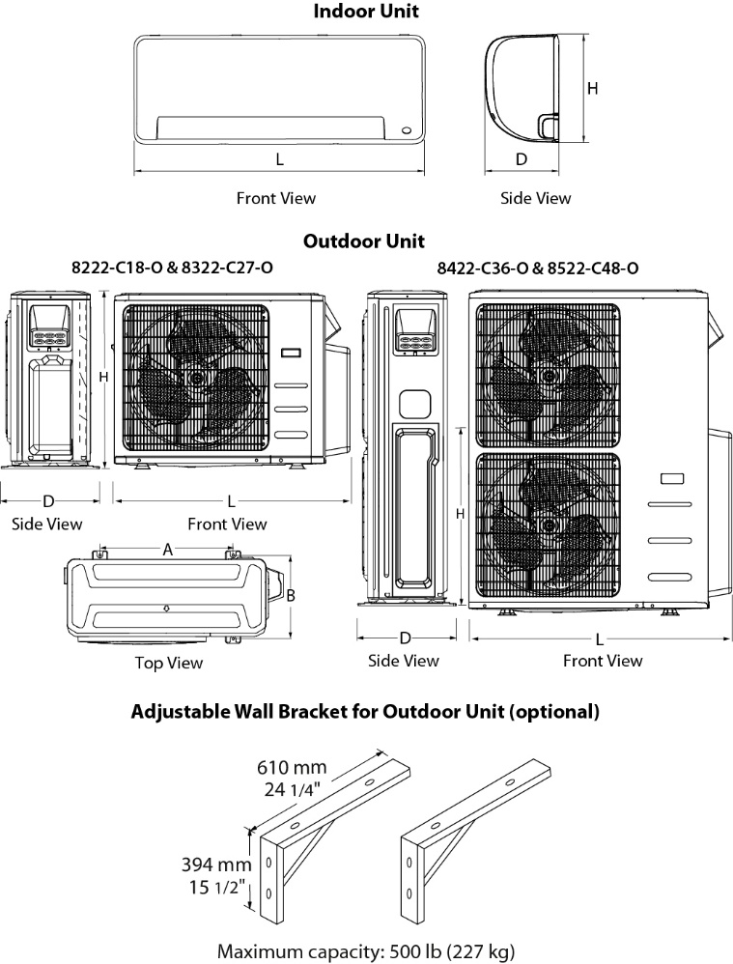

|  |  |  |  |  |  |  |
| --- | --- | --- | --- | --- | --- | --- |
| **Indoor Unit** | **L** | | **H** | | **D** | |
| **in.** | **mm** | **in.** | **mm** | **in.** | **mm** |
| **8028-C09-I**  **8028-C12-I** | 31 5/16 | 795 | 11 5/8 | 295 | 8 7/8 | 225 |
| **8028-C18-I** | 38 | 965 | 12 9/16 | 319 | 9 7/16 | 239 |
| **8028-C24-I** | 44 7/8 | 1140 | 14 9/16 | 370 | 10 13/16 | 275 |

|  |  |  |  |  |  |  |  |  |  |  |
| --- | --- | --- | --- | --- | --- | --- | --- | --- | --- | --- |
| **Outdoor Unit** | **L** | | **H** | | **D** | | **A** | | **B** | |
| **in.** | **mm** | **in.** | **mm** | **in.** | **mm** | **in.** | **mm** | **in.** | **mm** |
| **8222-C18-O**  **8322-C27-O** | 37 1/4 | 946 | 31 7/8 | 810 | 16 1/8 | 410 | 26 1/2 | 673 | 15 7/8 | 403 |
| **8422-C36-O**  **8522-C48-O** | 37 1/2 | 952 | 52 1/2 | 1333 | 16 5/16 | 415 | 24 15/16 | 634 | 15 15/16 | 404 |

**Options**See OTP Options section

**Specifications may change without prior notice**

|  |  |
| --- | --- |
| Project: | Approval  Information |
| Consultant Engineer: |
| Electrical Contractor: |
| Distributor: |
| Date: |
| Contact at manufacturer: |
| Comments: | |