Series

Capella 28 Ductless Single Zone Heat Pump

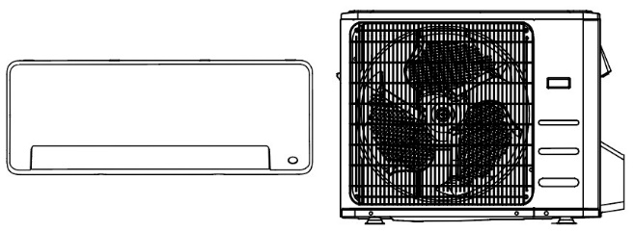**Logo AHRILogo Inverter**



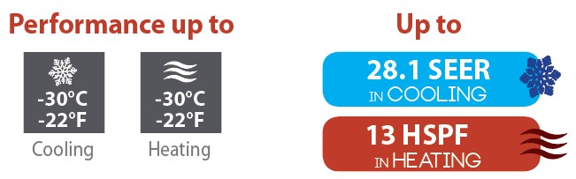

Features

Operation mode - Cooling, heating, dehumidifying, fan and auto.

Nominal capacity - 9000, 12000, 18000, 24000 BTU/hr.

Voltage - 230/208V, 60 Hz, 1-phase.

Indoor unit - High wall installation, dual side connection.

- Plastic housing, standard white.

- Cross-flow fan with selectable speed from 0% to 100% and

3 operation modes (turbo, auto and silence).

- Evaporator fins covered with hydrophilic coating for improved corrosion resistance.

- Washable filters.

Outdoor unit - Variable speed rotary compressor (INVERTER), with PCB control protection.

- Electronic expansion valve for precise control of refrigerant flow.

- Condenser fins covered with a hydrophilic coating for improved corrosion resistance.

- Quiet axial-flow fan.

- Multi-hole pan with smart heater to prevent ice formation.

- Compressor blanket and preheating technology.

- Installation on aluminum wall bracket or ground stand (optional).

Connection piping - Minimum piping length of 10 ft. (3 m).

* Flared connections.

Control - Wireless remote included with wall bracket.

- Set temperature: 16 to 32 °C (61 to 90 °F).

- Temperature display format: °C or °F.

- Interface (optional HP6000ZB-MA and GT130 required).

Warranty - 10-year basic warranty on parts and 10-year basic warranty on the compressor (labor not included).

- Labour warranty (sold separately) from the 1st to 10th year, on parts and labour with system replacement if the compressor fails.

**A**pplication - Dining room-kitchen, living room, family room, commercial building, office building, condo, restaurant.

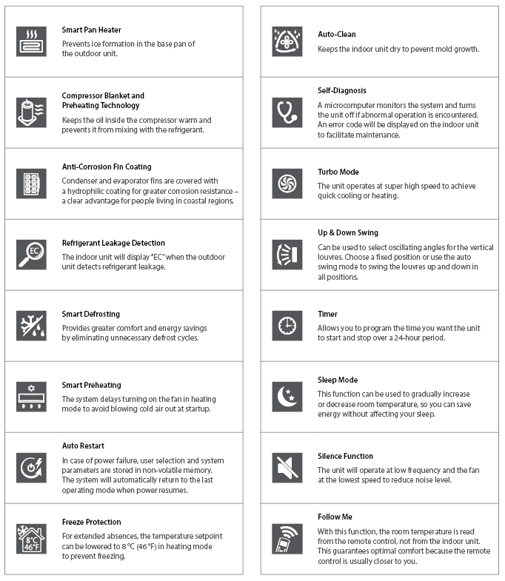**Features and functions**

**Models**

|  |  |  |  |  |  |  |  |  |
| --- | --- | --- | --- | --- | --- | --- | --- | --- |
| **Product #1** | | | **Indoor Unit** | | **8028-C09-I** | **8028-C12-I** | **8028-C18-I** | **8028-C24-I** |
| **Outdoor Unit** | | **8028-C09-O** | **8028-C12-O** | **8028-C18-O** | **8028-C24-O** |
| **Qty** | | | | |  |  |  |  |
| **Technical Performance** | | | | | |  | |  |
| **Voltage** | |  | | Volts | 230/208 | 230/208 | 230/208 | 230/208 |
| **Cooling capacity** | | **Nominal** | | W (BTU/hr) | 2638 (9000) | 3517 (12000) | 5275 (18000) | 7034 (24000) |
| **Min. – max.** | | W (BTU/hr) | 967 - 4191  (3300 - 14300) | 967 - 4191  (3300 - 14300) | 2600 - 5687  8870 - 19400 | 2008 - 7913  6850 - 27000 |
| **Heating capacity** | | **Nominal** | | W (BTU/hr) | 3460 (11800) | 3517 (12000) | 5275 (18000) | 8504 (29000) |
| **Min. – max.** | | W (BTU/hr) | 1465 - 4455  (5000 - 15200) | 1465 - 4484  (5000 - 15300) | 4425 - 5715  (15100 - 19500) | 3488 - 9085  (11900 - 31000) |
| **Used cooling power input** | | **Nominal** | | W | 556 | 857 | 1440 | 1845 |
| **Min. – max.** | | W | 180 - 1180 | 180 - 1180 | 230 - 1760 | 310 - 2400 |
| **Used heating power input** | | **Nominal** | | W | 907 | 907 | 1700 | 2500 |
| **Min. – max.** | | W | 370 - 1500 | 370 - 1500 | 1390 - 2050 | 670 - 2700 |
| **Cooling rated current** | | | | A | 2.5 | 3.72 | 6.3 | 8.1 |
| **Heating rated current** | | | | A | 4.1 | 4.1 | 7.3 | 10.9 |
| **MCA** | | | | A | 15 | 15 | 16 | 25 |
| **Max. over-current protection (MOCP)** | | | | A | 15 | 15 | 25 | 35 |
| **SEER (SEER2)** | | | | - | 28.1 (28.1) | 25.5 (25.5) | 21.5 (21.5) | 21.5 (21.5) |
| **HSPF (HSPF2)** | | | | - | 13 (11.5) | 13 (10.4) | 13 (11.3) | 12 (11.4) |
| **EER** | | | | W/W | 16.2 | 14 | 12.5 | 13 |
| **COP** | | | | W/W | 3.81 | 3.88 | 3.1 | 3.4 |
| **AHRI number** | | | | - | 207709204 | 207709205 | 207709206 | 207709207 |
| **ENERGY STAR** | | | | - | ✓ | ✓ | ✓ | ✓ |
| **Indoor Unit** | | | | |  |  |  |  |
| **Dehumidification** | | | | pt/hr (l/hr) | 2.13 (1.14) | 2.54 (1.44) | 3.8 (2.16) | 5.49 (3.13) |
| **Air flow volume** | | **H / M / L2** | | cfm | 335 / 229 / 176 | 335 /229 / 176 | 524 / 376 / 306 | 611 / 414 / 319 |
| **Sound level** | | **H / M / L2** | | dB (A) | 38 / 33.5 / 23.5 | 38 / 33.5 / 23.5 | 46 / 42 / 24 | 46 / 39 / 34 |
| **Fan motor power output** | | | | W | 50 | 50 | 36 | 58 |
| **Fan motor RLA** | | | | A | 0.25 | 0.25 | 0.4 | 0.5 |
| **Net weight** | | | | lb (kg) | 22.7 (10.3) | 22.9 (10.4) | 27 (12.3) | 44 (20) |
| **Outdoor Unit** | | | | |  |  |  |  |
| **Air flow volume** | | | | cfm | 1324 | 1324 | 1765 | 2235 |
| **Sound level** | | | | dB (A) | 55 | 56 | 59 | 62 |
| **Compressor power input** | | | | W | 885 | 885 | 2045 | 2045 |
| **Compressor LRA** | | | | A | 8.8 | 8.8 | 14.25 | 17.1 |
| **Compressor RLA** | | | | A | 50 | 50 | 36 | 58 |
| **Fan motor power output** | | | | W | - | - | - | - |
| **Fan motor RLA** | | | | A | 0.42 | 0.36 | 0.76 | 0.5 |
| **Refrigerant volume (R410A)** | | | | oz (g) | 41.62 (1180) | 41.62 (1180) | 65.2 (1850) | 91.7 (2600) |
| **Net weight** | | | | lb (kg) | 74 (33.6) | 74 (33.4) | 101 (45.8) | 134 (61) |
| **Operating ambient temperature** | **Cooling** | | | °C (°F) |  | -30 to 50 (-22 to 122) | |  |
| **Heating** | | | °C (°F) |  | -30 to 30 (-22 to 86) | |  |
| **Connection Piping/Refrigerant** | | | | | |  | |  |
| **Pre-charge length** | | | | ft. (m) | 25 (7.5) | 25 (7.5) | 25 (7.5) | 25 (7.5) |
| **Additional refrigerant charge** | | | | oz/ft. (g/m) | 0.16 (15) | 0.16 (15) | 0.16 (15) | 0.32 (30) |
| **Liquid pipe outer diameter** | | | | in. | 1/4 | 1/4 | 1/4 | 3/8 |
| **Gas pipe outer diameter** | | | | in. | 3/8 | 1/2 | 1/2 | 5/8 |
| **Maximum height difference** | | | | ft. (m) | 33 (10) | 33 (10) | 66 (20) | 82 (25) |
| **Maximum total length** | | | | ft. (m) | 82 (25) | 82 (25) | 98 (30) | 164 (50) |

**1***1 indoor unit and 1 outdoor unit. Note that each unit is individually packaged.*

*2 Cross-Flow Fan Speeds: (H) High (80%) / (M) Medium (60%) / (L) Low (40%).*

**Capacity Variation Ratio According to Temperature**

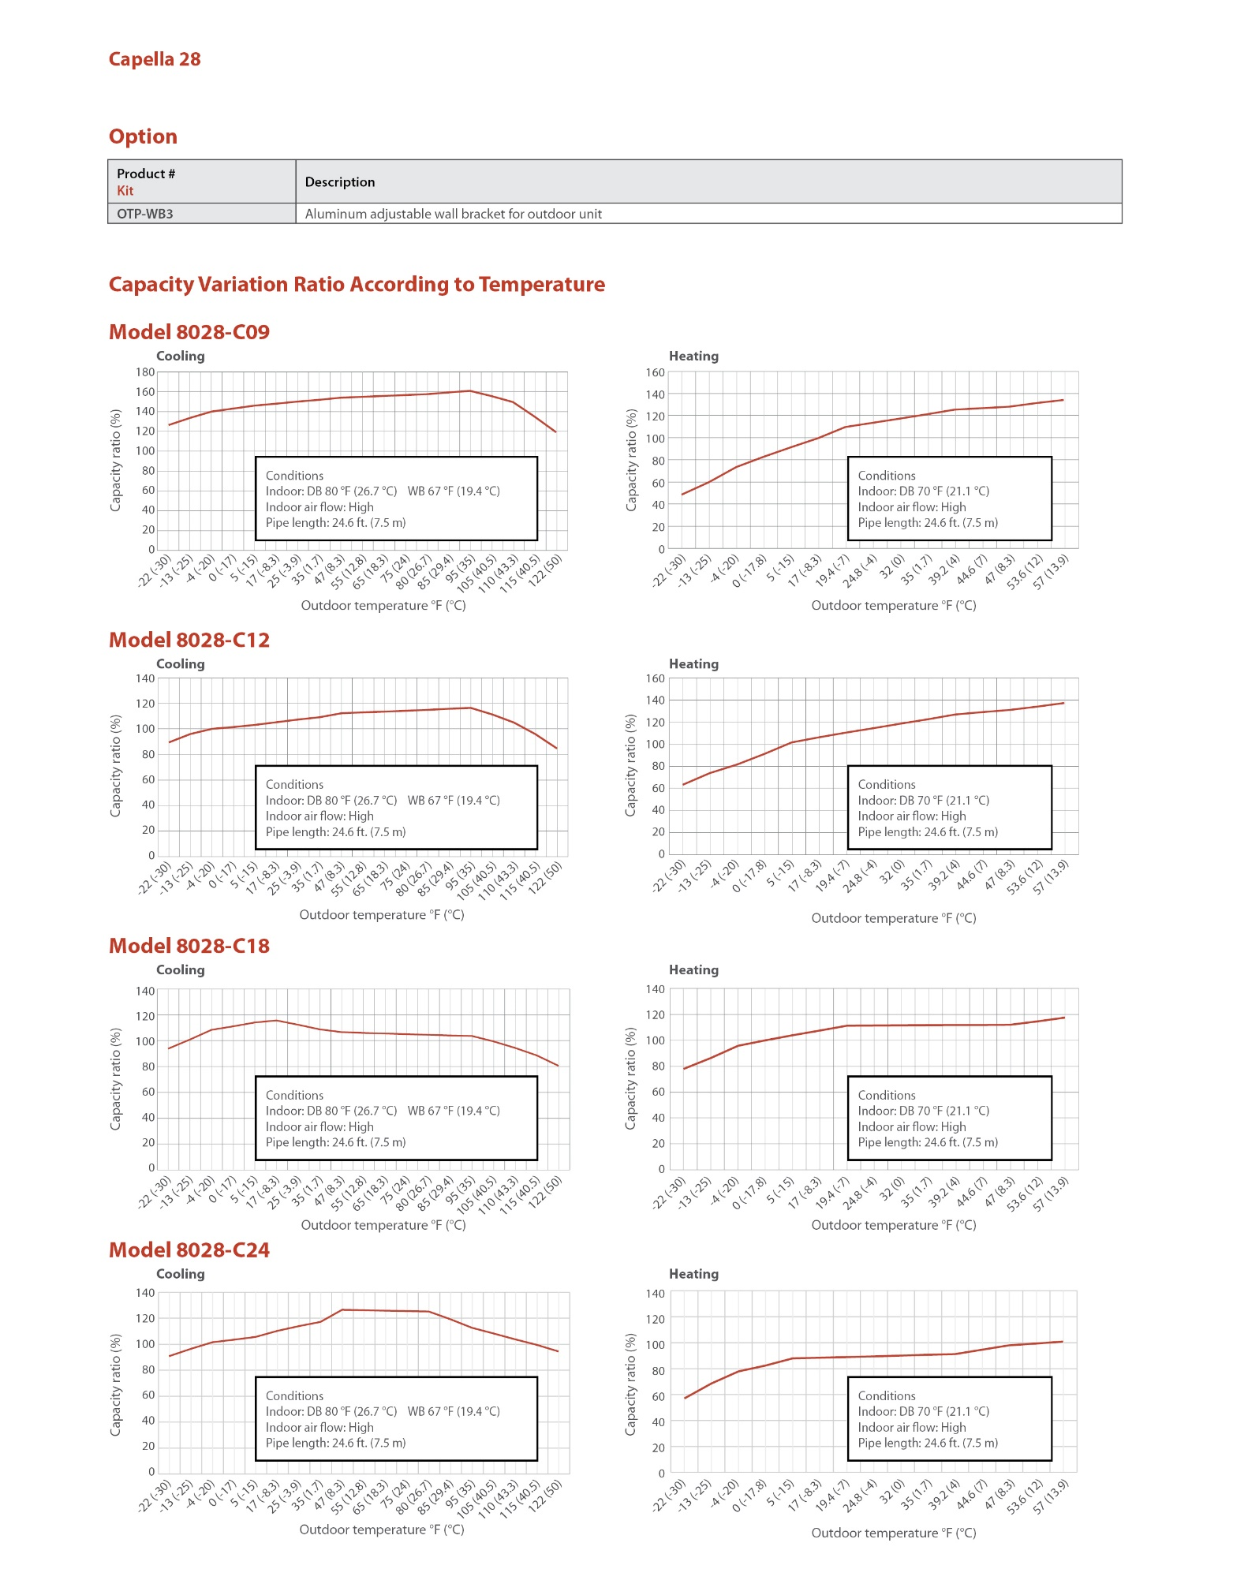

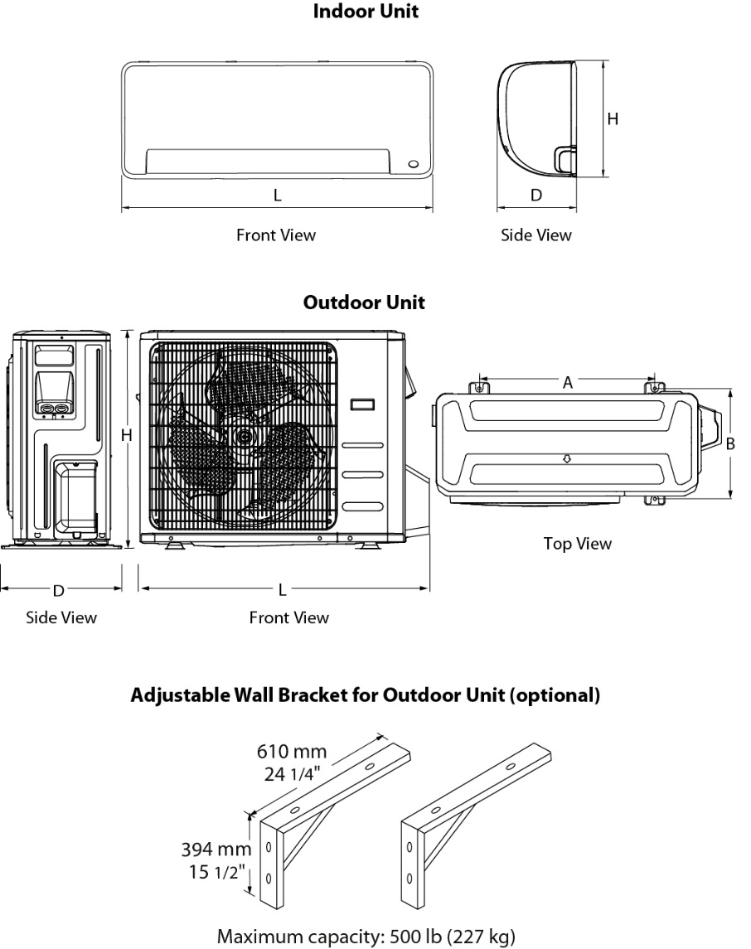

|  |  |  |  |  |  |  |
| --- | --- | --- | --- | --- | --- | --- |
| **Indoor Unit** | **L** | | **H** | | **D** | |
| **in.** | **mm** | **in.** | **mm** | **in.** | **mm** |
| **8028-C09-I**  **8028-C12-I** | 31 5/16 | 795 | 11 5/8 | 295 | 8 7/8 | 225 |
| **8028-C18-I** | 38 | 965 | 12 9/16 | 319 | 9 7/16 | 239 |
| **8028-C24-I** | 44 7/8 | 1140 | 14 9/16 | 370 | 10 13/16 | 275 |

|  |  |  |  |  |  |  |  |  |  |  |
| --- | --- | --- | --- | --- | --- | --- | --- | --- | --- | --- |
| **Outdoor Unit** | **L** | | **H** | | **D** | | **A** | | **B** | |
| **in.** | **mm** | **in.** | **mm** | **in.** | **mm** | **in.** | **mm** | **in.** | **mm** |
| **8028-C09-O**  **8028-C12-O** | 31 11/16 | 805 | 21 13/16 | 554 | 13 | 330 | 20 1/8 | 511 | 12 | 305 |
| **8028-C18-O** | 35 1/16 | 890 | 26 1/2 | 673 | 13 7/16 | 342 | 26 1/8 | 663 | 13 11/16 | 348 |
| **8028-C24-O** | 37 1/4 | 946 | 31 7/8 | 810 | 16 1/8 | 410 | 26 1/2 | 673 | 17 15/16 | 455 |

**Options**See OTP Options section

**Specifications may change without prior notice**

|  |  |
| --- | --- |
| Project: | Approval  Information |
| Consultant Engineer: |
| Electrician Contractor: |
| Distributor: |
| Date: |
| Contact at manufacturer: |
| Comments: | |