Series

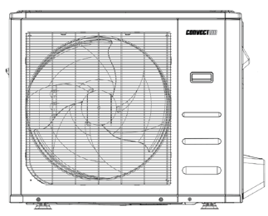
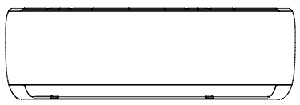
Capella 16 Ductless Single Zone Heat Pump



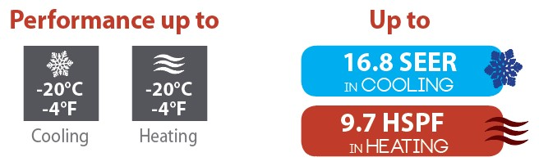

Features
Operation mode - Cooling, heating, dehumidifying, fan and auto.
Nominal capacity - 9000, 12000, 18000, 24000 BTU/hr.
Voltage - 230/208V, 60 Hz, 1-phase.
Indoor unit - High wall installation, dual side connection.
- Plastic housing, standard white.
- 3-speed cross-flow fan (high, medium and low)
with 3 operation modes (turbo, auto and silence).
- Evaporator fins covered with hydrophilic coating for improved corrosion resistance.
- Washable filters.
Outdoor unit - Variable speed rotary compressor (INVERTER), with PCB control protection.
- Electronic expansion valve for precise control of refrigerant flow.
- Condenser fins covered with a hydrophilic coating for improved corrosion resistance.
- Quiet axial-flow fan.
- Multi-hole pan with smart heater to prevent ice formation.
- Compressor blanket and preheating technology.
- Installation on aluminum wall bracket or ground stand (optional).
Connection piping - Minimum piping length of 10 ft. (3 m).
- Flared connections.
Control - Wireless remote included with wall bracket.
- Set temperature: 17 to 32 °C (63 to 90 °F).
- Temperature display format: °C or °F.
- Interface (optional HP6000ZB-MA and GT130 required).
Warranty - 10-year basic warranty on parts and 10-year basic warranty on the compressor
(labor not included).
Application - Dining room-kitchen, living room, family room, commercial building, office building, condo, restaurant.

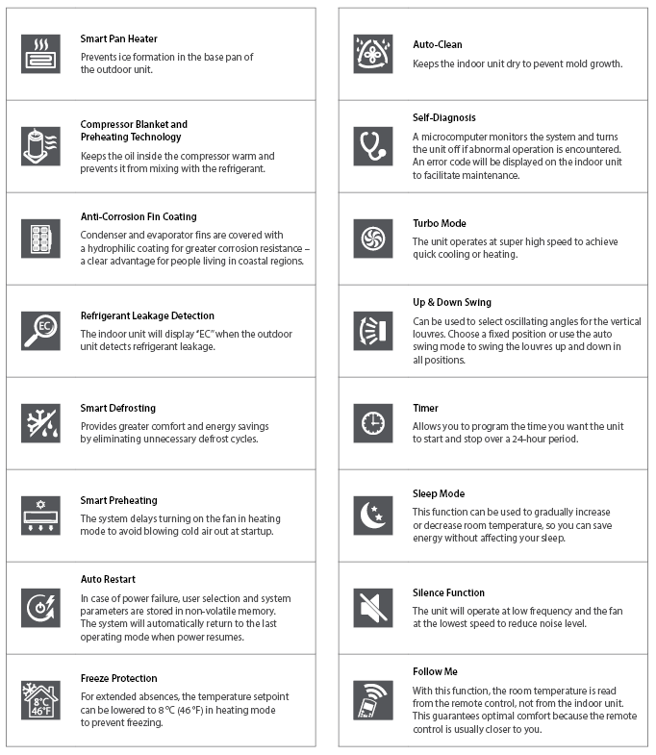
Features and functions

Models
Product #¹ |  |  | Indoor Unit |  | 8016-C09-I | 8016-C12-I | 8016-C18-I | 8016-C24-I
 |  |  | Outdoor Unit |  | 8016-C09-O | 8016-C12-O | 8016-C18-O | 8016-C24-O
Qty
Technical Performance
Voltage |  |  |  | Volts | 230/208 | 230/208 | 230/208 | 230/208
Cooling capacity |  | Nominal |  | W (BTU/hr) | 2639 (9000) | 3519 (12000) | 4985 (17000) | 7034 (24000)
 |  | Min. – max. |  | W (BTU/hr) | 0 - 3517  (0 - 12000) | 0 - 3517  (0 - 12000) | 2022 - 5744  (6900 - 19600) | 1875 - 7121  (6400 - 24300)
Heating capacity |  | Nominal |  | W (BTU/hr) | 3519 (12000) | 3519 (12000) | 5279 (18000) | 7038 (24000)
 |  | Min. – max. |  | W (BTU/hr) | 0 - 3519  (0 - 12000) | 0 - 3519  (0 - 12000) | 1314 - 5513  (4480 - 18800) | 1965 - 8064  (6700 - 27500)
Used cooling power input |  | Nominal |  | W | 1345 | 1385 | 1720 | 2695
 |  | Min. – max. |  | W | 180 - 1180 | 180 - 1580 | 190 - 1890 | 335 - 2940
Used heating power input |  | Nominal |  | W | 1180 | 1212 | 1700 | 2475
 |  | Min. – max. |  | W | 350 - 1400 | 370 - 1500 | 815 - 2050 | 660 - 2600
Cooling rated current |  |  |  | A | 5.92 | 5.92 | 7.6 | 12.3
Heating rated current |  |  |  | A | 5.27 | 5.27 | 7.5 | 11.3
MCA |  |  |  | A | 12 | 12 | 15 | 19
Max. over-current protection (MOCP) |  |  |  | A | 15 | 15 | 20 | 30
SEER (SEER2) |  |  |  | - | 16.8 (18.5) | 16.8 (17.6) | 16.8 (18.3) | 16.5 (17)
HSPF (HSPF2) |  |  |  | - | 9.4 (8.8) | 9.4 (8.8) | 9.7 (8.7) | 9.5 (8)
EER |  |  |  | W/W | 8.8 | 8.8 | 9.9 | 8.9
COP |  |  |  | W/W | 2.9 | 2.9 | 3.1 | 2.84
AHRI number |  |  |  | - | 207709200 | 207709201 | 207709202 | 207709203
ENERGY STAR |  |  |  | - | - | - | - | -
Indoor Unit
Dehumidification |  |  |  | pt/hr (l/hr) | 2.11 (1) | 2.54 (1.2) | 3.8 (1.8) | 5.49 (2.6)
Air flow volume |  | H / M / L² |  | cfm | 318 / 241 / 176 | 318 / 241 / 176 | 464 / 369/ 275 | 565 / 447 / 341
Sound level |  | H / M / L² |  | dB (A) | 41.5 / 34.5 / 25.5 | 41.5 / 34.5 / 25.5 | 44 / 38 / 30 | 46 / 40 / 33.5
Fan motor power output |  |  |  | W | 47.4 | 47.4 | 58.5 | 89
Fan motor RLA |  |  |  | A | 0.34 | 0.34 | 0.66 | 0.45
Net weight |  |  |  | lb (kg) | 17.2 (7.8) | 17.2 (7.8) | 22.93 (10.4) | 28.88 (13.1)
Outdoor Unit
Air flow volume |  |  |  | cfm | 1058.82 | 1058.82 | 1235.29 | 1764.71
Sound level |  |  |  | dB (A) | 54.5 | 54.5 | 57 | 59.5
Compressor power input |  |  |  | W | 1140 | 1140 | 2085 | 2085
Compressor LRA |  |  |  | A | - | - | - | -
Compressor RLA |  |  |  | A | 6.47 | 6.47 | 7.5 | 14.25
Fan motor power output |  |  |  | W | - | - | - | -
Fan motor RLA |  |  |  | A | 0.34 | 0.47 | 0.82 | 0.76
Refrigerant volume (R410A) |  |  |  | oz (g) | 25.75 (709) | 25.75 (709) | 47.97 (1332) | 62.8 (1758)
Net weight |  |  |  | lb (kg) | 52.9 (24) | 52.9 (24) | 64.15 (29.1) | 97.88 (44.4)
Operating ambient  temperature | Cooling |  |  | °C (°F) | -20 to 50 (-4 to 122)
Operating ambient  temperature | Heating |  |  | °C (°F) | -20 to 30 (-4 to 86)
Connection Piping/Refrigerant
Pre-charge length |  |  |  | ft. (m) | 25 (7.5) | 25 (7.5) | 25 (7.5) | 25 (7.5)
Additional refrigerant charge |  |  |  | oz/pi (g/m) | 0.16 (15) | 0.16 (15) | 0.16 (15) | 0.32 (30)
Liquid pipe outer diameter |  |  |  | in. | 1/4 | 1/4 | 1/4 | 3/8
Gas pipe outer diameter |  |  |  | in. | 3/8 | 3/8 | 1/2 | 5/8
Maximum height difference |  |  |  | ft. (m) | 33 (10) | 33 (10) | 66 (20) | 66 (20)
Maximum total length |  |  |  | ft. (m) | 82 (25) | 82 (25) | 98 (30) | 98 (30)

¹ 1 indoor unit and 1 outdoor unit. Note that each unit is individually packaged.
² Cross-Flow Fan Speeds: (H) High / (M) Medium / (L) Low.

Capacity Variation Ratio According to Temperature
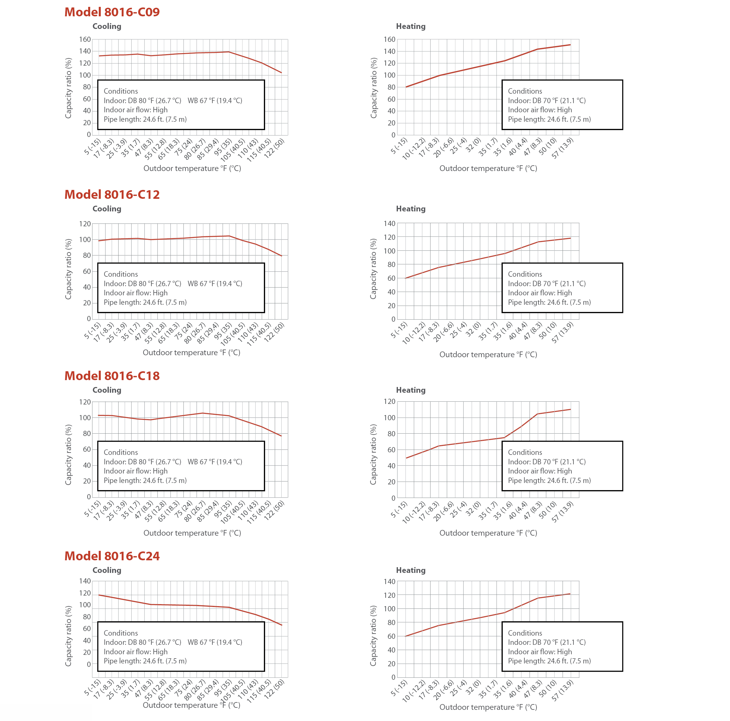

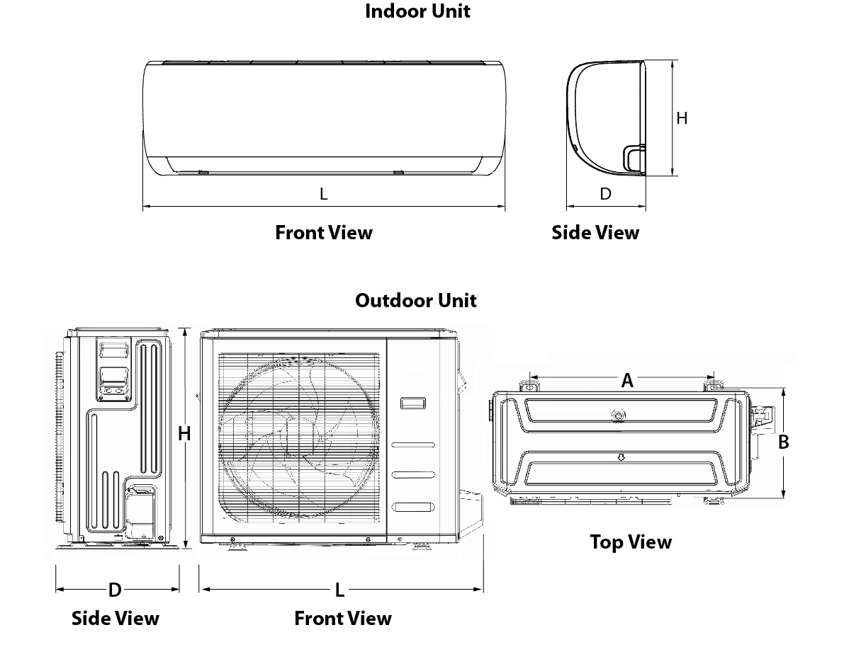

Indoor Unit | L |  | H |  | D
Indoor Unit | in. | mm | in. | mm | in. | mm
8016-C09-I | 28 1/8 | 715 | 11 1/4 | 285 | 7 5/8 | 194
8016-C12-I | 31 11/16 | 805 | 11 1/4 | 285 | 7 5/8 | 194
8016-C18-I | 37 11/16 | 957 | 11 7/8 | 302 | 8 3/8 | 213
8016-C24-I | 40 15/16 | 1040 | 12 7/8 | 327 | 8 11/16 | 220

Outdoor Unit | L |  | H |  | D |  | A |  | B
Outdoor Unit | in. | mm | in. | mm | in. | mm | in. | mm | in. | mm
8016-C09-O  8016-C12-O | 28 3/8 | 720 | 19 1/2 | 495 | 10 5/8 | 270 | 17 13/16 | 452 | 10 1/16 | 255
8016-C18-O | 30 1/8 | 765 | 21 7/8 | 555 | 11 15/16 | 303 | 17 13/16 | 452 | 11 1/4 | 286
8016-C24-O | 35 1/16 | 890 | 26 1/2 | 673 | 13 7/16 | 342 | 26 1/8 | 663 | 13 15/16 | 354

Options
See OTP Options section

Specifications may change without prior notice
Project: | Approval  Information
Consultant Engineer: | Approval  Information
Electrician Contractor: | Approval  Information
Distributor: | Approval  Information
Date: | Approval  Information
Contact at manufacturer: | Approval  Information
Comments:

